**FULL-STACK PROJECT**

**(2020-2021)**

**Medical-Site Web Application**

**FINAL REPORT**



**Institute of Engineering & Technology**

**Submitted by -:**

**Kush Mittal (181500342)**

**Ashish Agarwal (181500137)**

***Supervised By-:***

**Mr. PANKAJ KAPOOR**

**Department of Computer Engineering & Applications**

**Acknowledgement :**

* We would like to give special thanks of gratitude to our mentor Mr. Pankaj Kapoor for supporting us at every moment.
* We learn many things during this project.
* The completion of the project is possible only with the support of team members:

1. Kush Mittal (181500342)
2. Ashish Agarwal (181500137)

**INDEX:**

* **Acknowledgement**
* **Index page**
* **Project details**
* **Project description**
* **Working code along with file name**

**Working screen-shots**

**Data Flow Diagrams**

* **Level-01**
* **Level-02**
* **Level-03**

**\*\* Summary/conclusion**

**\*\* References**

**PROJECT DETAILS:**

* It is a pharmaceutical based website which is used to provide various medical facilities under one common roof.
* The technologies used in this projects are:
* XAMPP
* MySQL
* HTML, CSS, JAVASCRIPT
* PHP

**PROJECT DESCRIPTION:**

There are many definitions for E-Health until now but still there is no consensus on one common definition. This is because of its ubiquitous and dynamic nature. The E-health information are widely used with different meanings and purposes. In our work, we develop the E-health application mostly used for diabetes patient.

There are many benefits to different people such as doctors, patients, etc. For example, doctor‟s orders can be placed electronically, which avoid wrong elucidation of hand wrote orders. And with the help of E-health, most doctors reduces the time of locating and reading patient health information.

To the patient, 5 they can begin to be gradually aware of the importance of self-care management. Moreover, it is also convenient for maintaining only with some experts in medical and application developers.

The pharmacy management system serves many purposes, including the safe and effective dispensing of pharmaceutical drugs. During the dispensing process, the system will prompt the pharmacist to verify the medication they have filled is for the correct patient, contains the right quantity and dosage, and displays accurate information on the prescription label. Advanced pharmacy management systems offer clinical decision support and may be configured to alert the pharmacist to perform clinical interventions, such as an opportunity to offer verbal counseling if the patient's prescription requires additional education in the pharmacy.

Medical shop owner can manage his data using such as medicine names, expiry dates, medicines left.

Medical shop owner can generate e-bills.

When user can write his/her symptoms so, we can provide medicines chart related to diseases so, he/she will easily find out which medicine he/she takes.

When a medicine shop owner or any one want to purchase a medicine so, we can re-direct our website page to other purchasing websites.

**FEATURES:**

* Admin Login.
  + Product Entry.
  + View users details.
  + View Order.
* User Login/Registration.
* Add to Cart.
* Pay using Card.
* View order.

**Project Implementation Details :**

∙ Firstly, we made a log-in page for the user, the user can sign-up on our website through his mobile number & then log-in after completing the sign-up process.

∙ After log-in into his account, user can get the option of adding medicine details into stock including details like quantity, price, expiry date, etc.

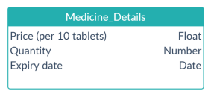

∙ He can also view the data of the stocks he has in his store so that there will be no untimely shortage/expiry of any medicine.

∙ He can also get a feature where he can type medicine name, quantity and can generate the bill for the customer.

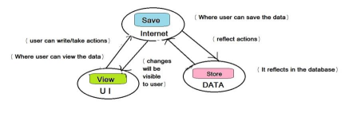

**Project Implementation Technology :**

* The project is loaded in visual studio 2010.
* We used visual studio for design and coding of project.
* Created and maintained all database into SQL Server 2008, in that we

create tables, write query for store data or record of projects.

**Technologies used:**

* Browser: Google Chrome/ Firefox.
* Front-End : HTML, CSS, Javascript.
* Programming language : PHP / JAVA / Ruby.
* Frameworks : Node.js / Angular.js / .NET / Ember.js
* Database : MySQL / Oracle / MongoDB.
* Git Package
* Visual Studio Code As IDE
* XAMPP SERVER

**WORKING CODE WITH ALONG FILE NAME:**

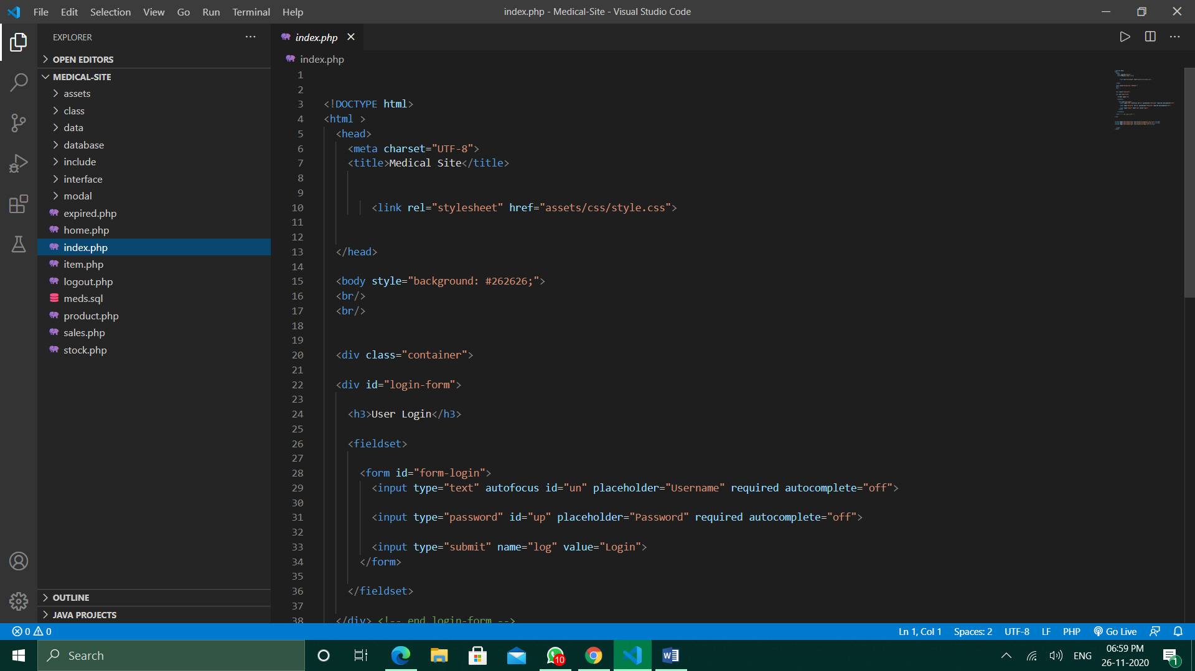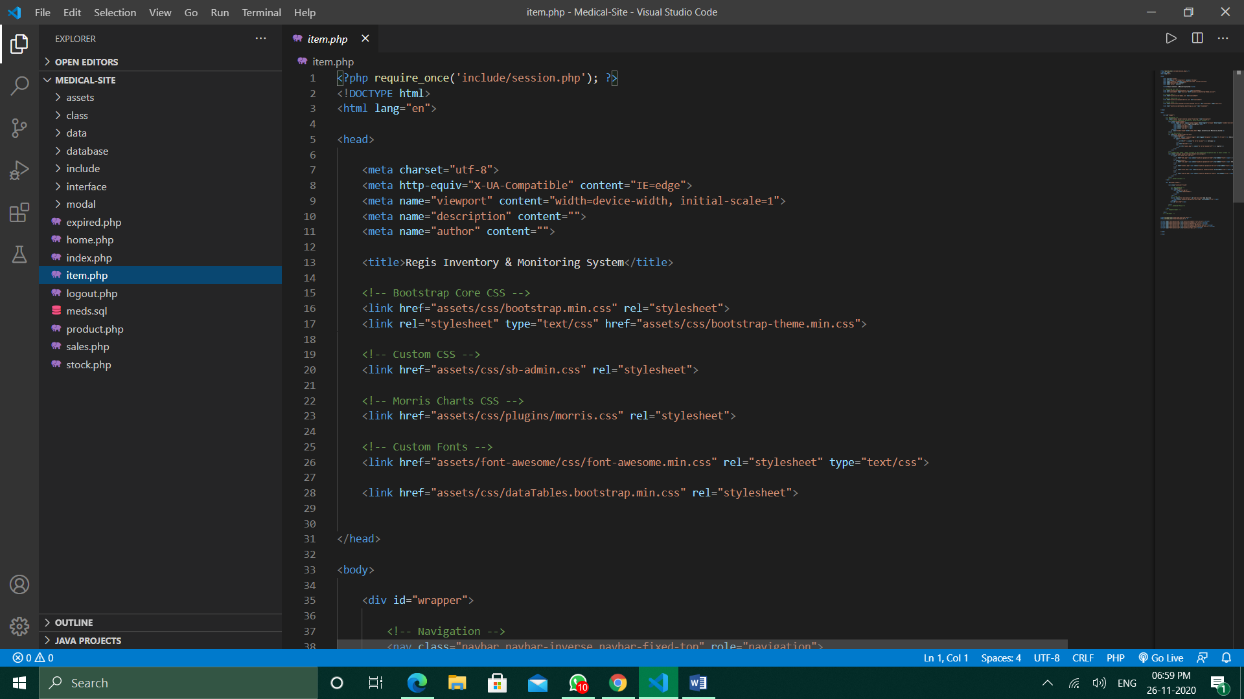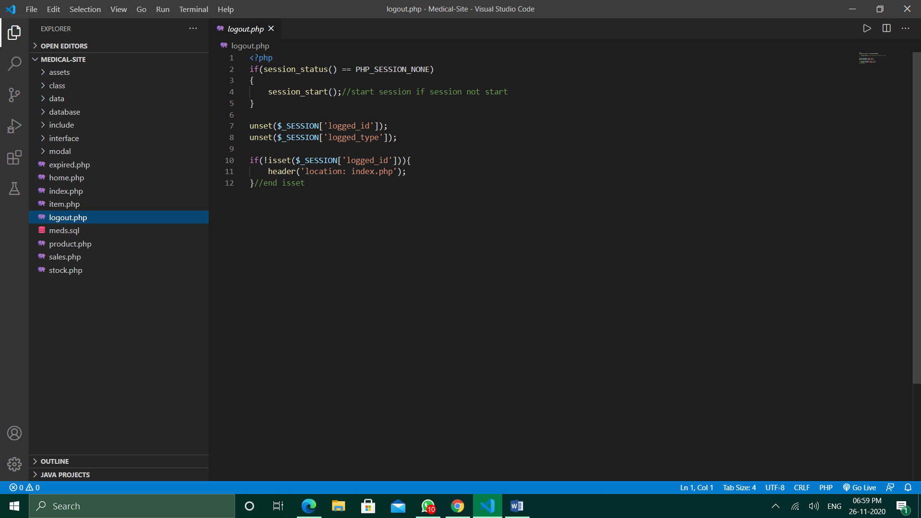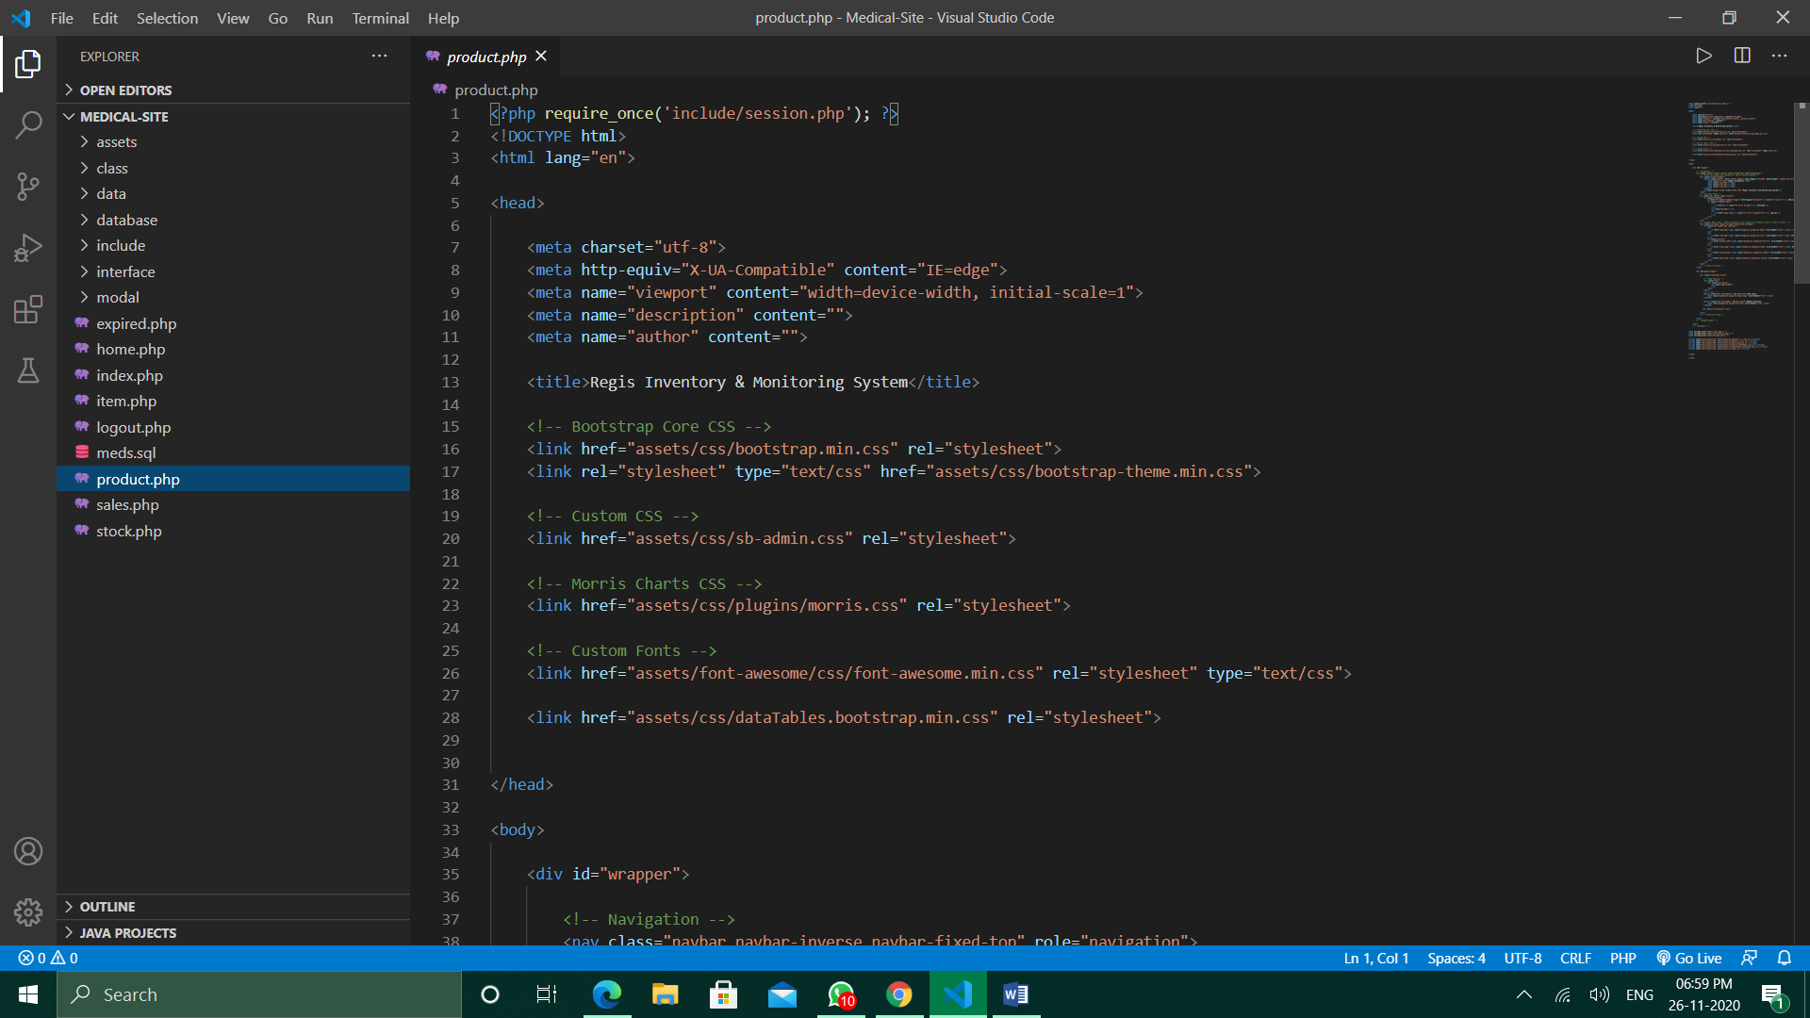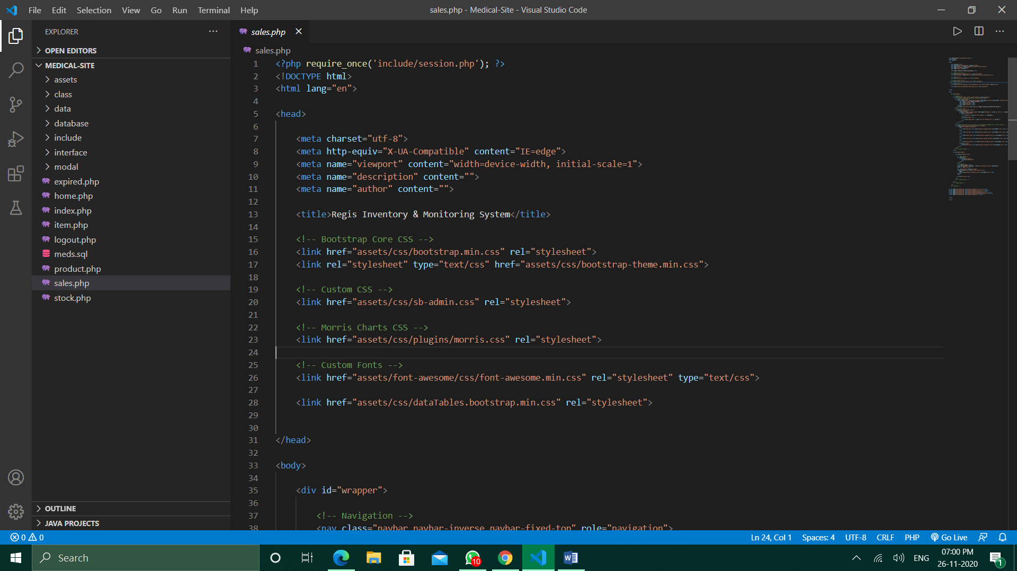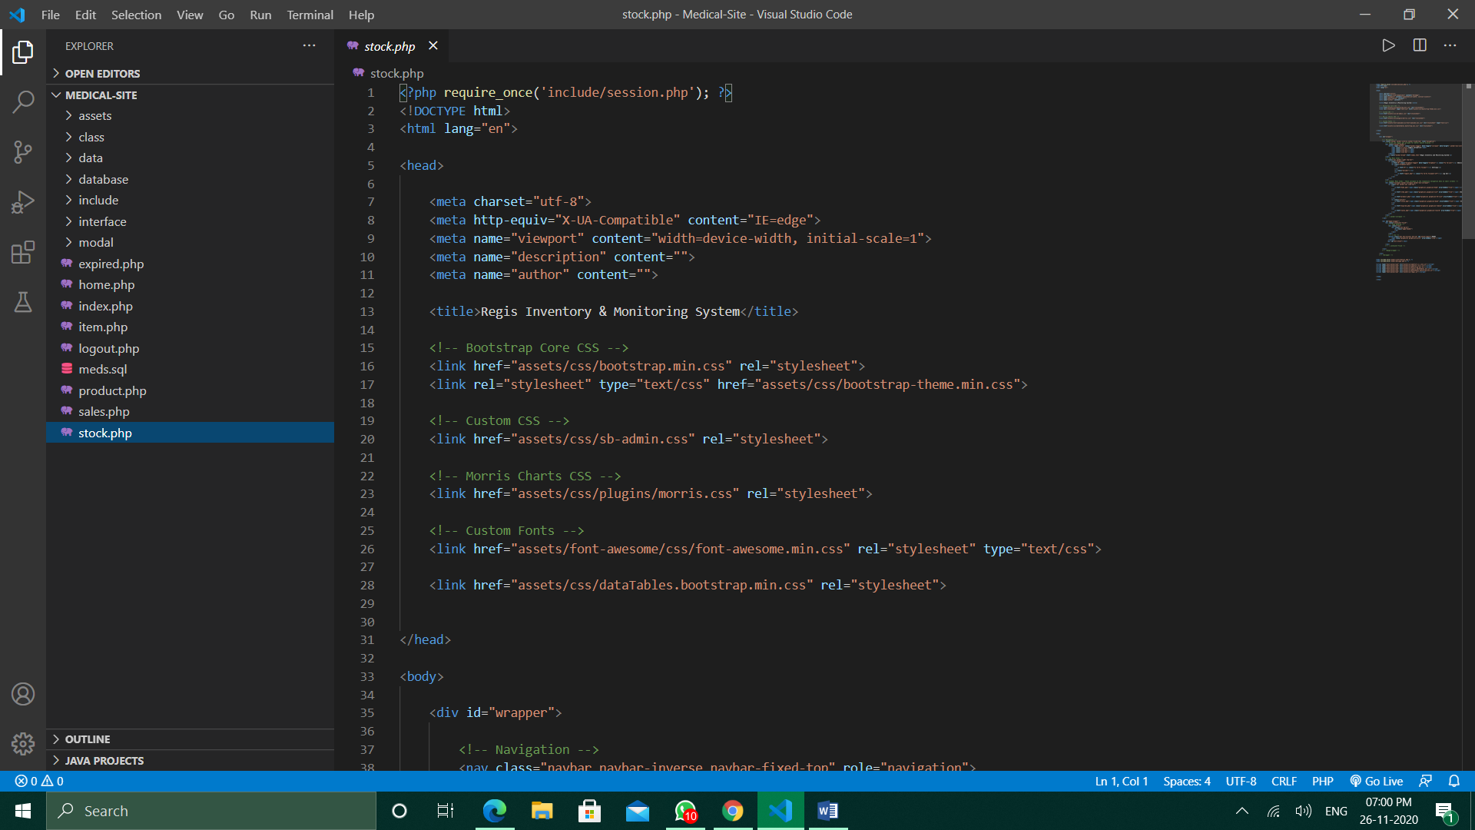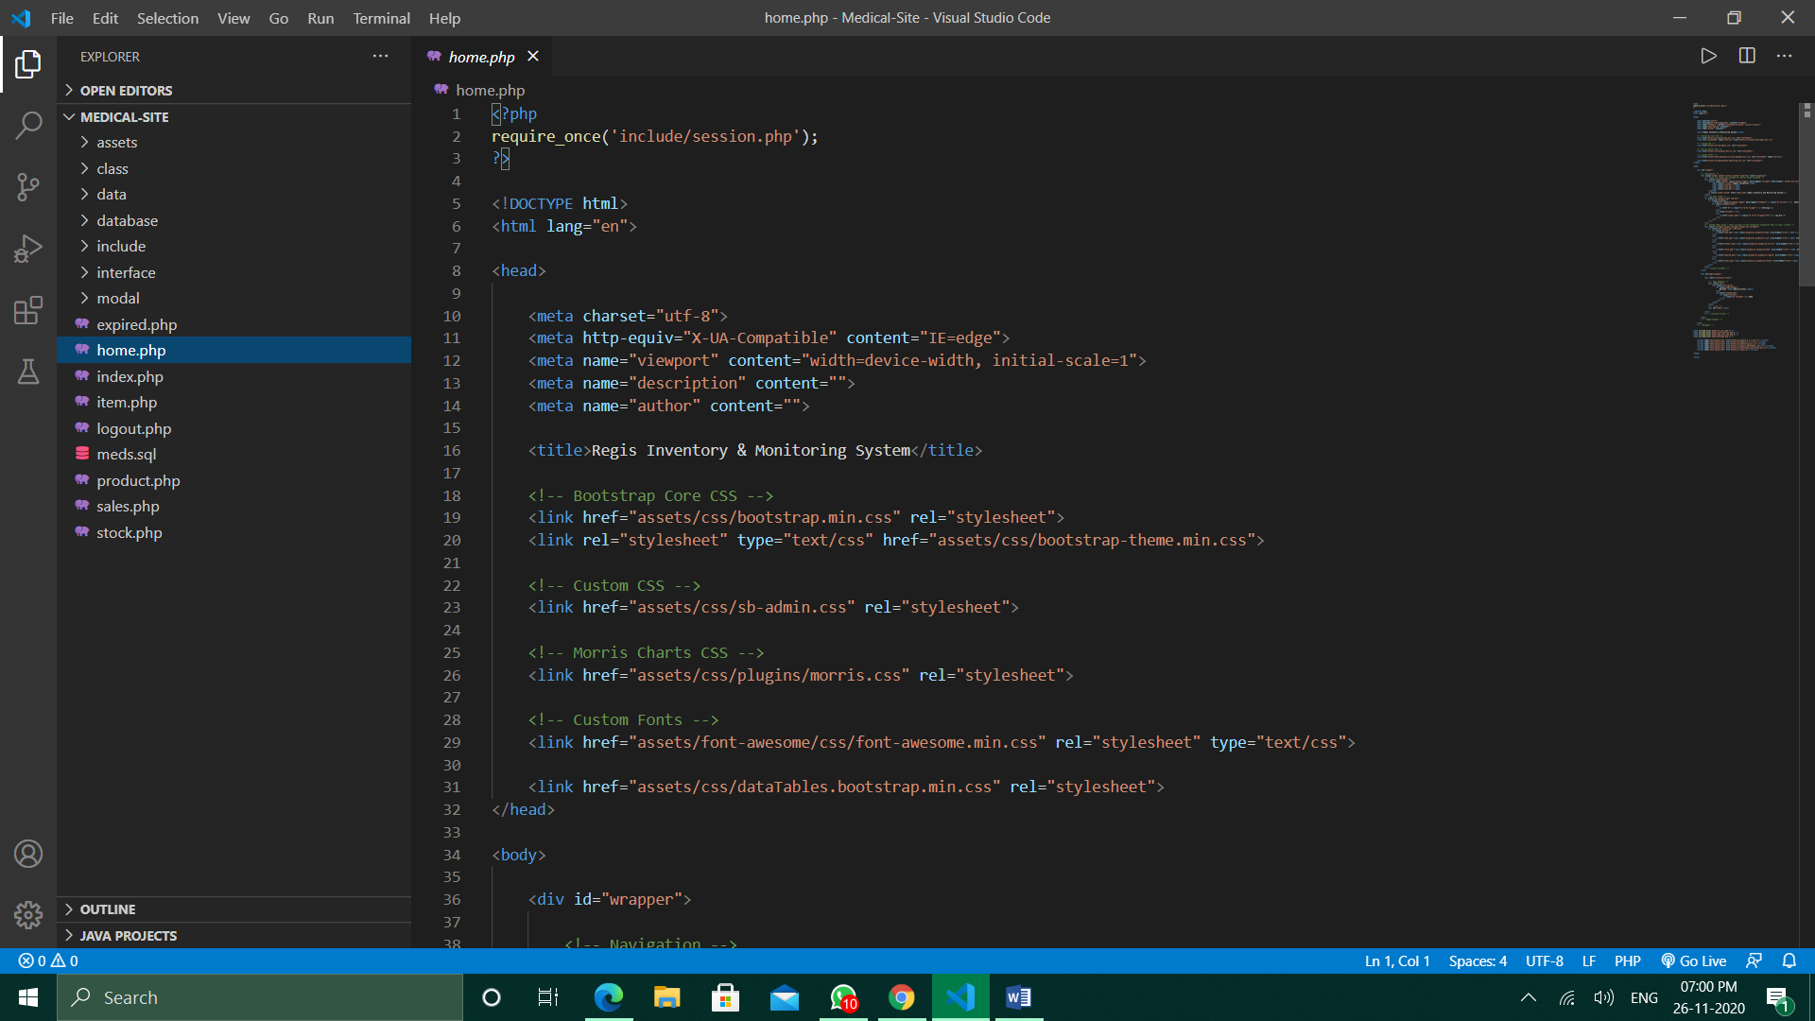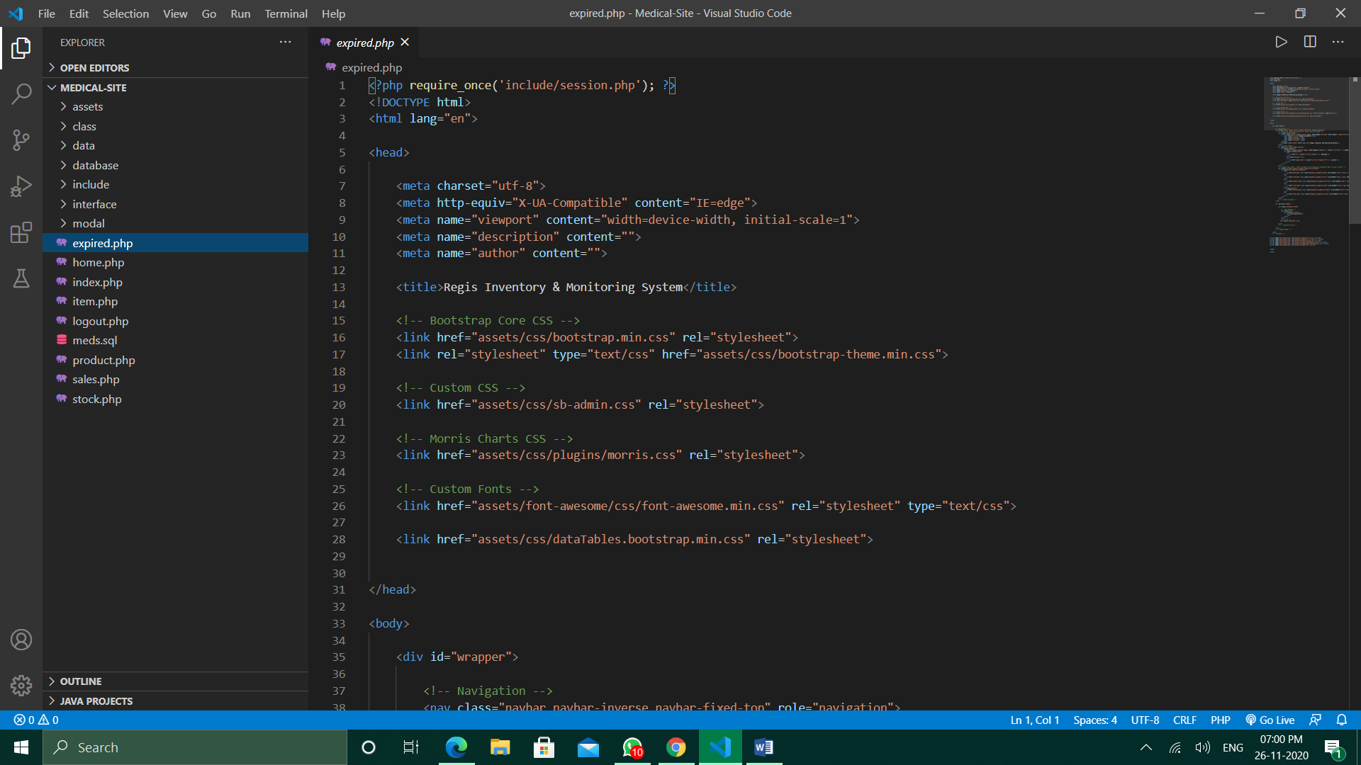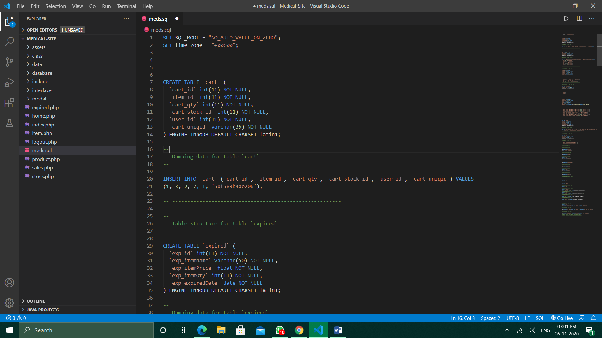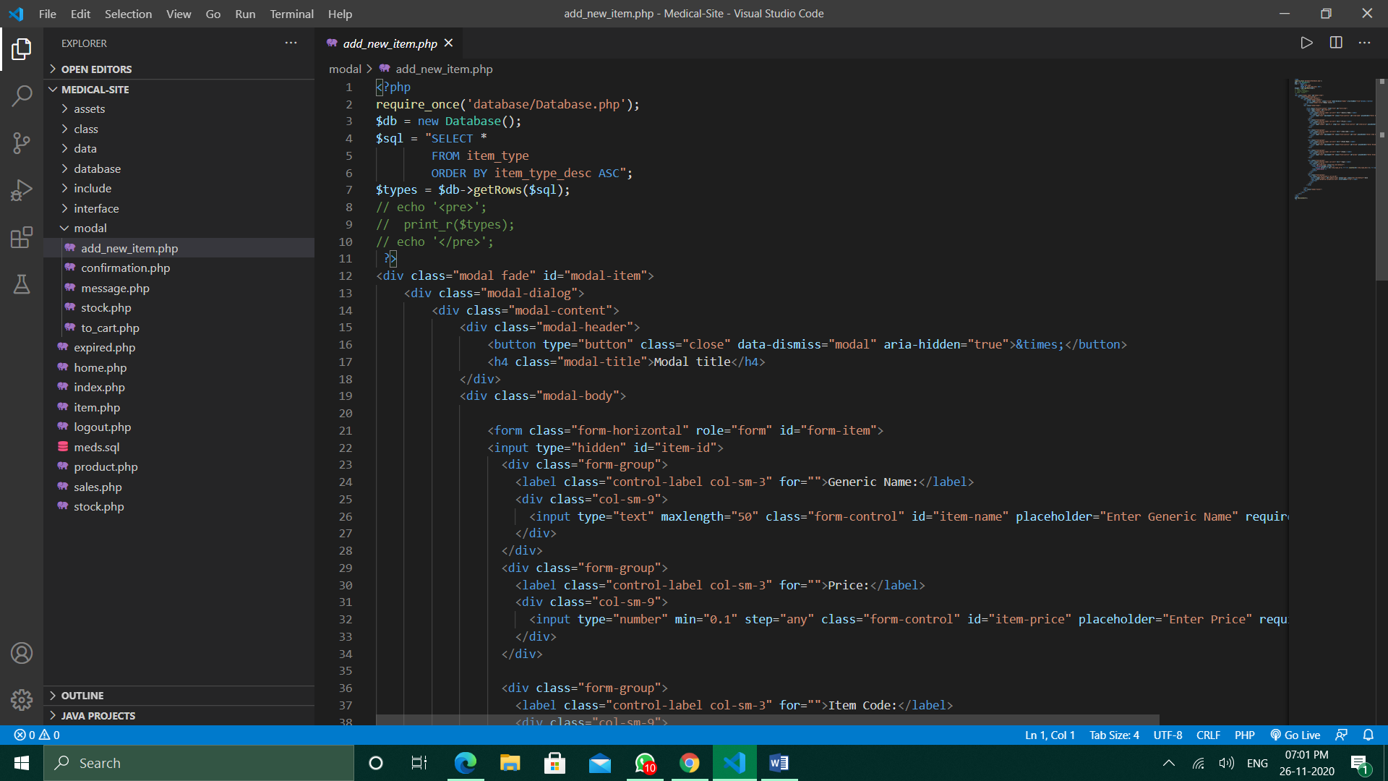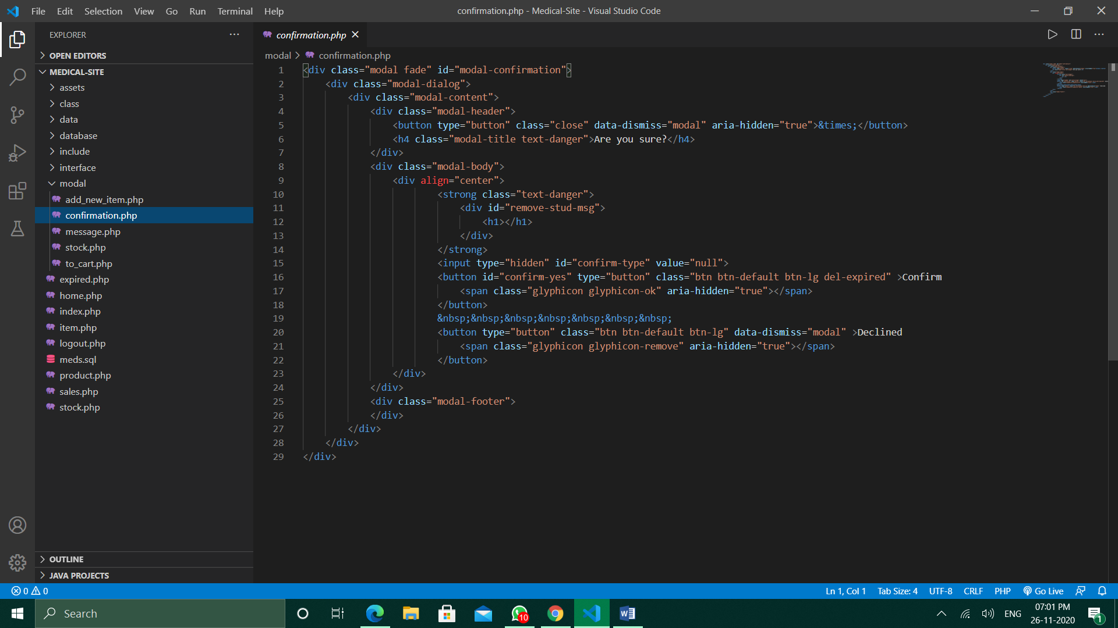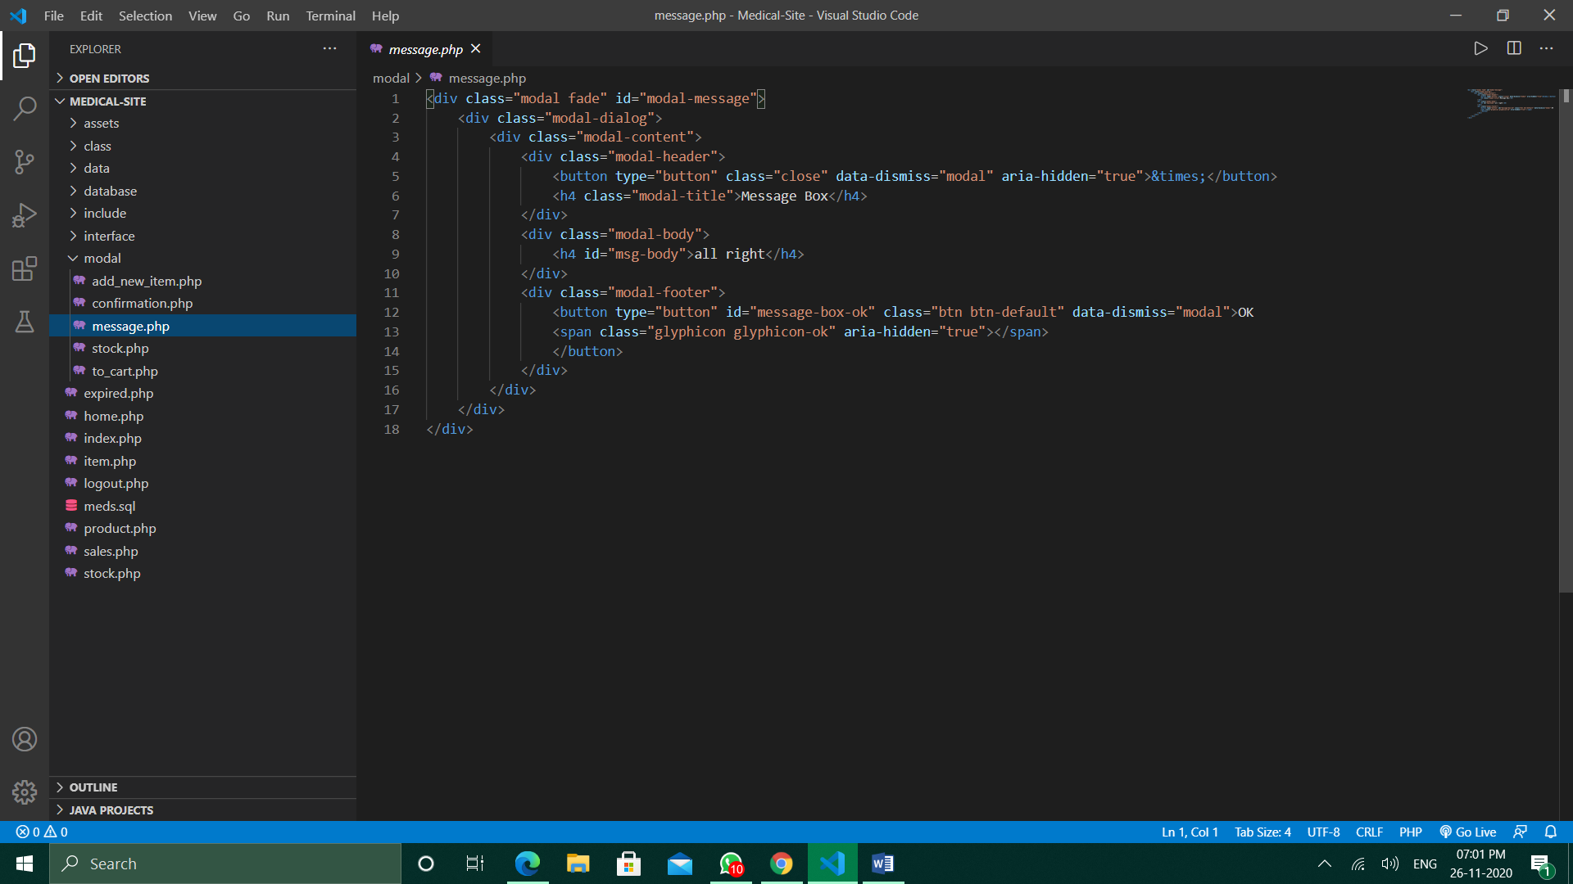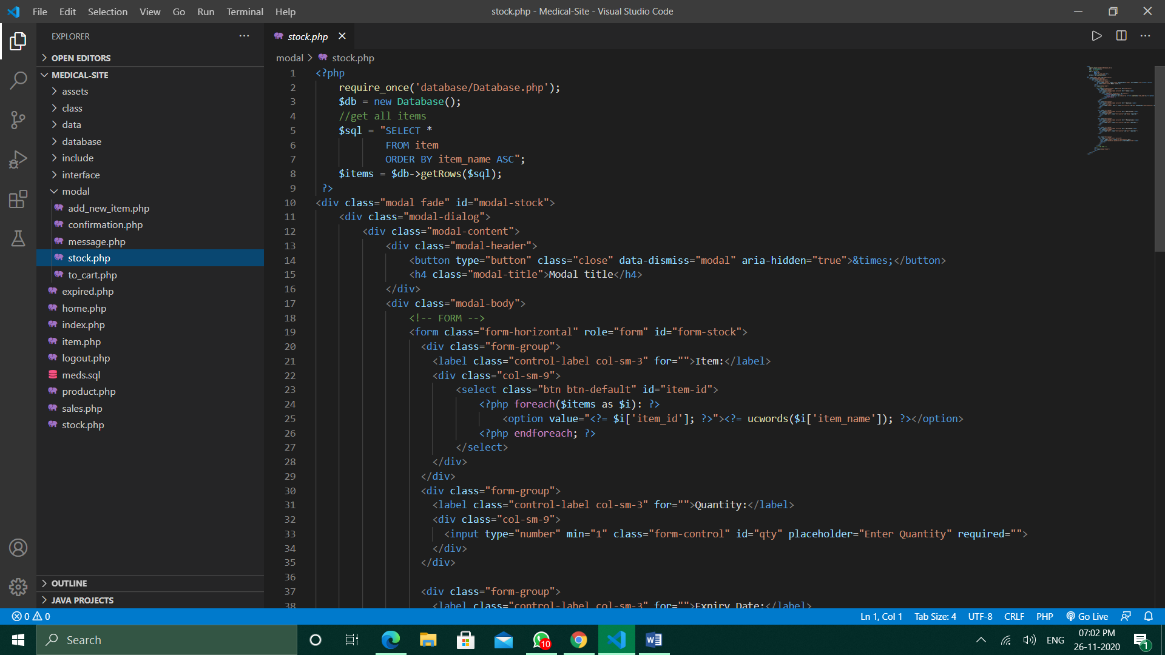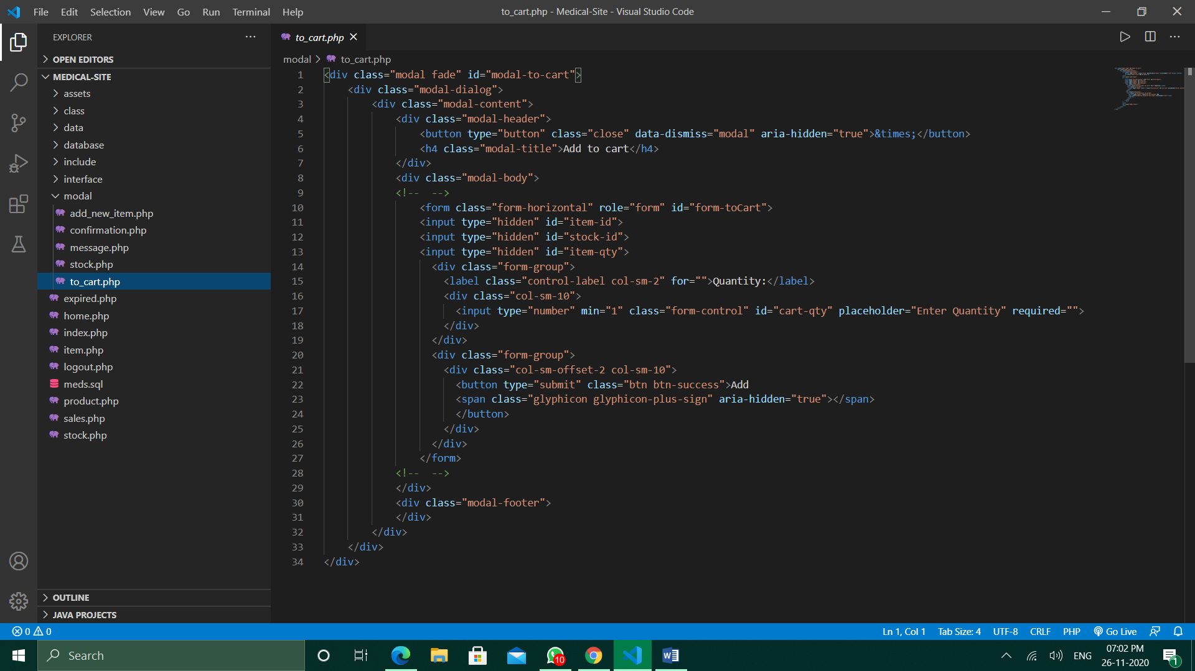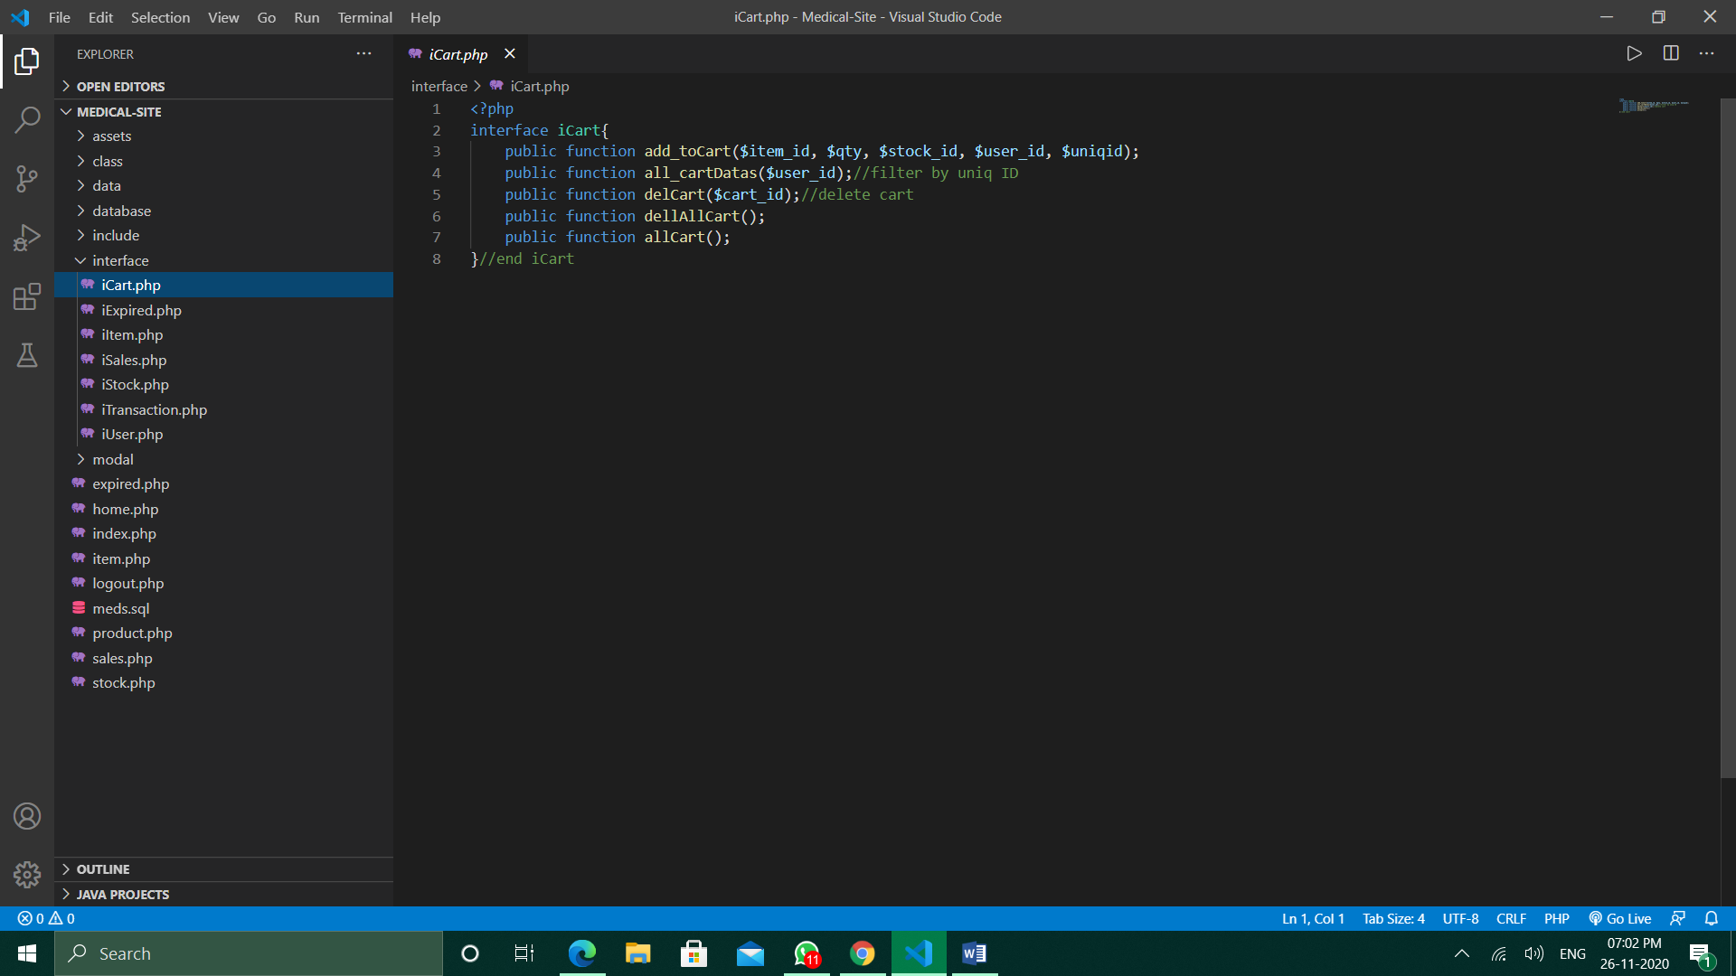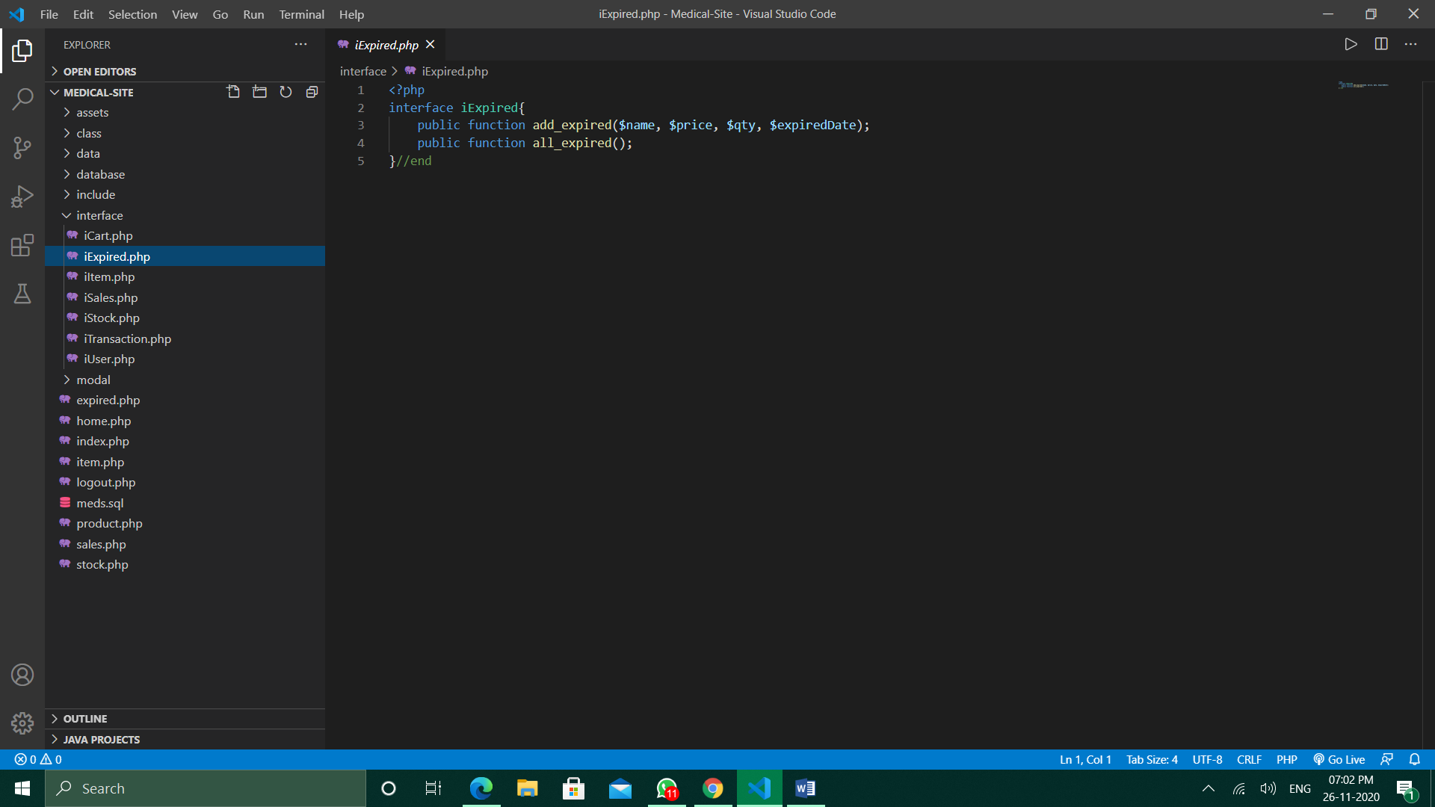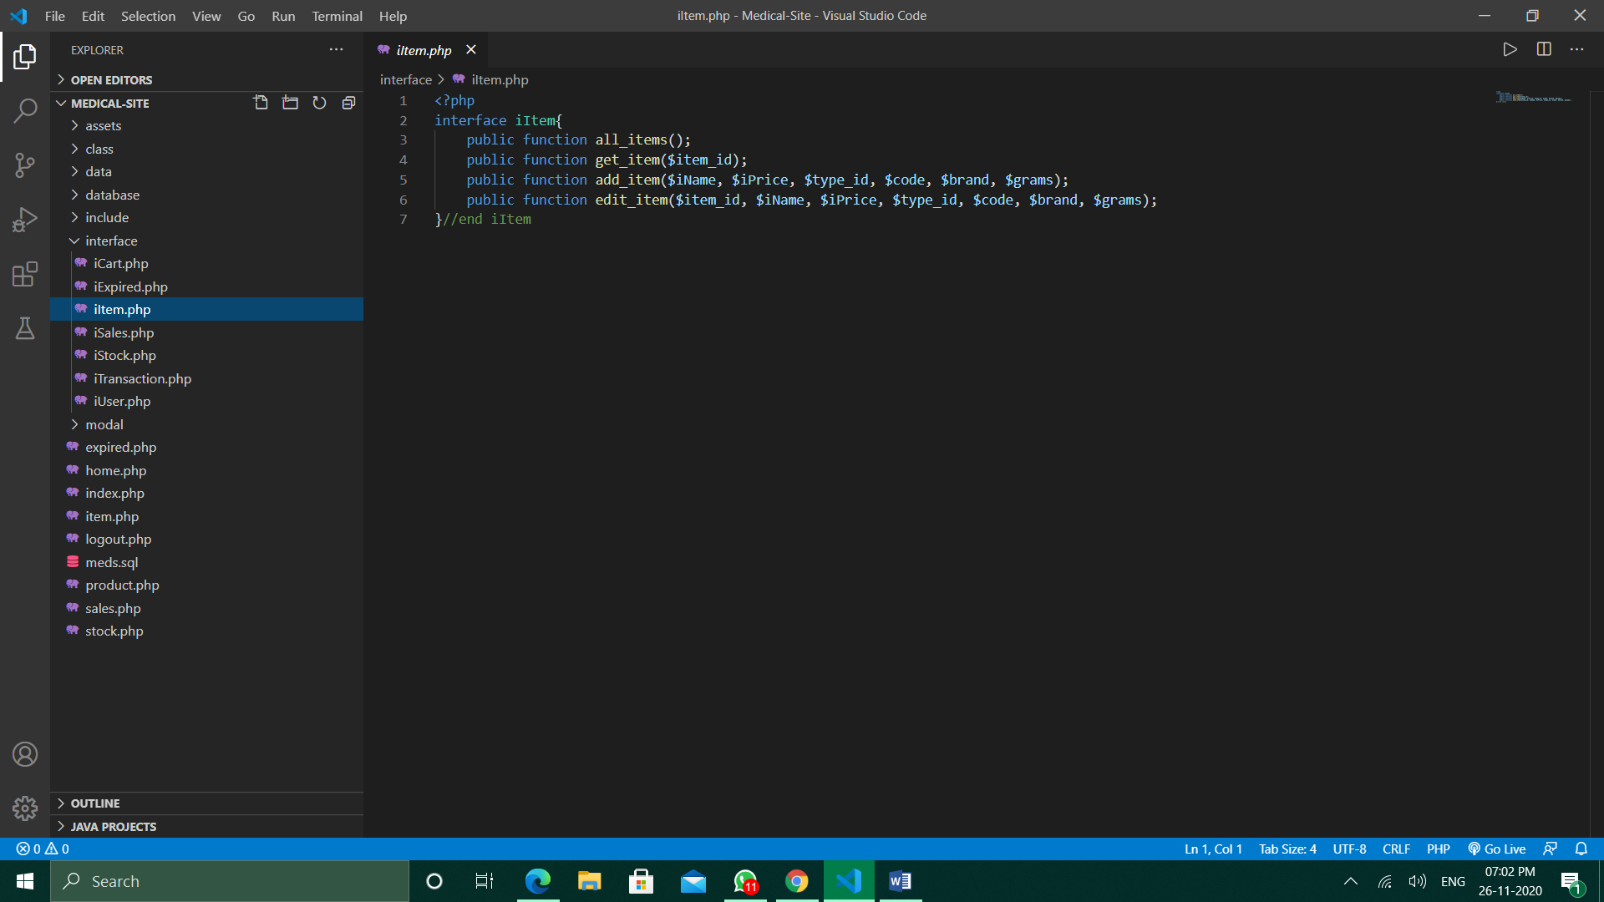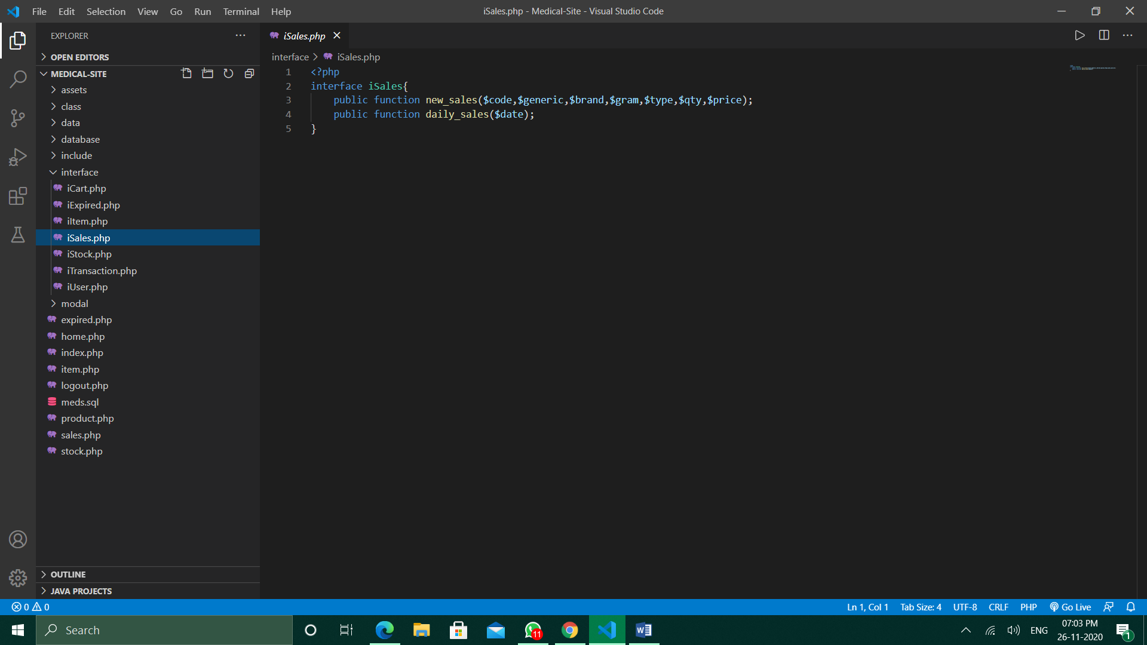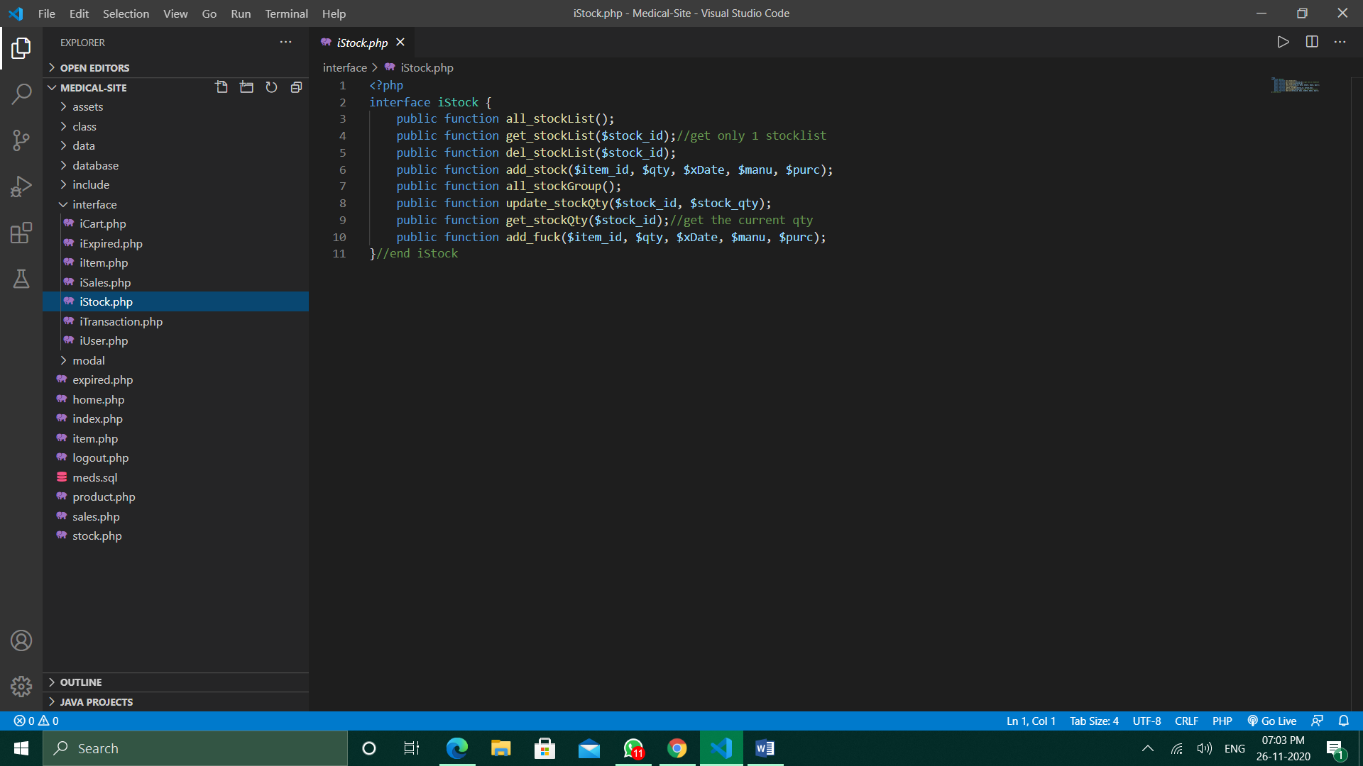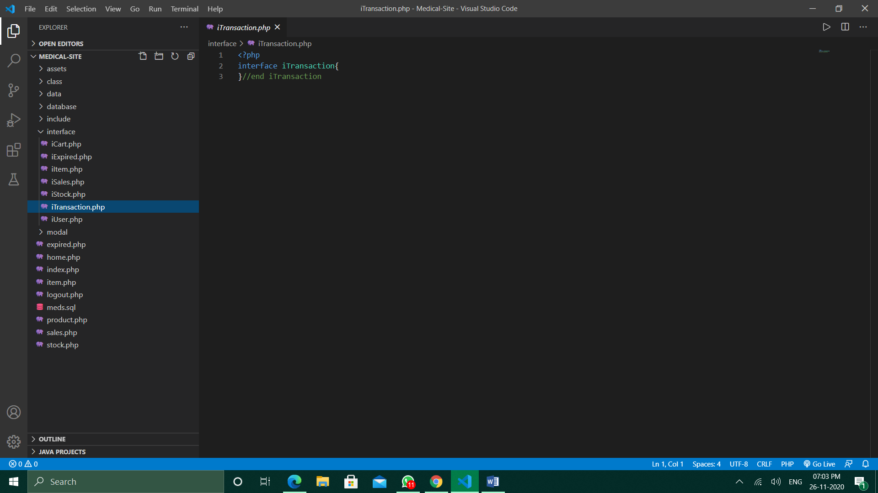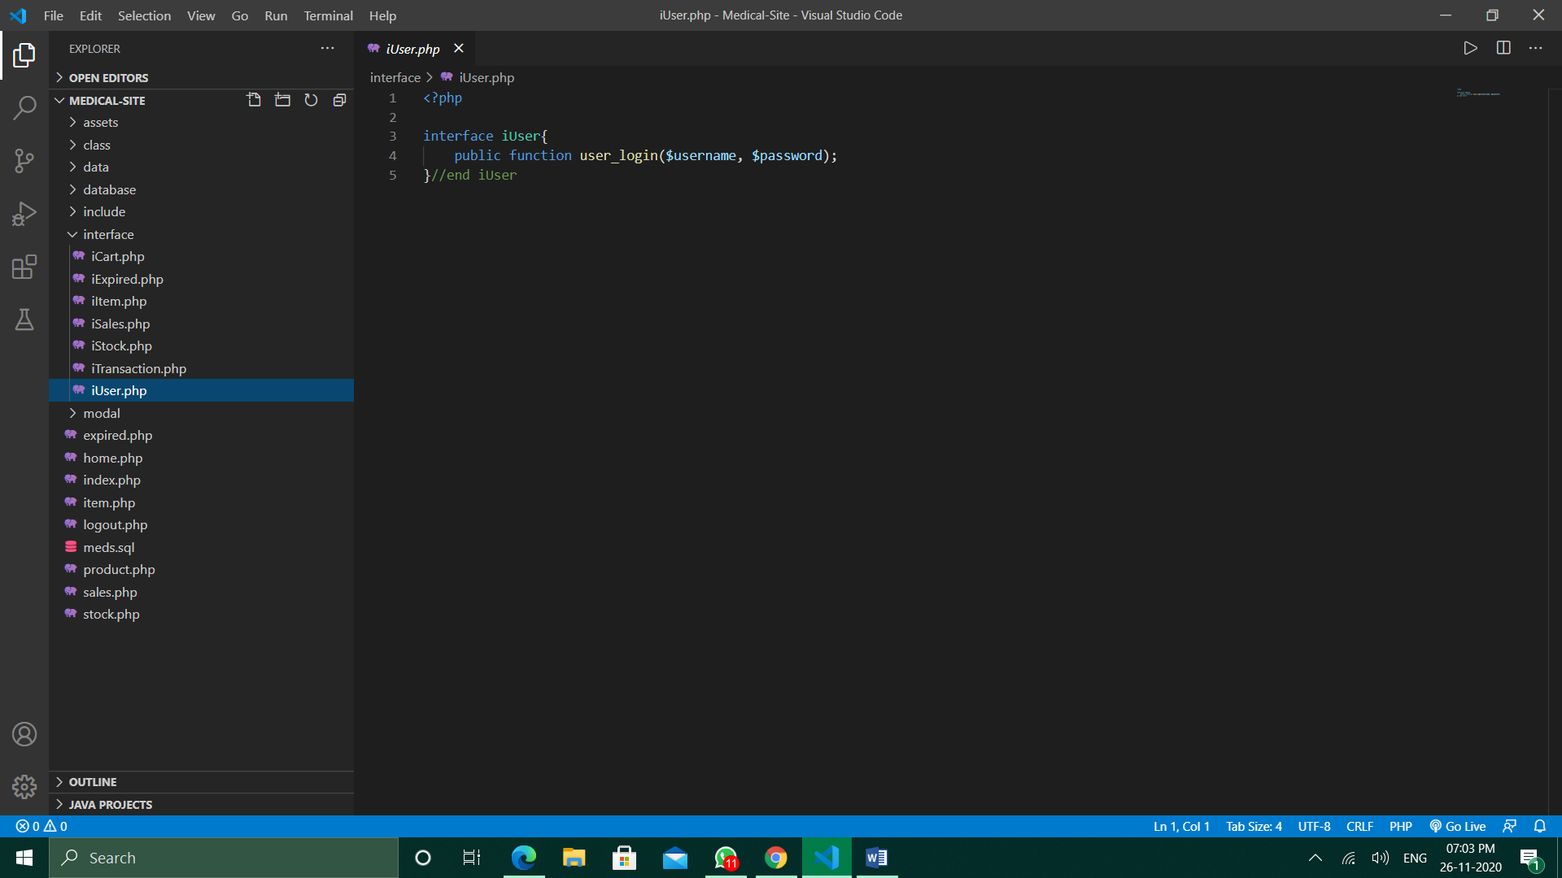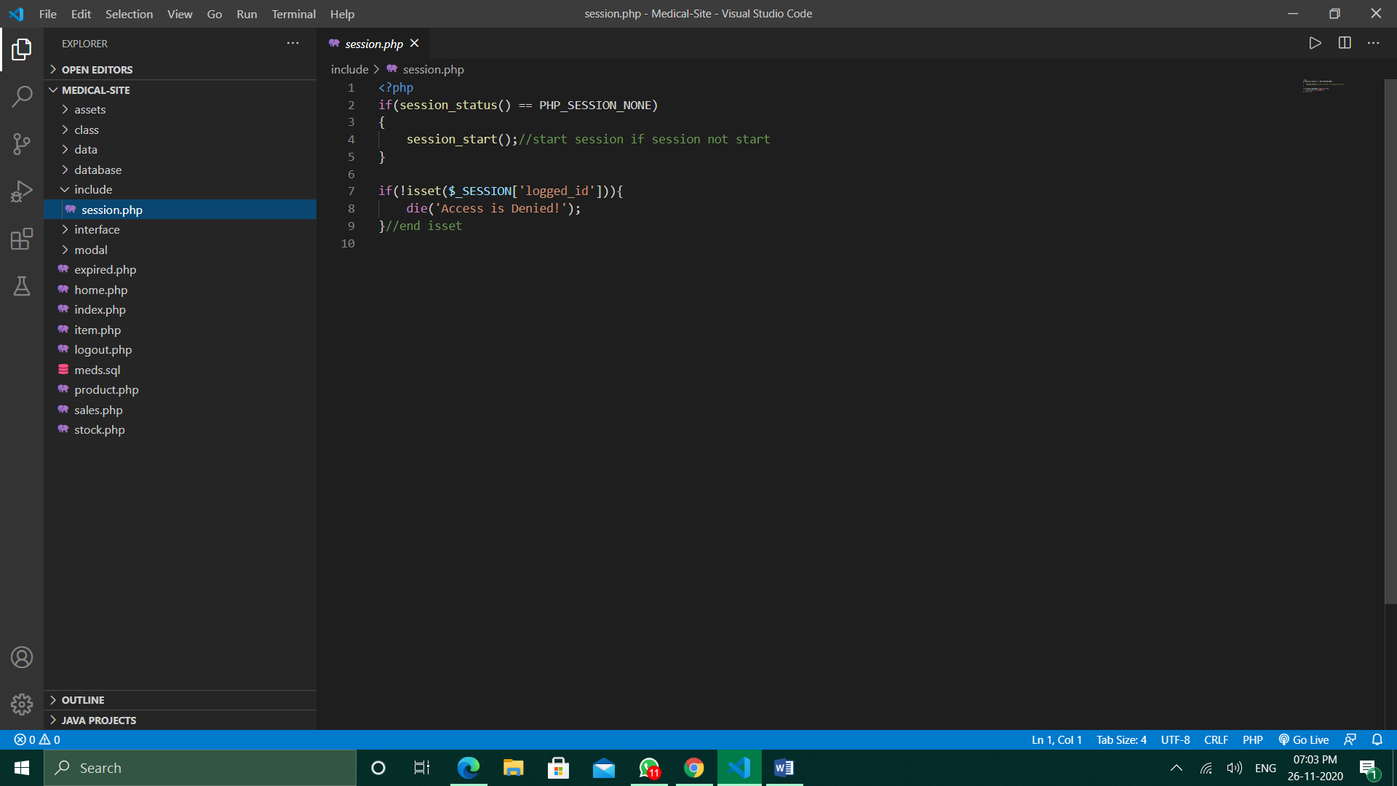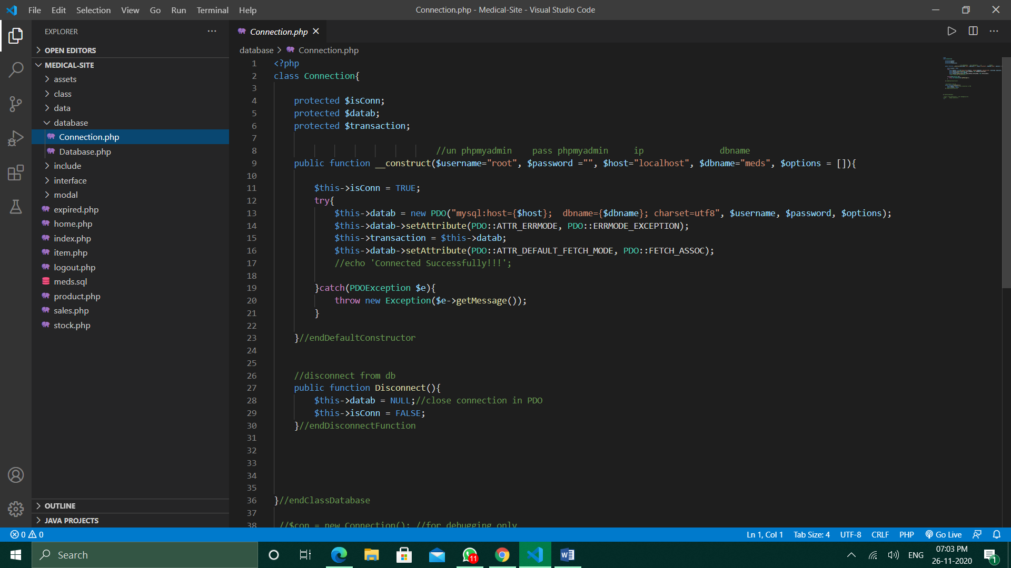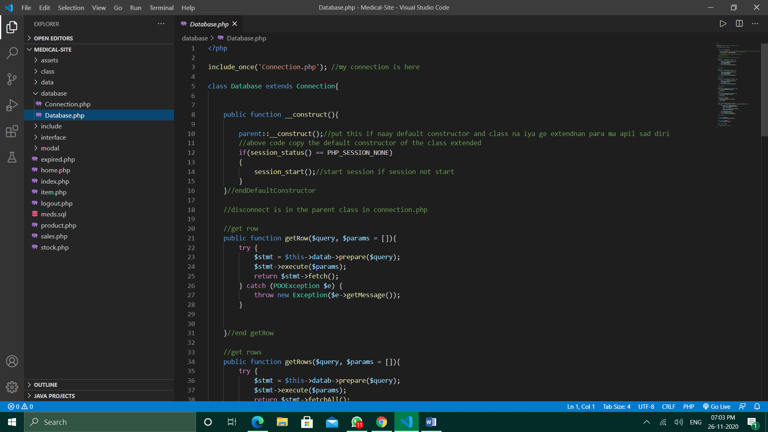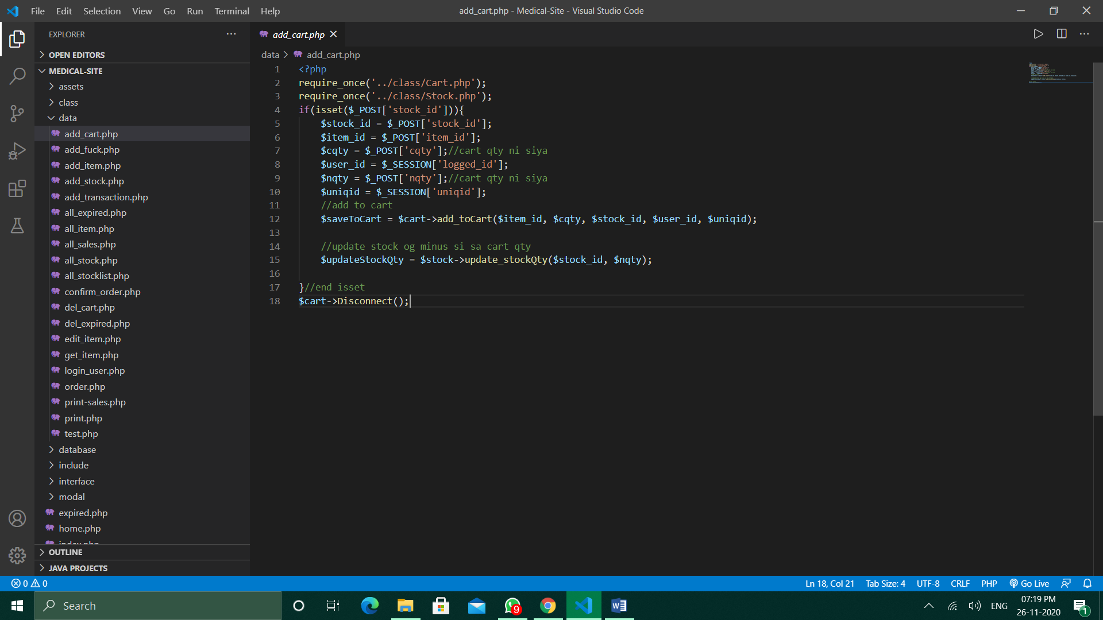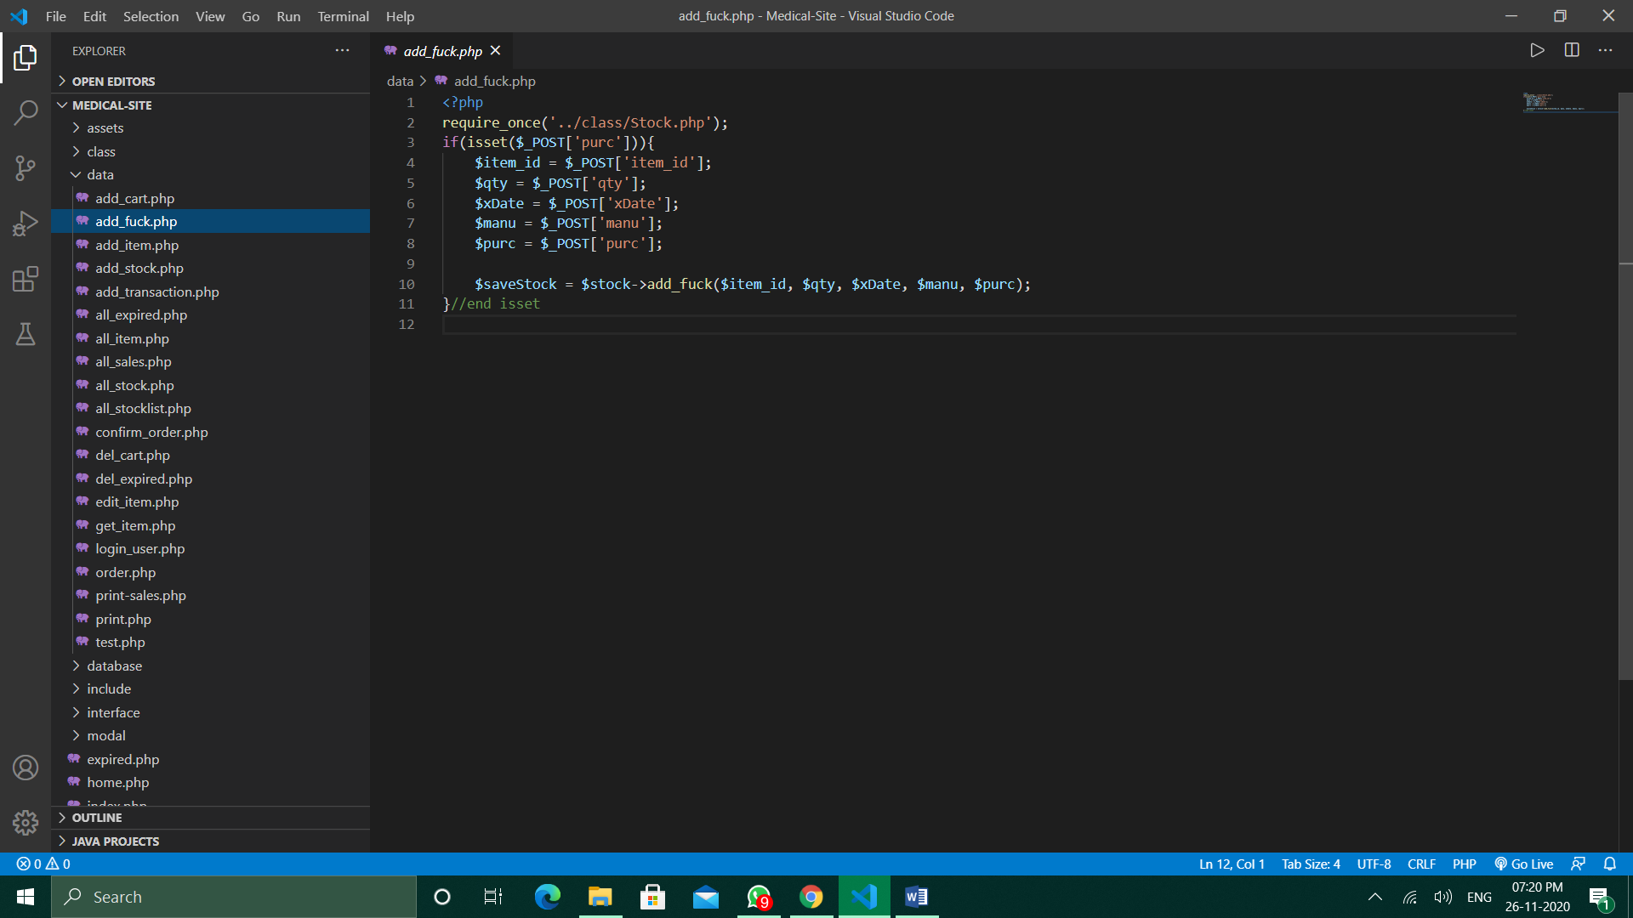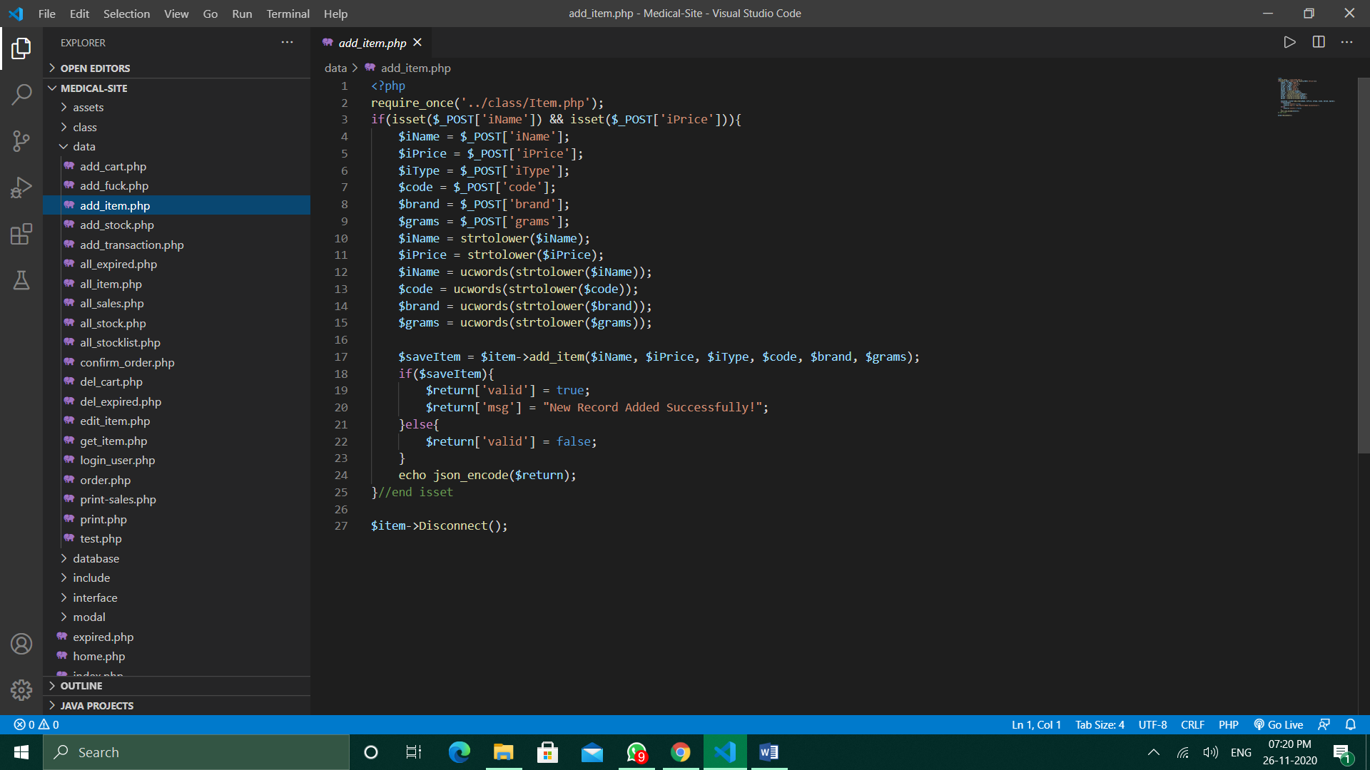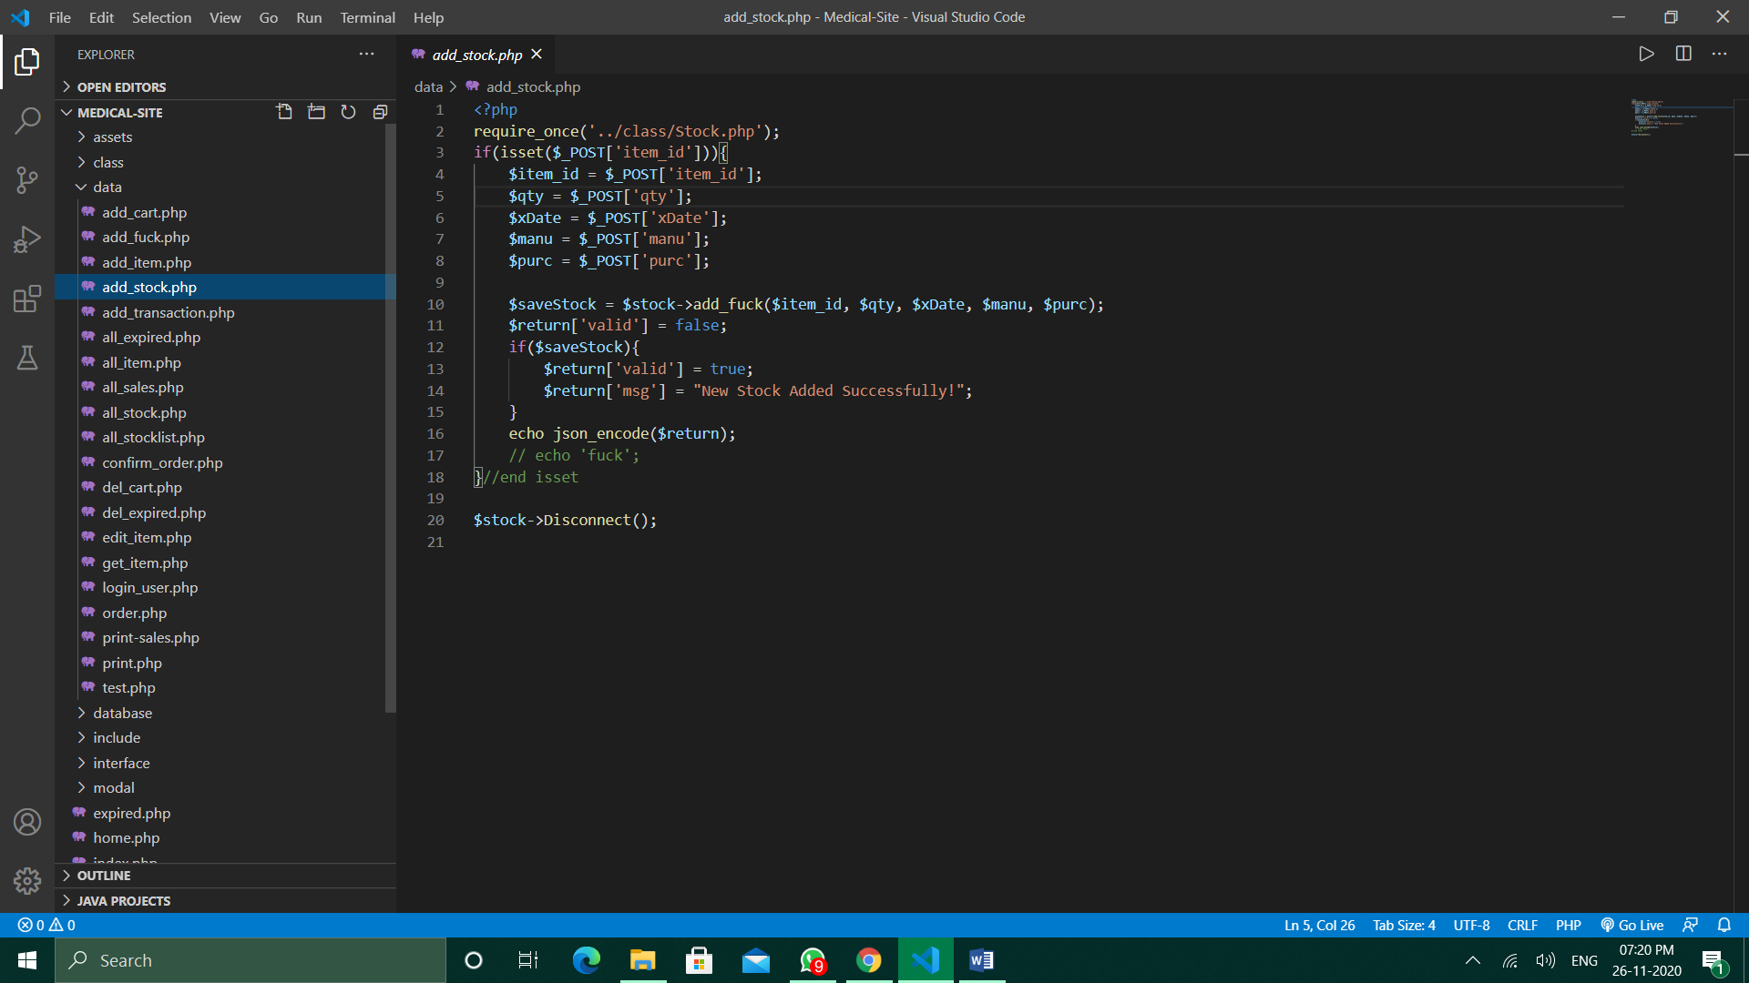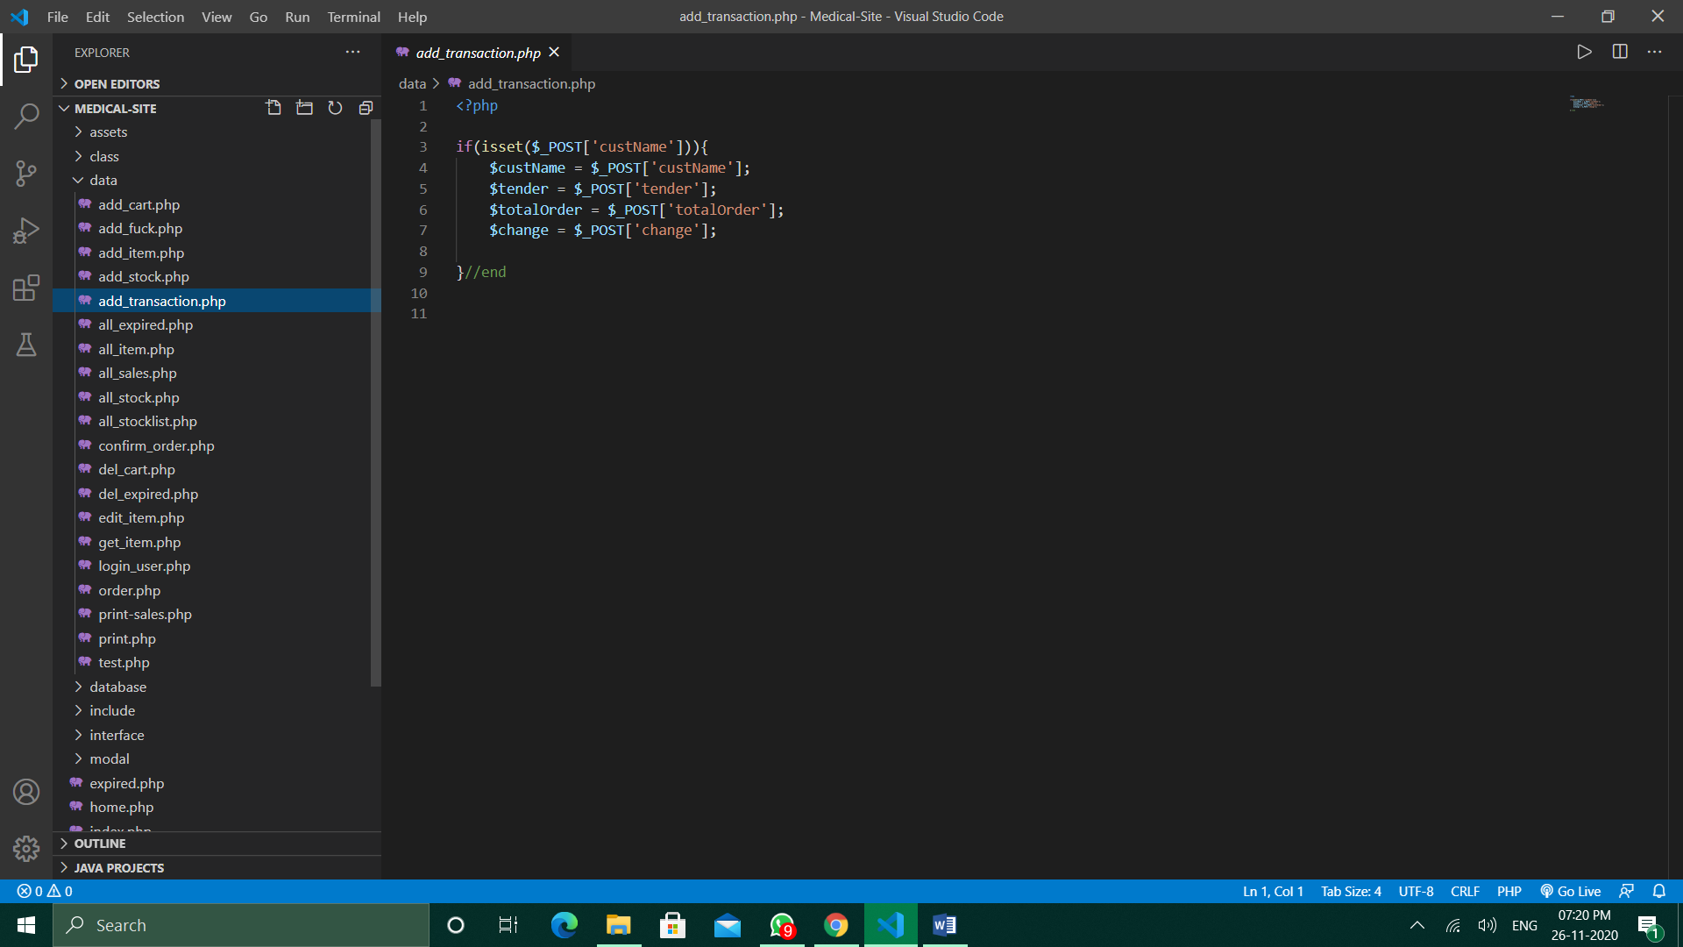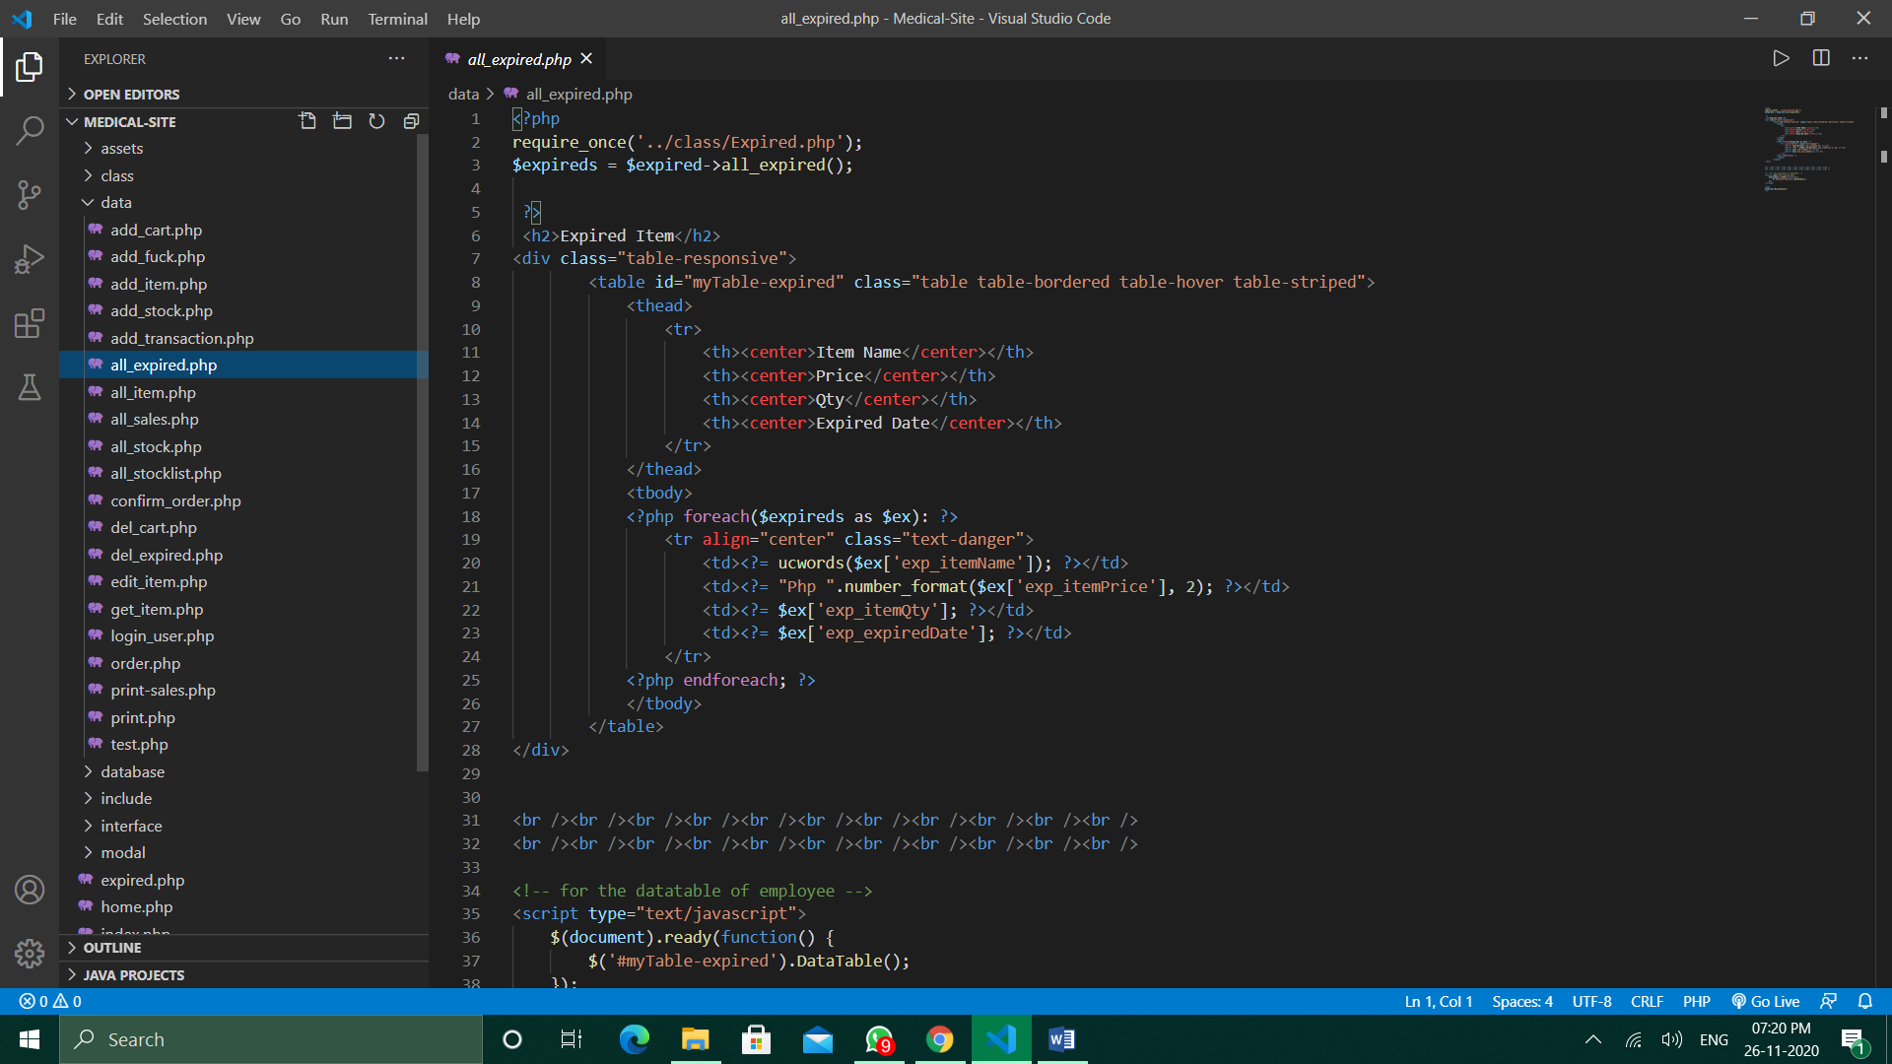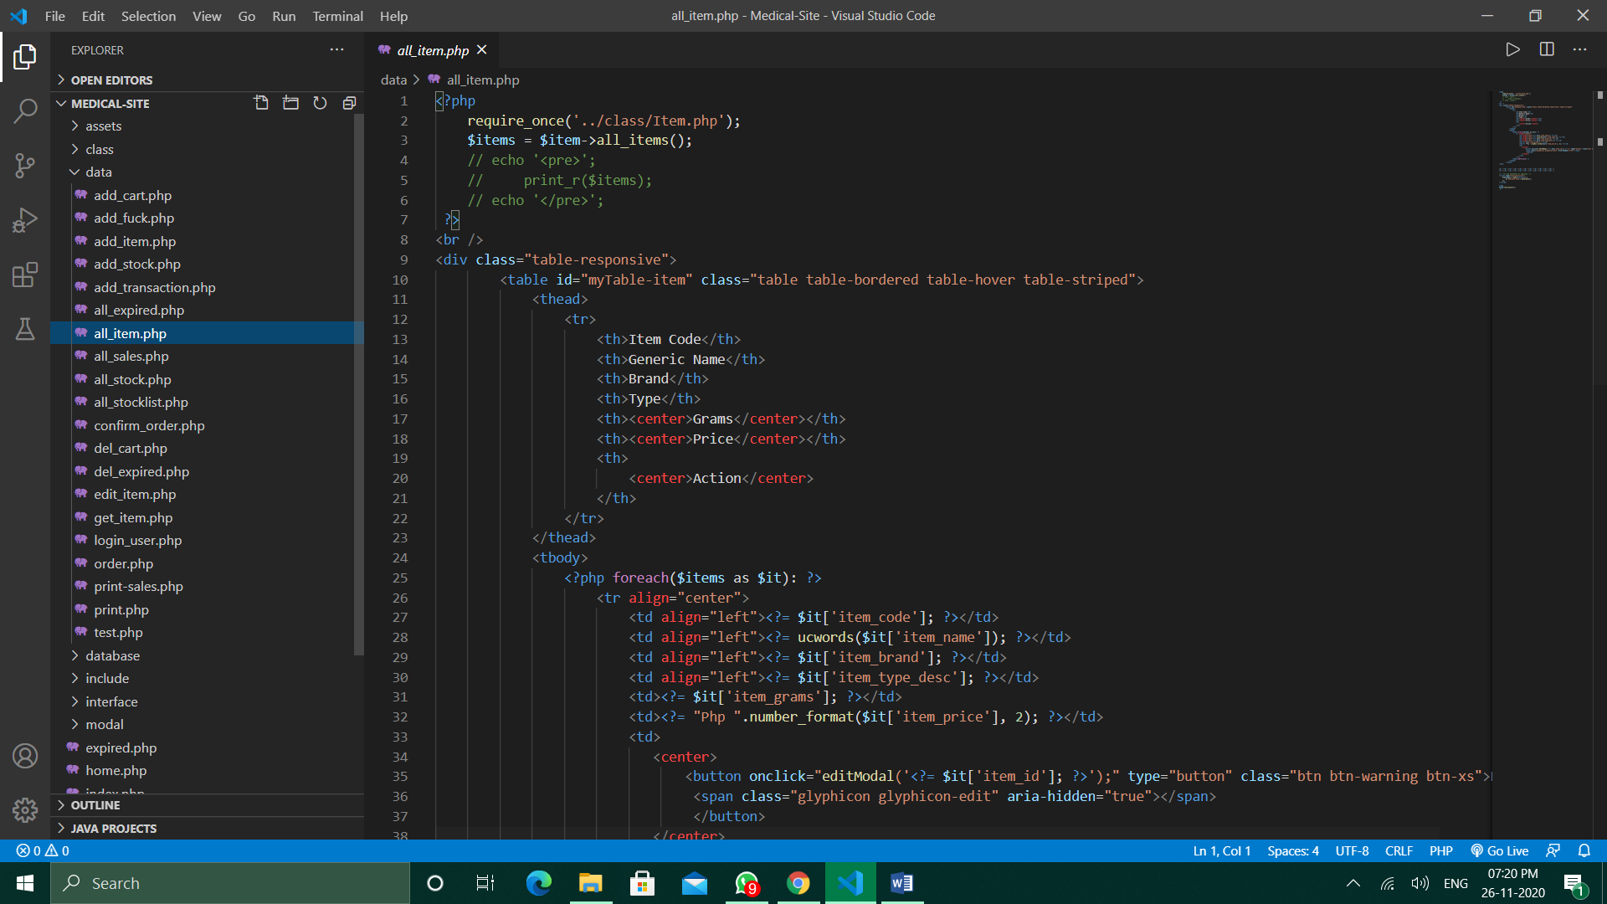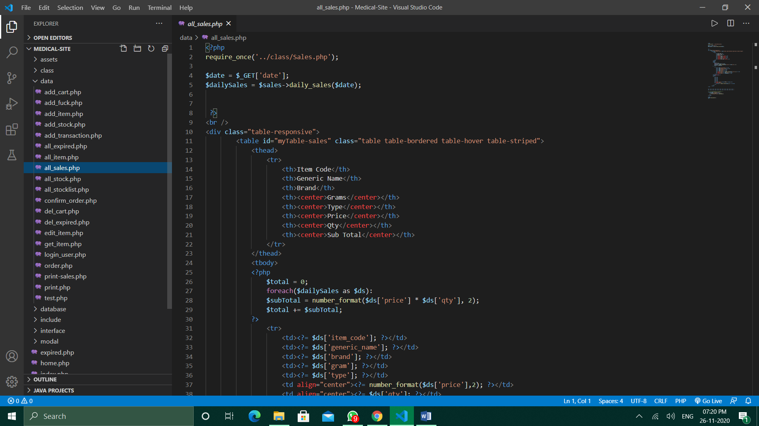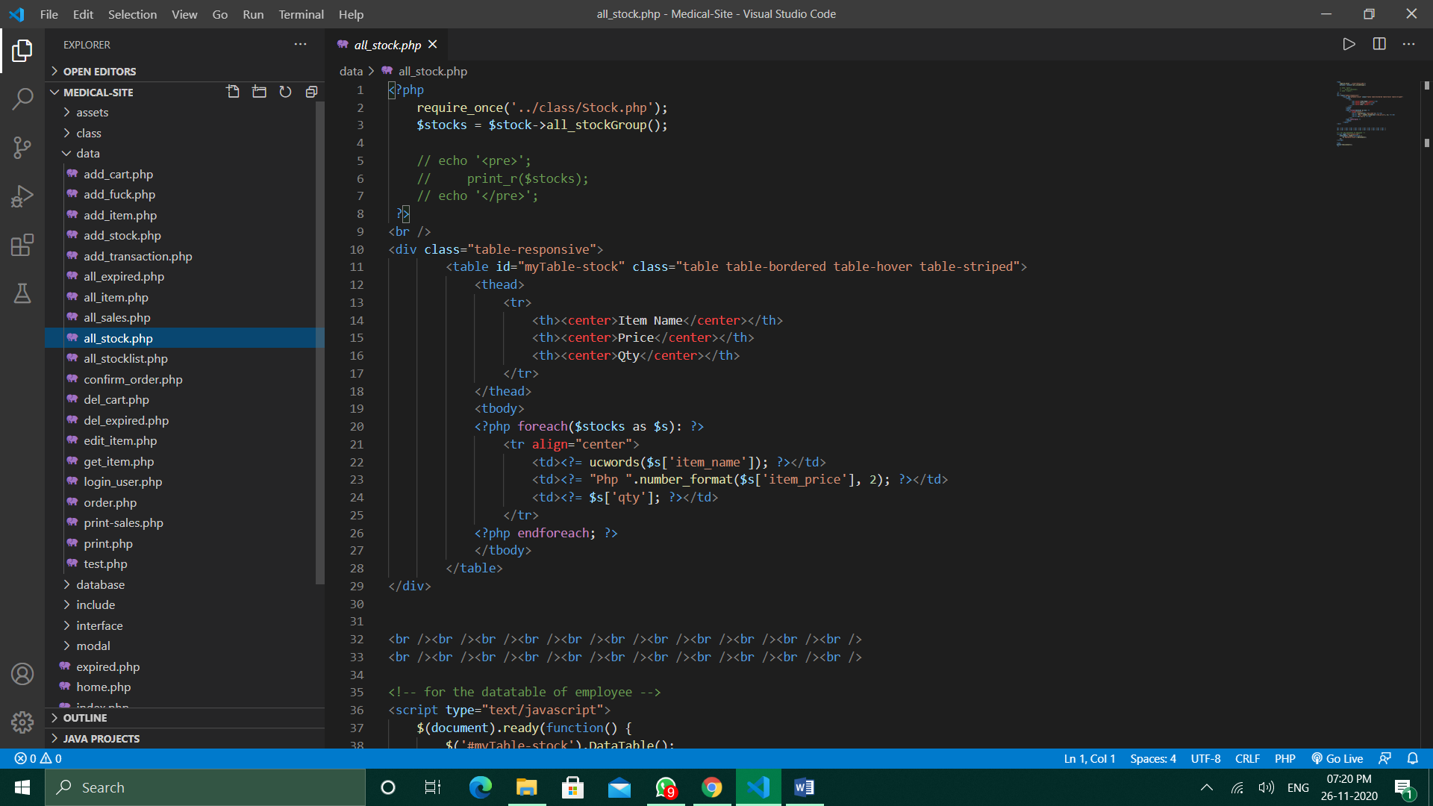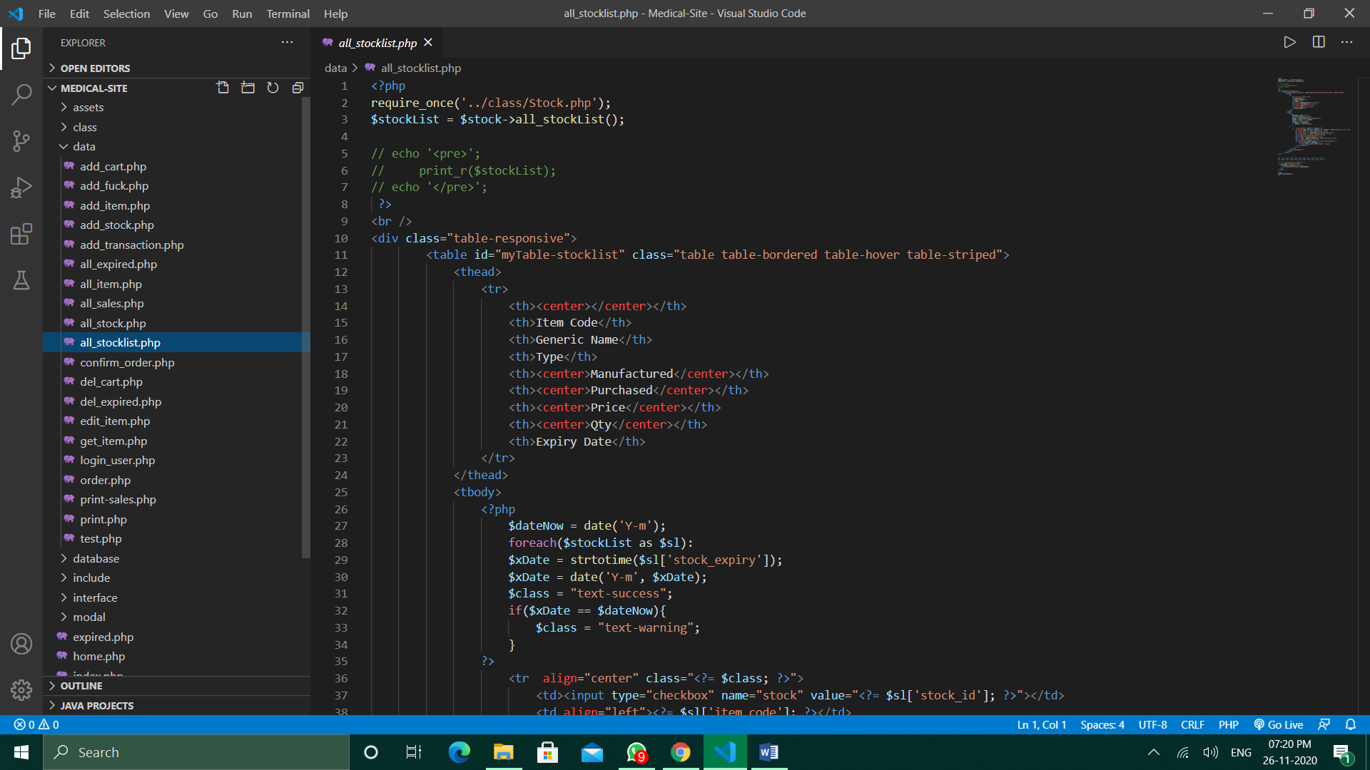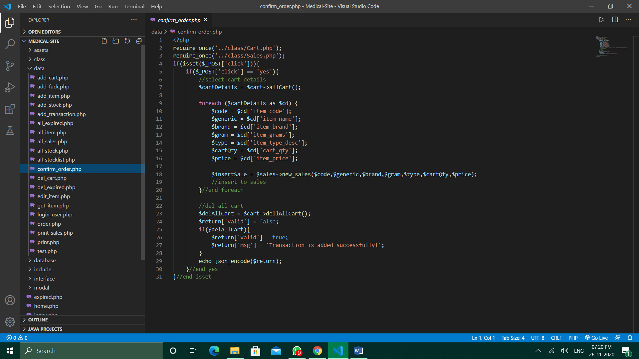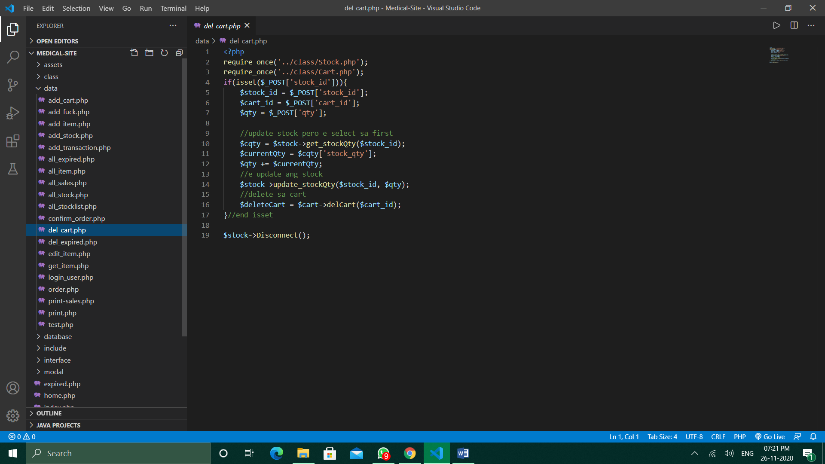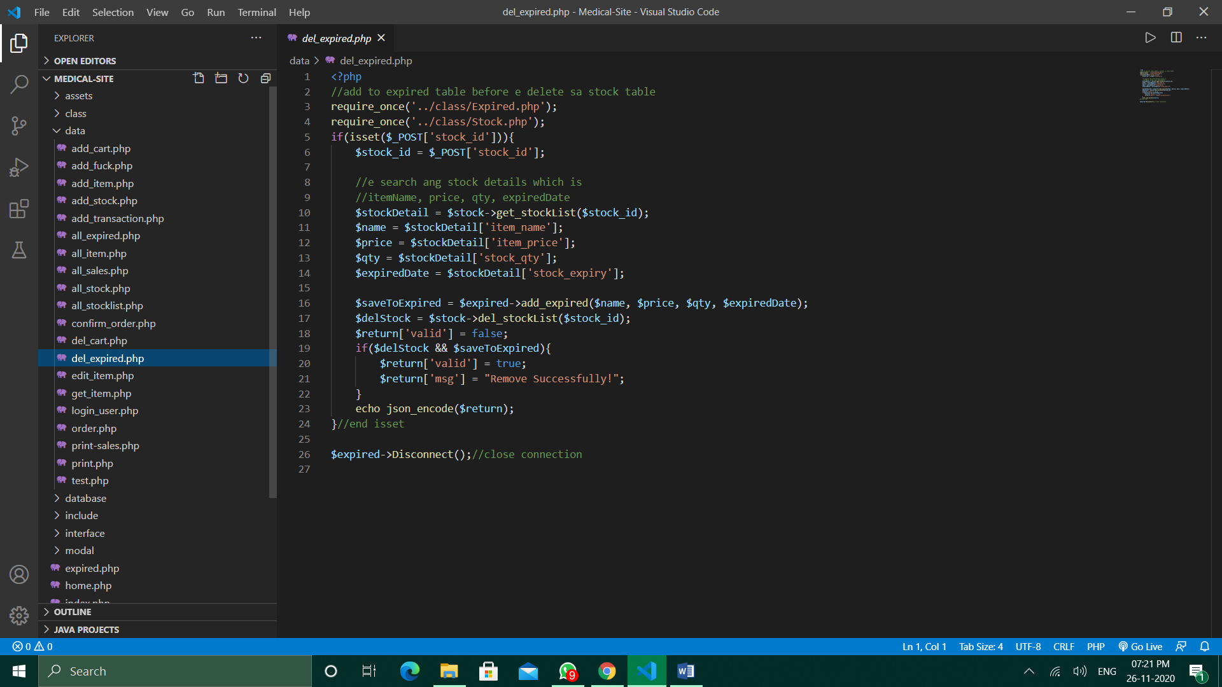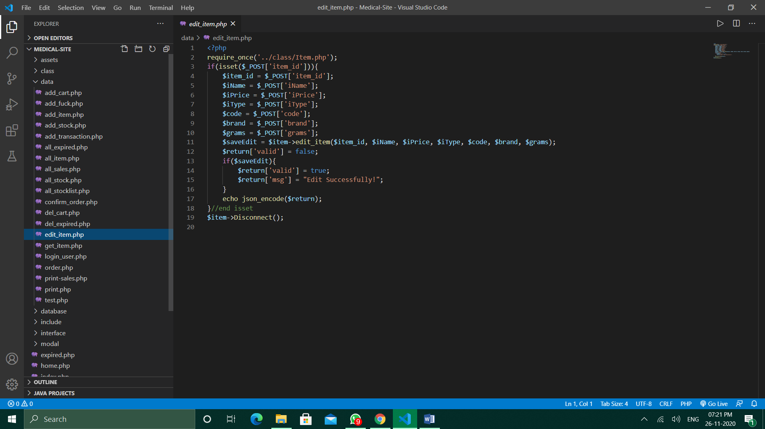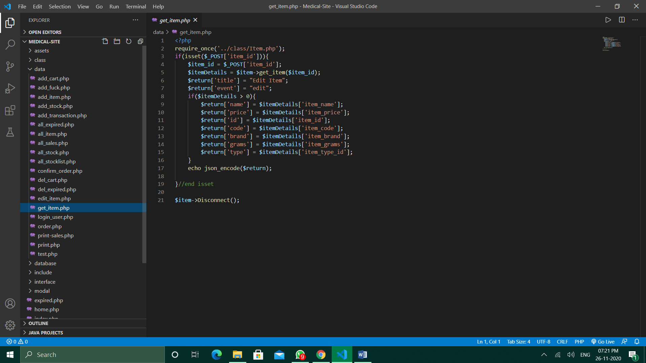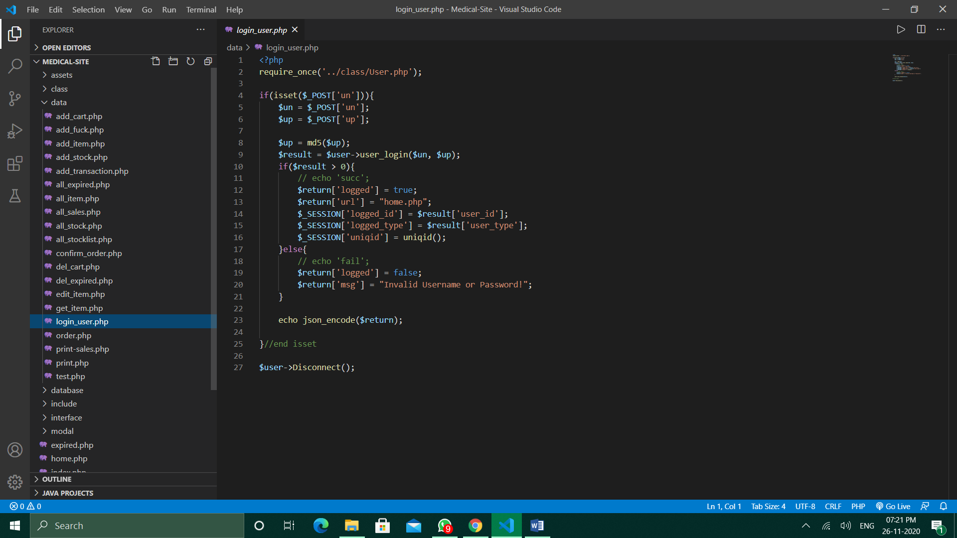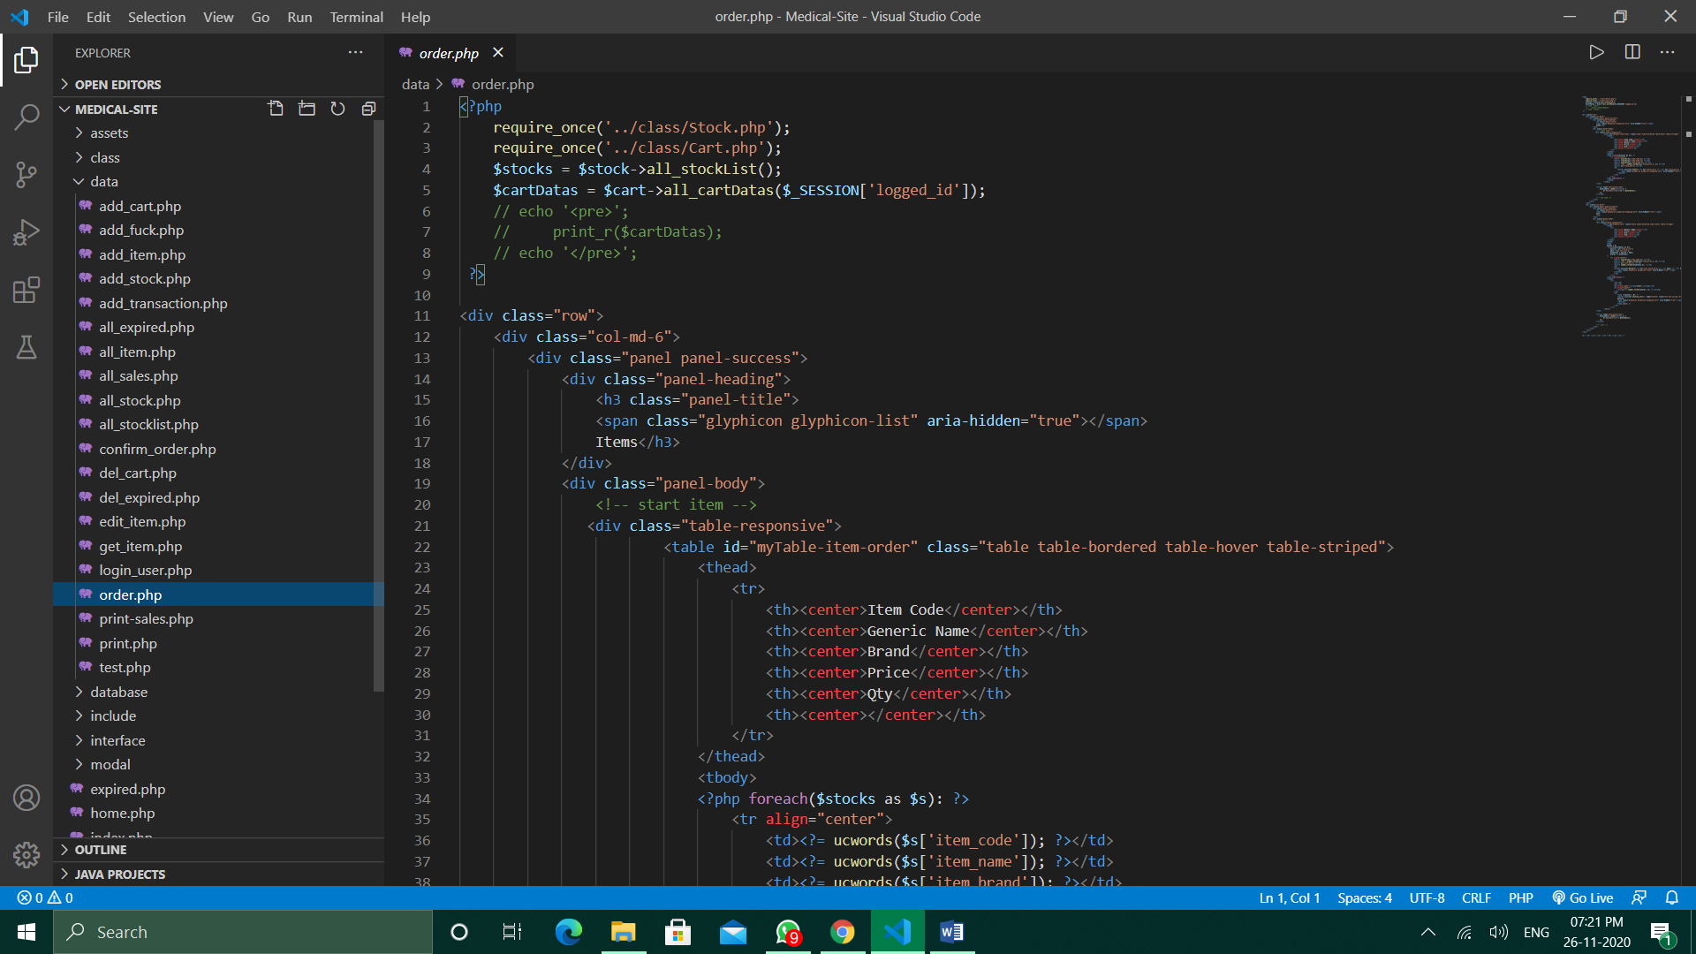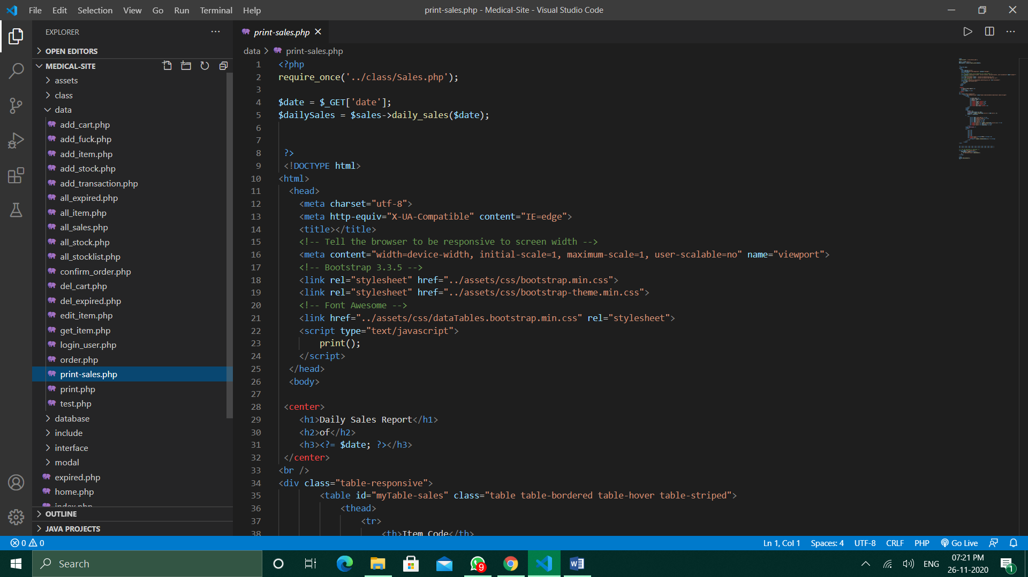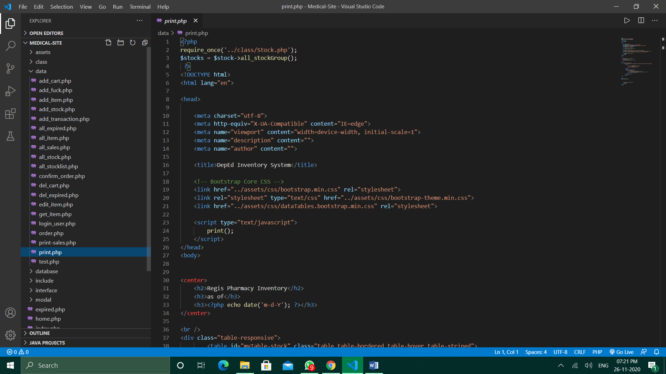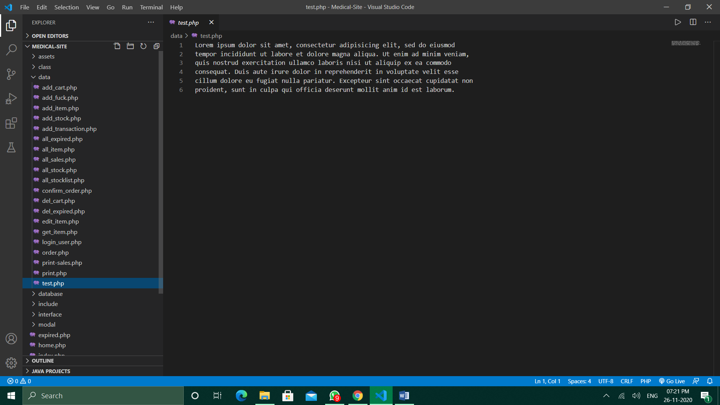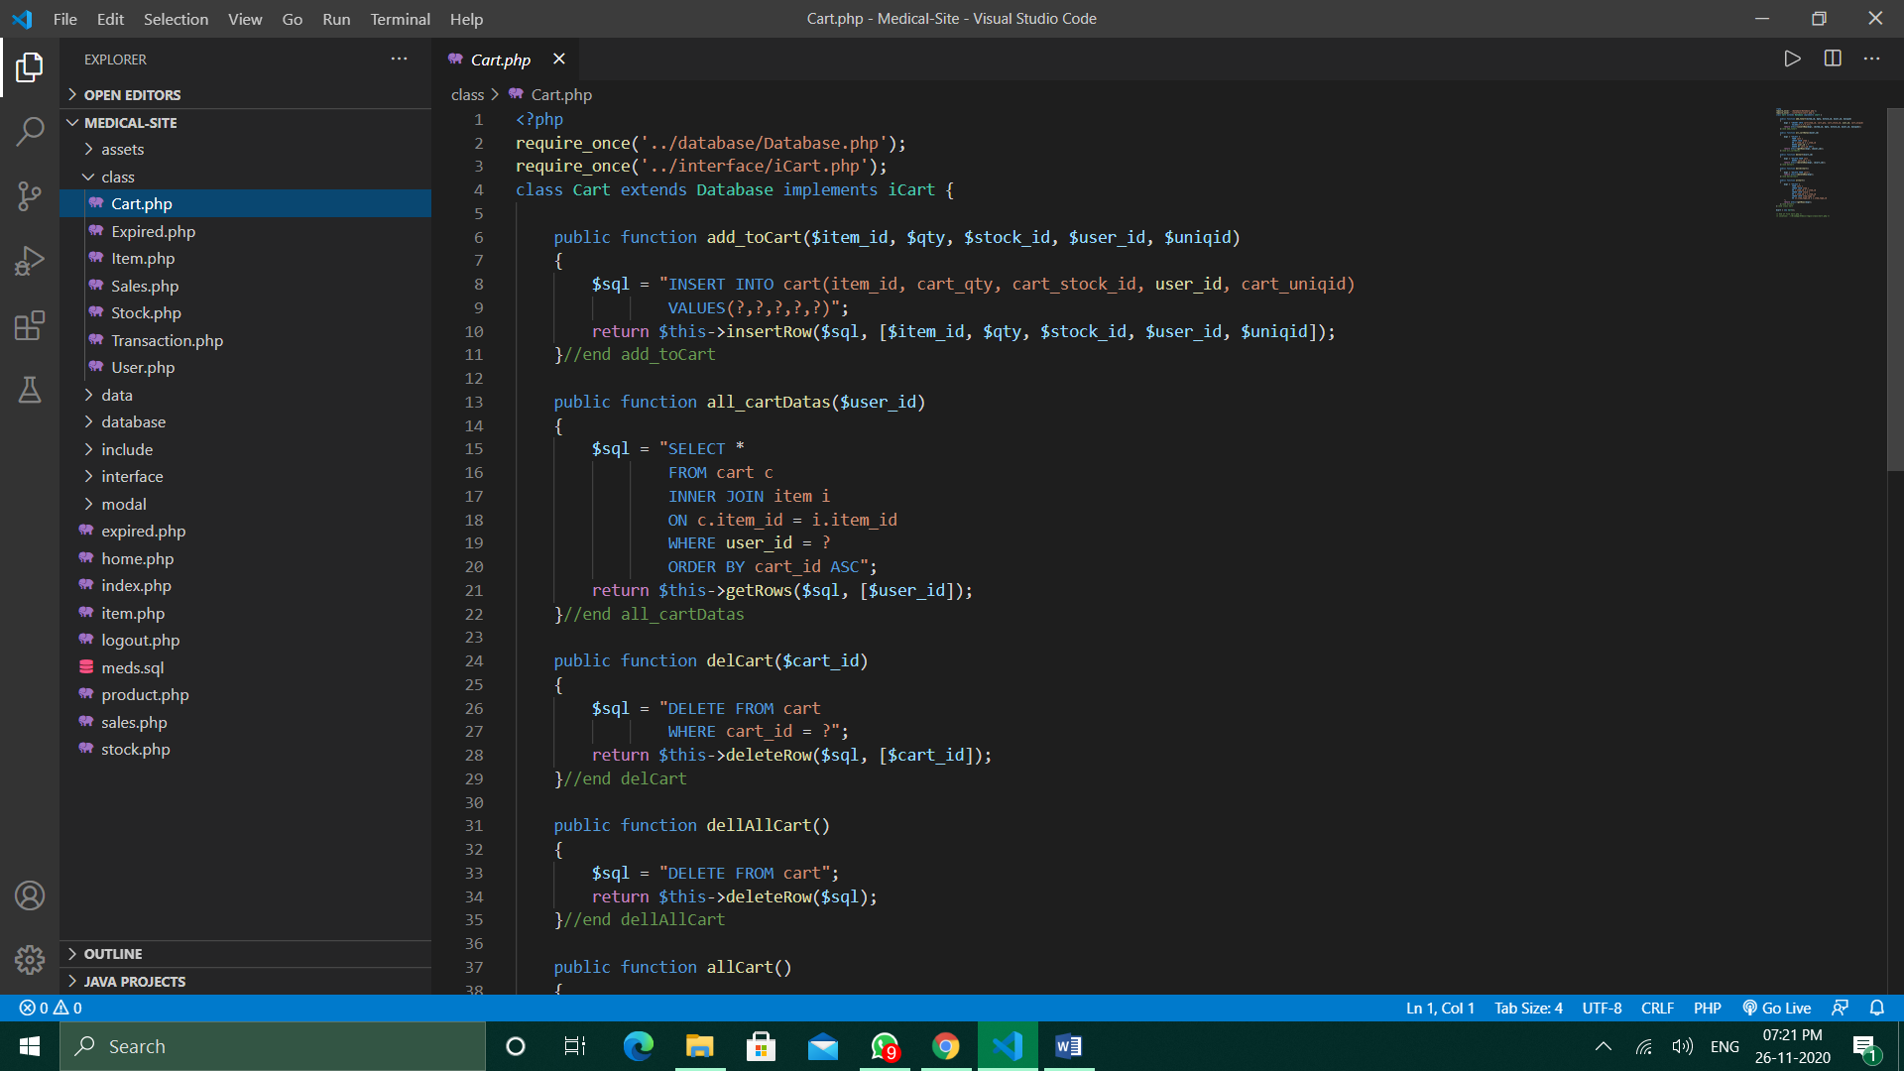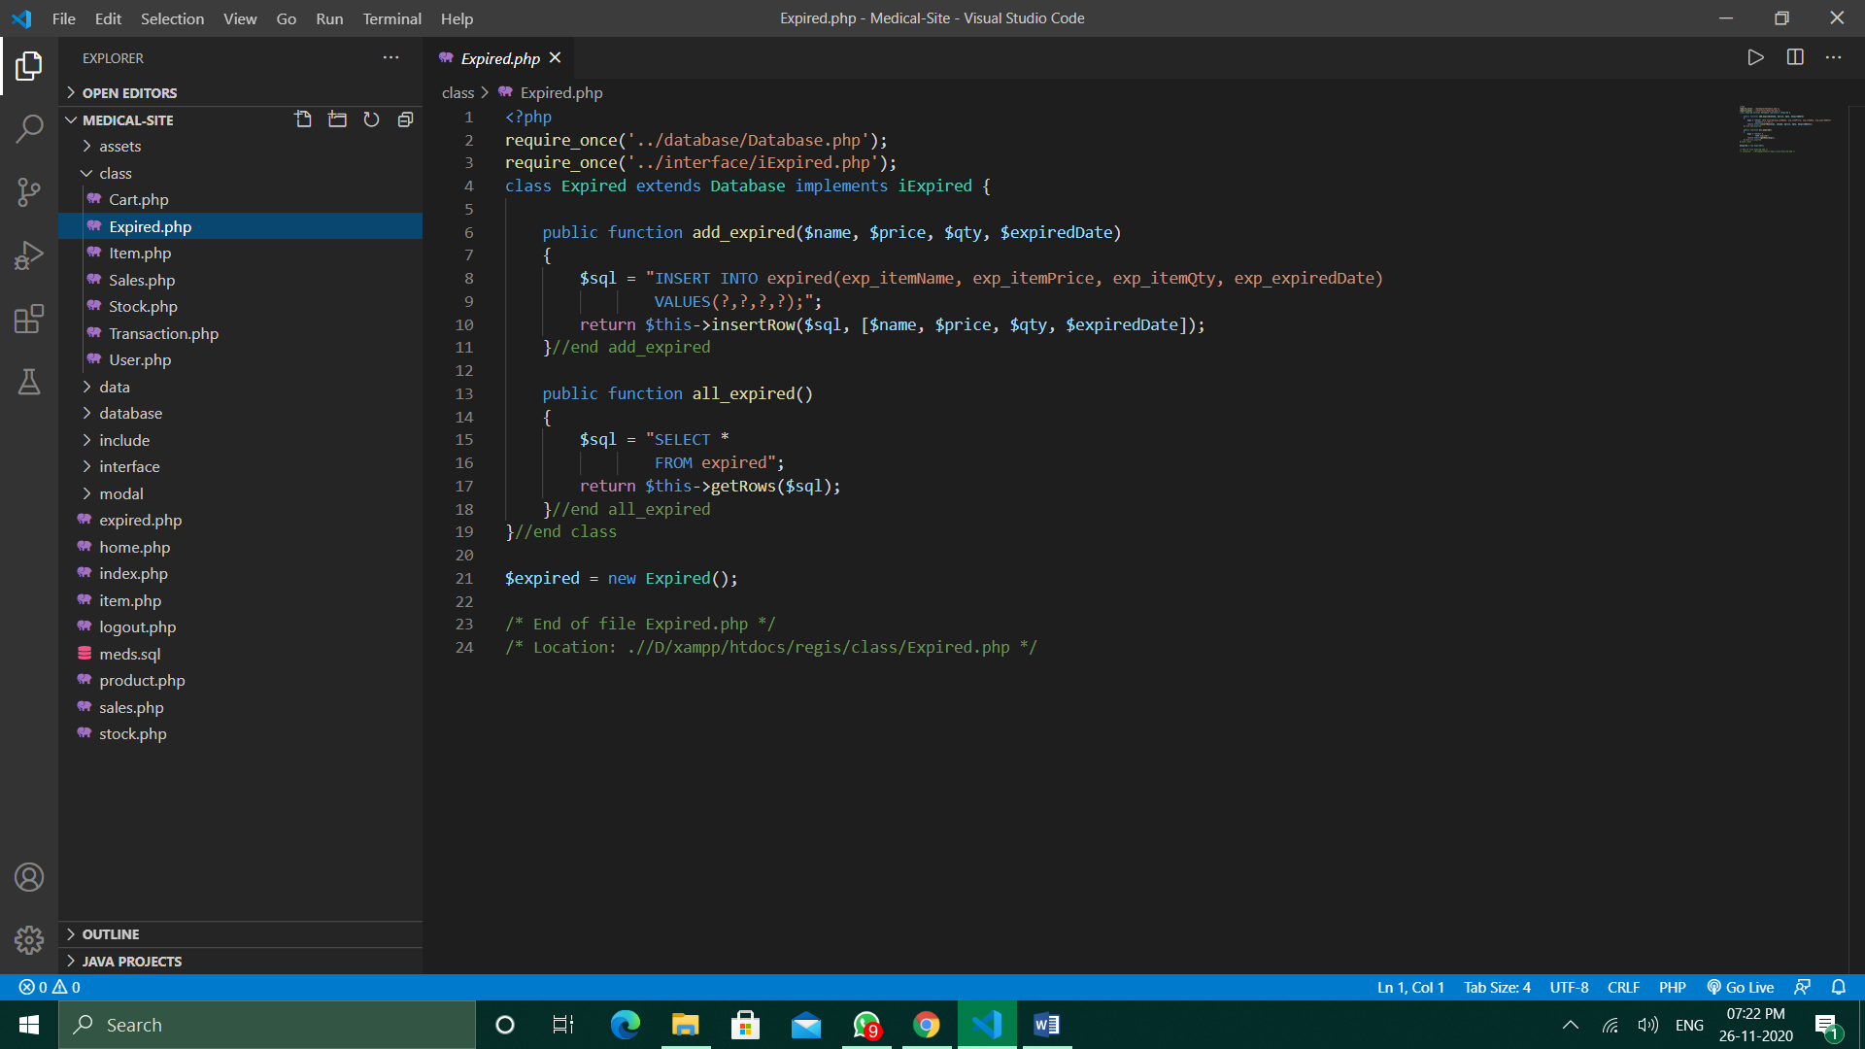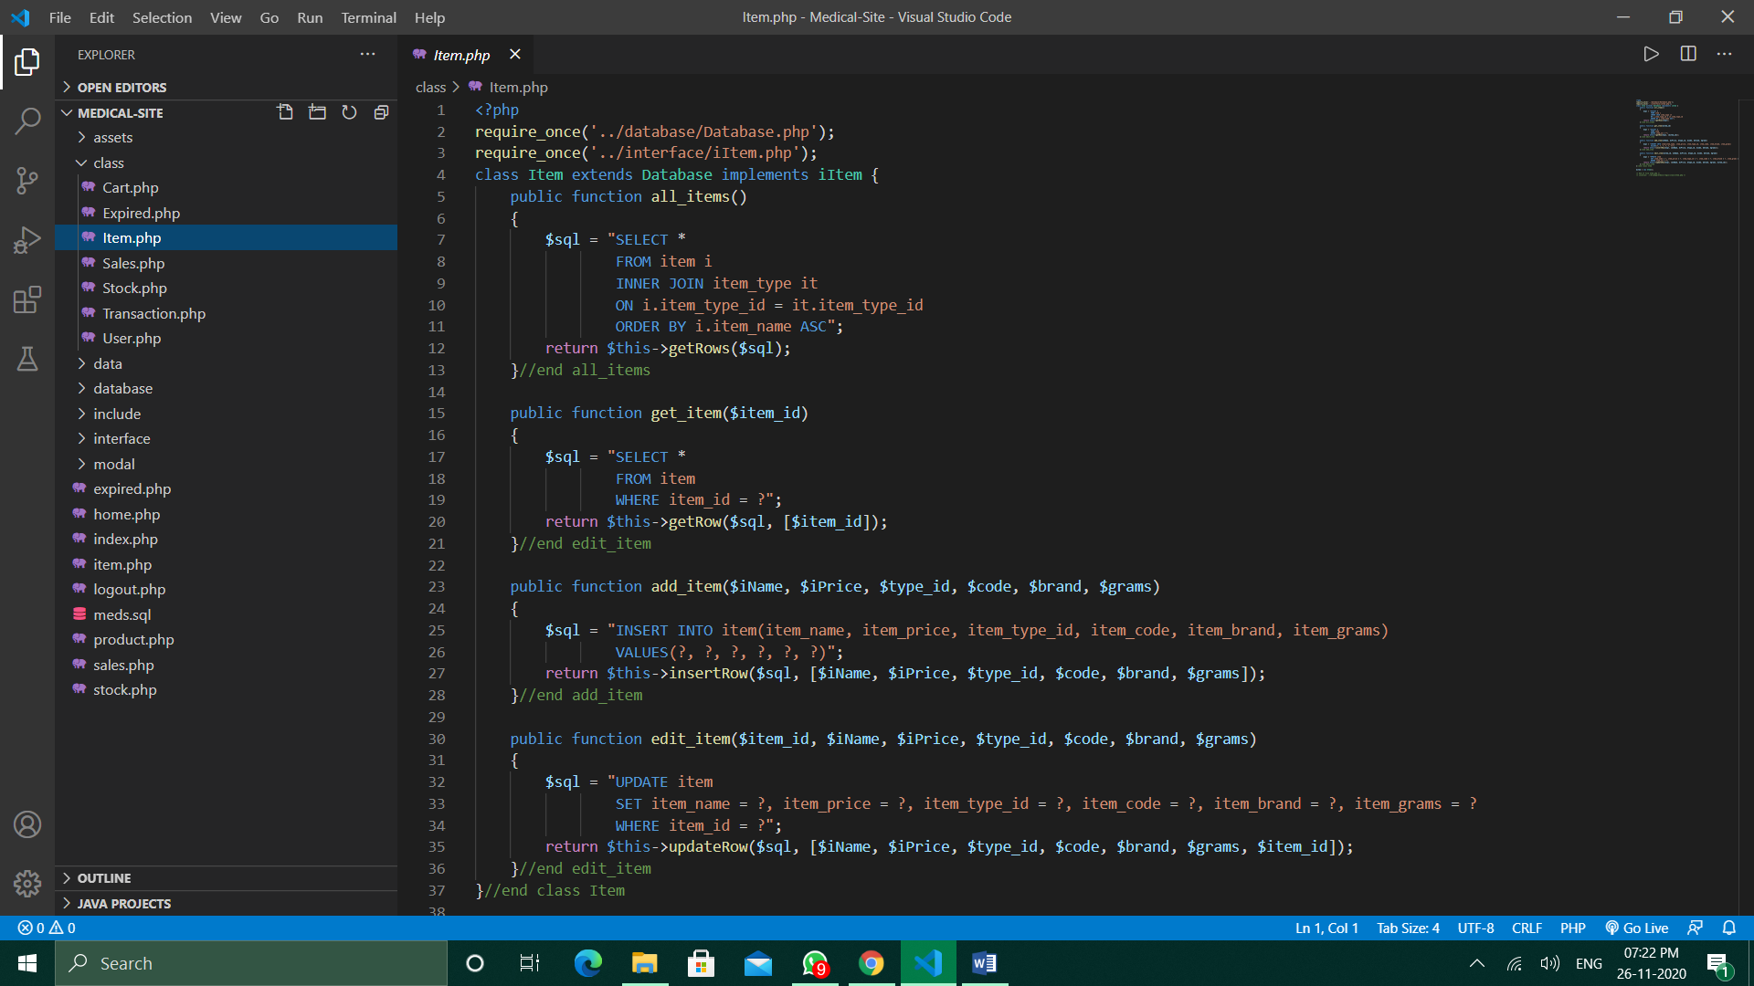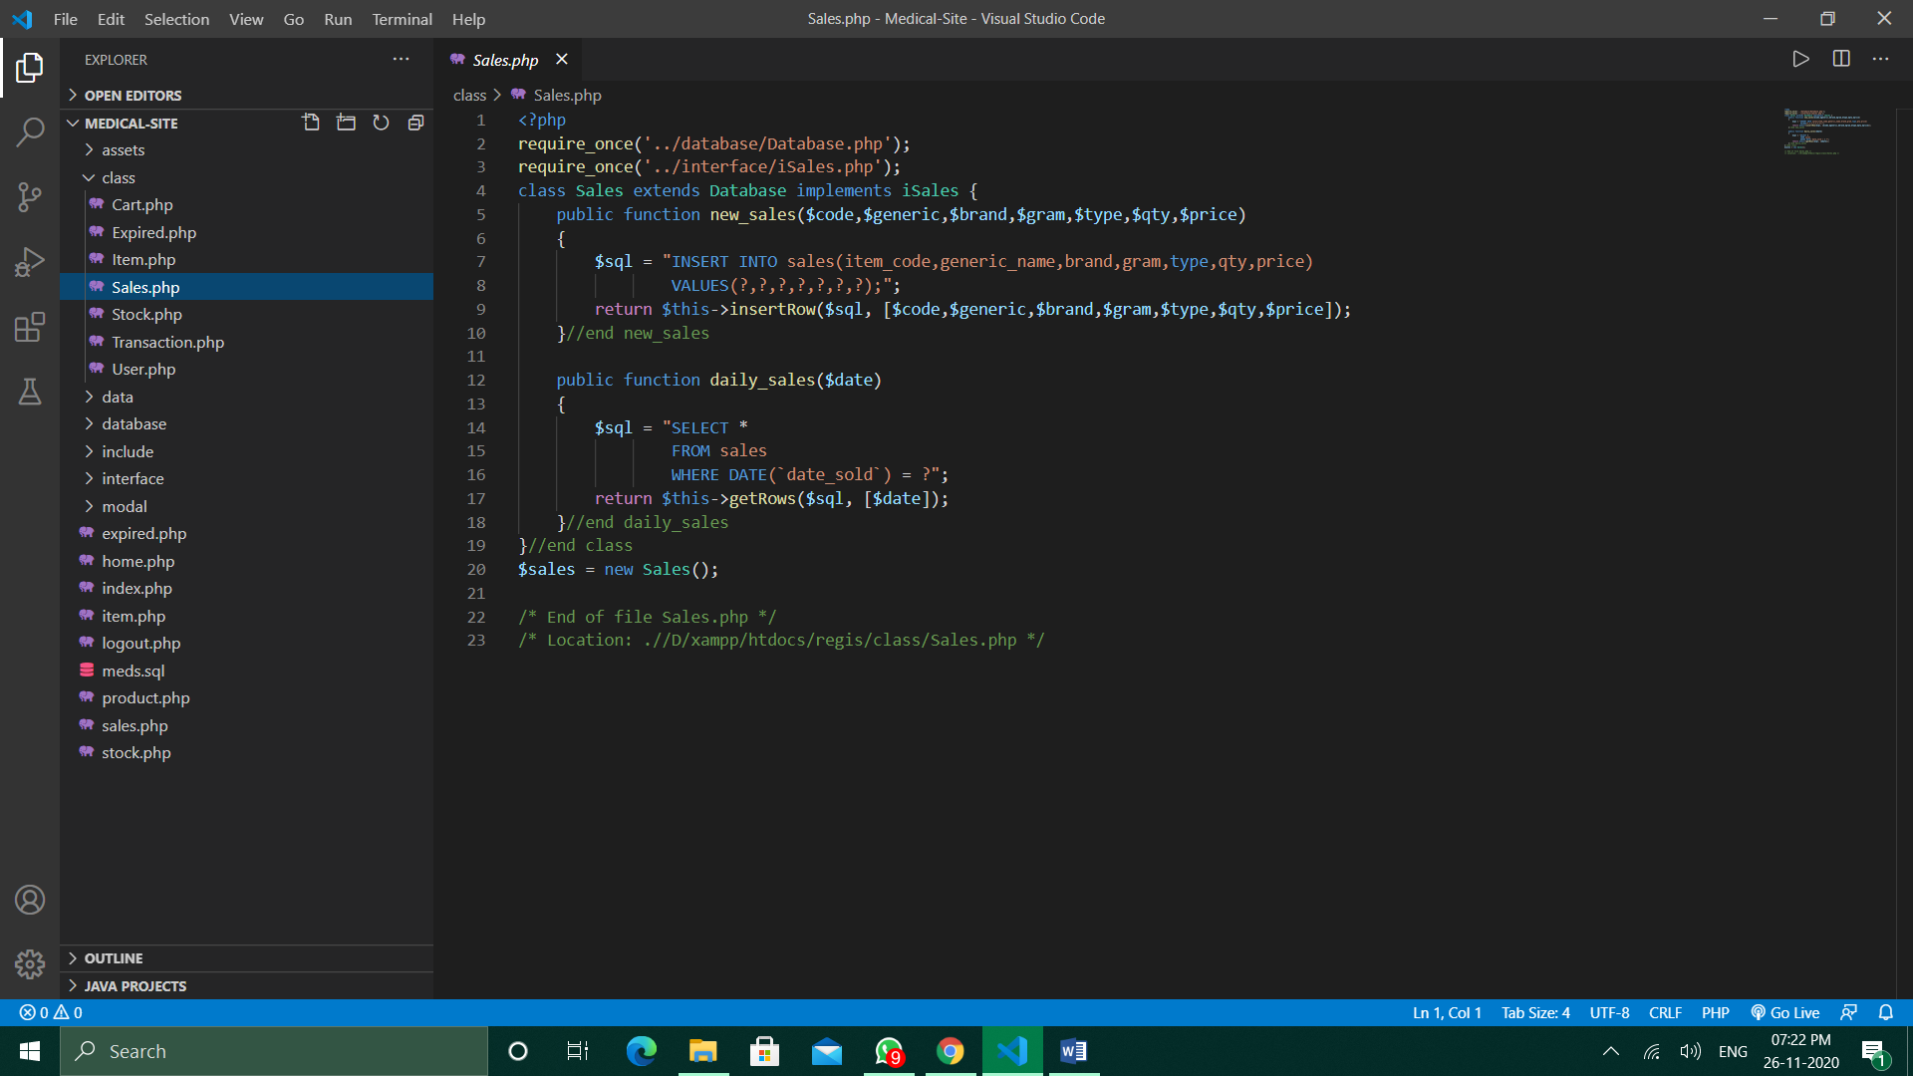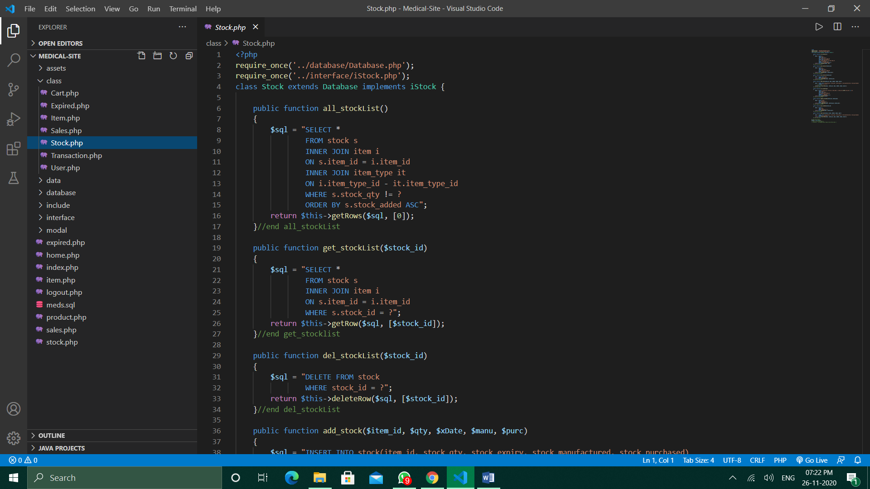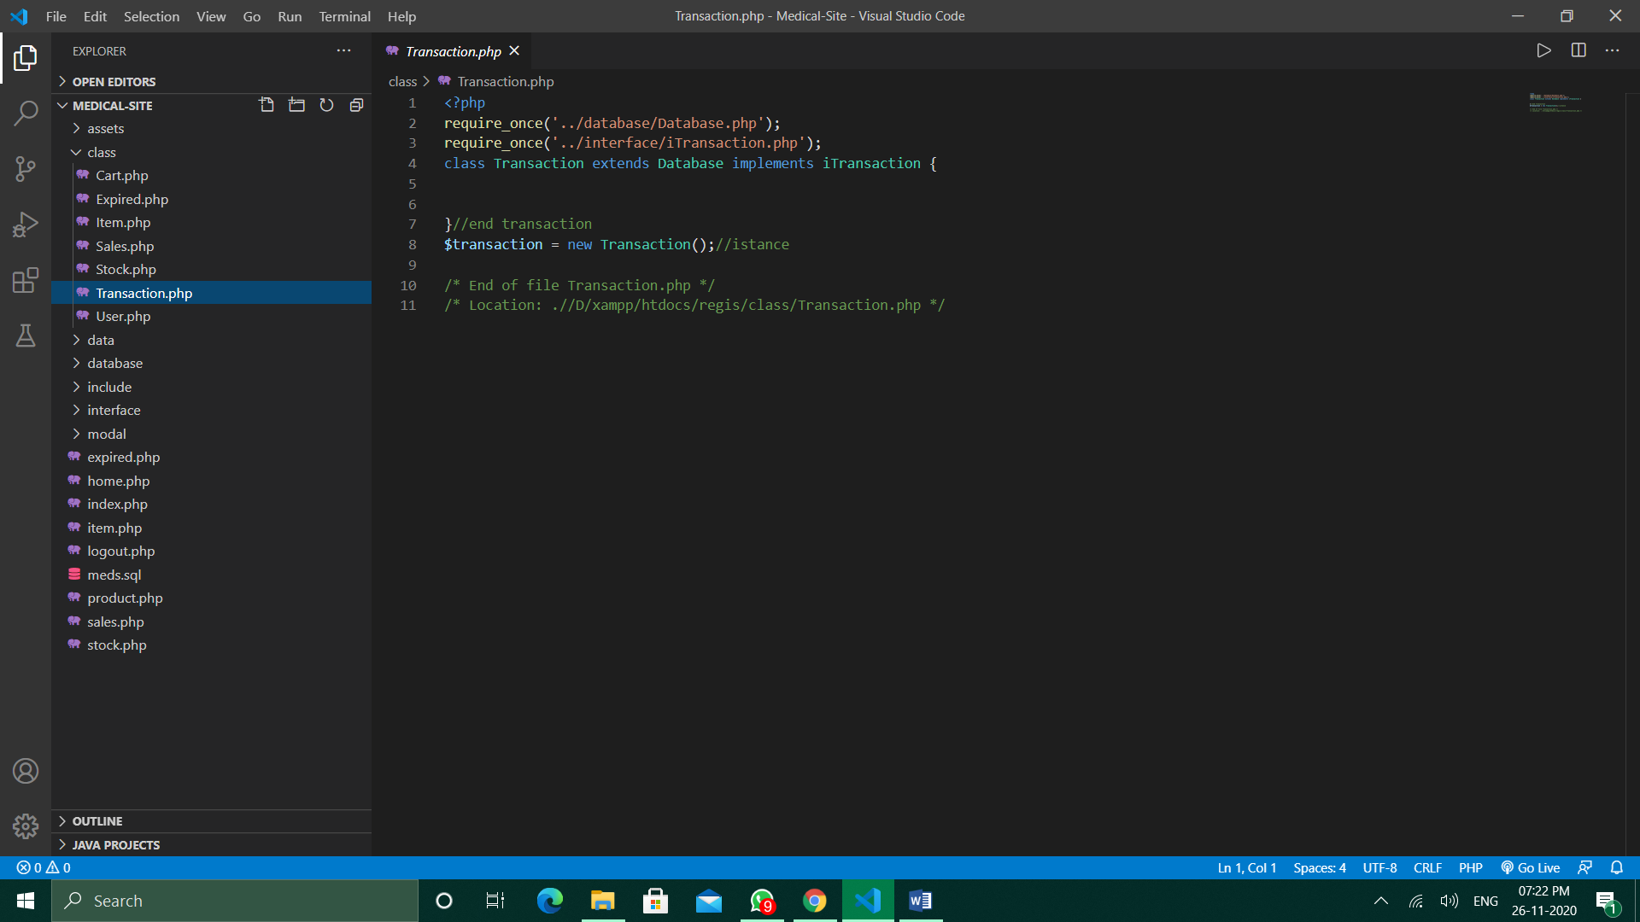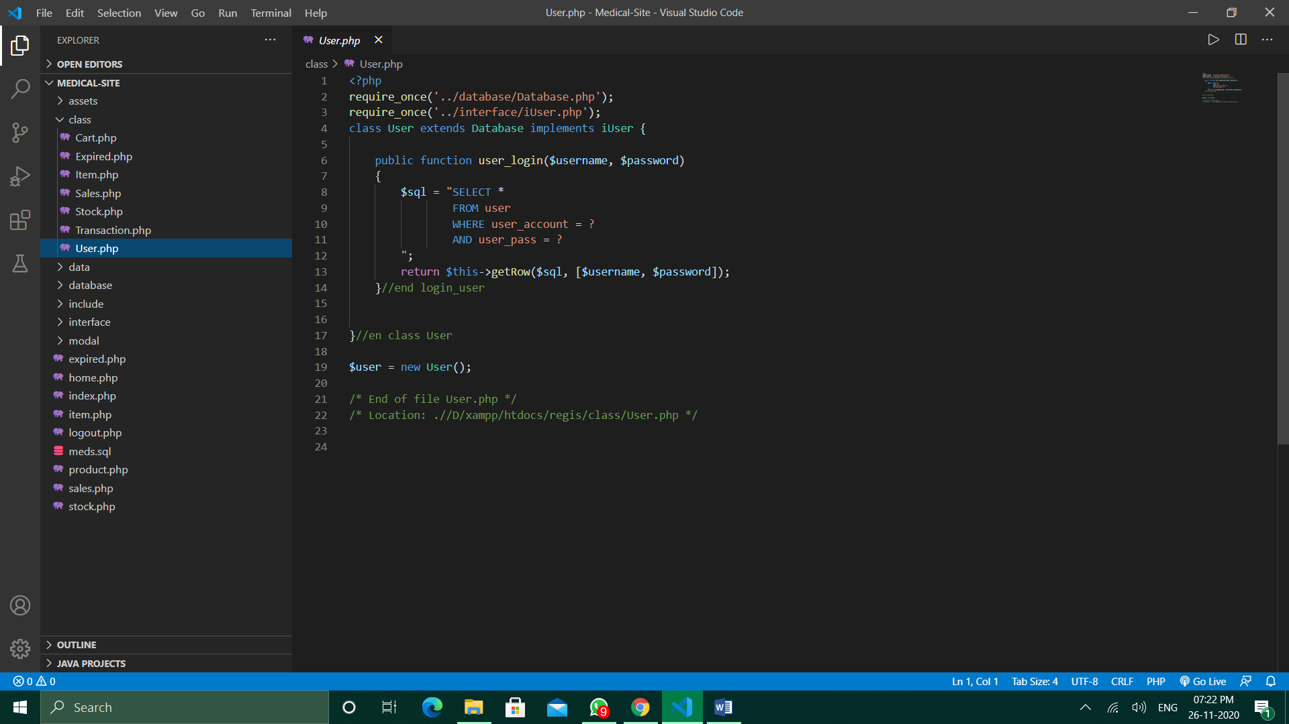

**WORKING SCREEN-SHOTS :**

* USER LOGIN.
* WELCOME page.
* DAILY SALES pages.
* EXPIRED ITEMS pages.
* DETAILS pages.
* PRINT-DETAILS pages.
* ENTRY page.
* NEW-STOCKS page.
* MESSAGE box.
* CONFIRMATION box.
* ADD to CART page.
* Some other pages.

**Actual Screenshots of the site :**

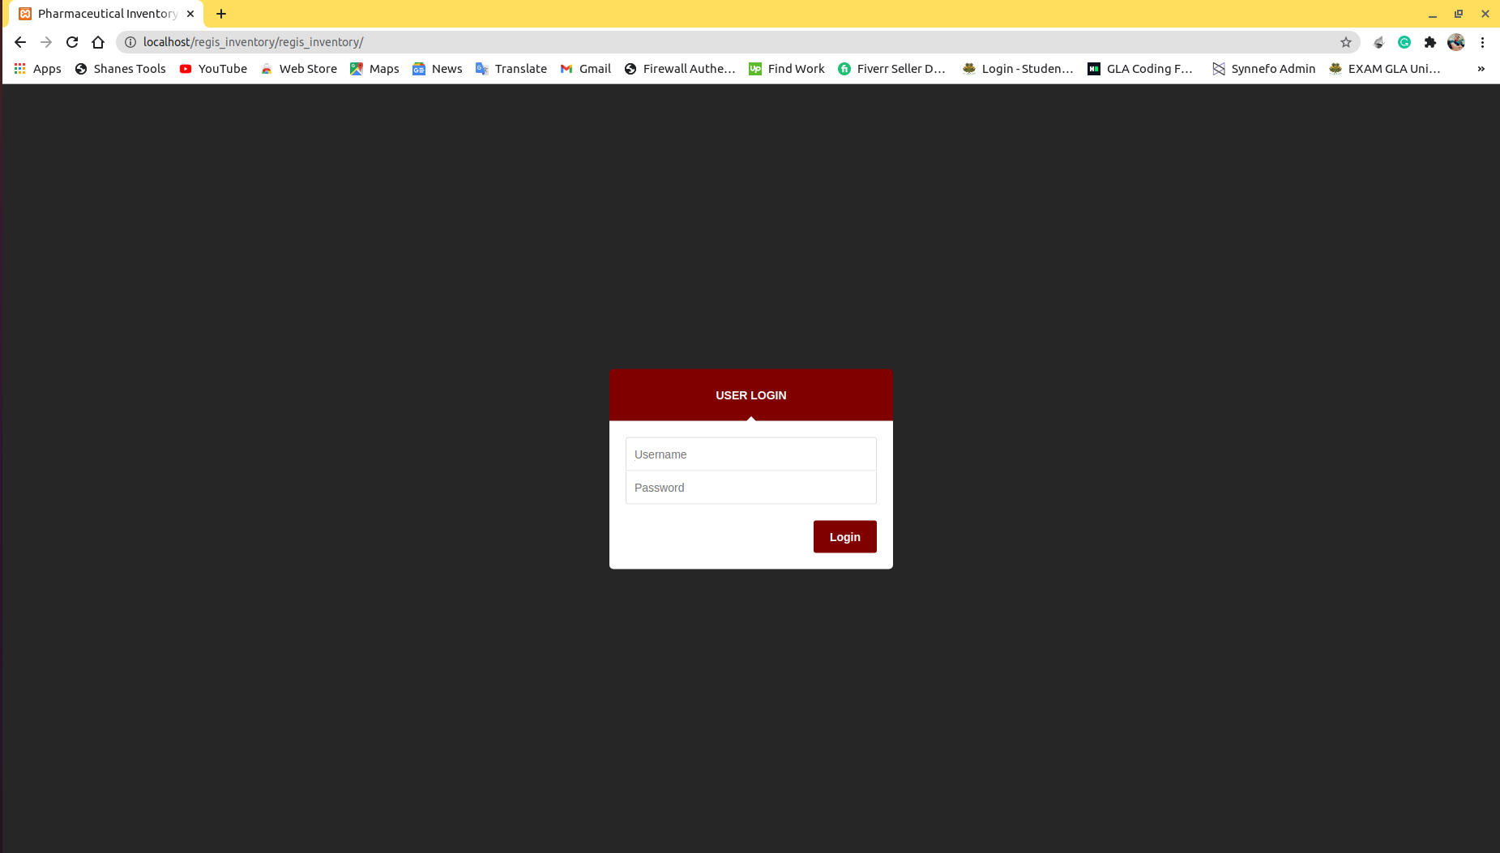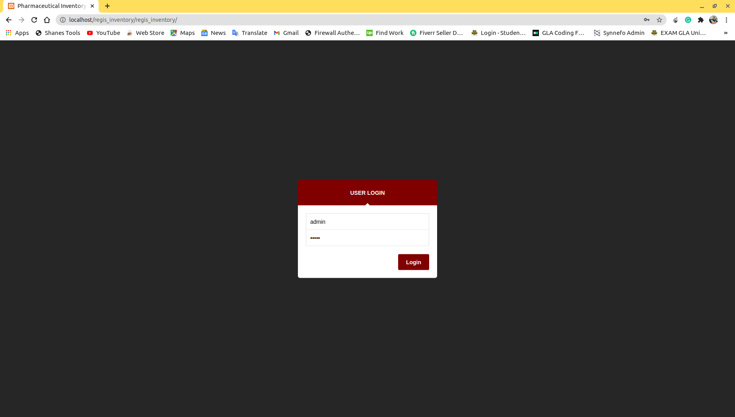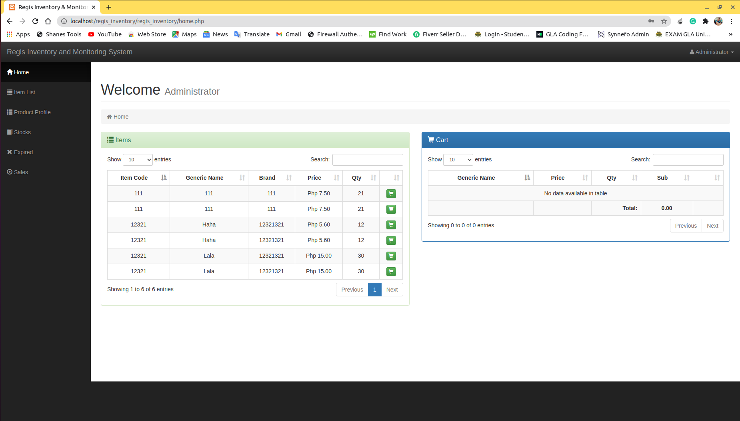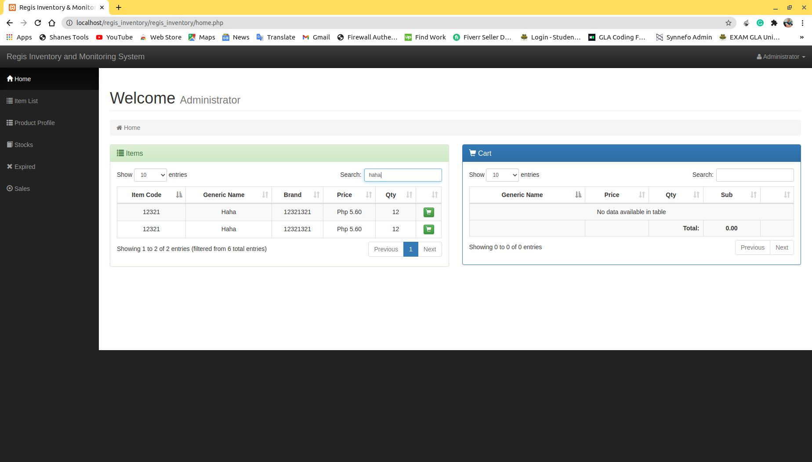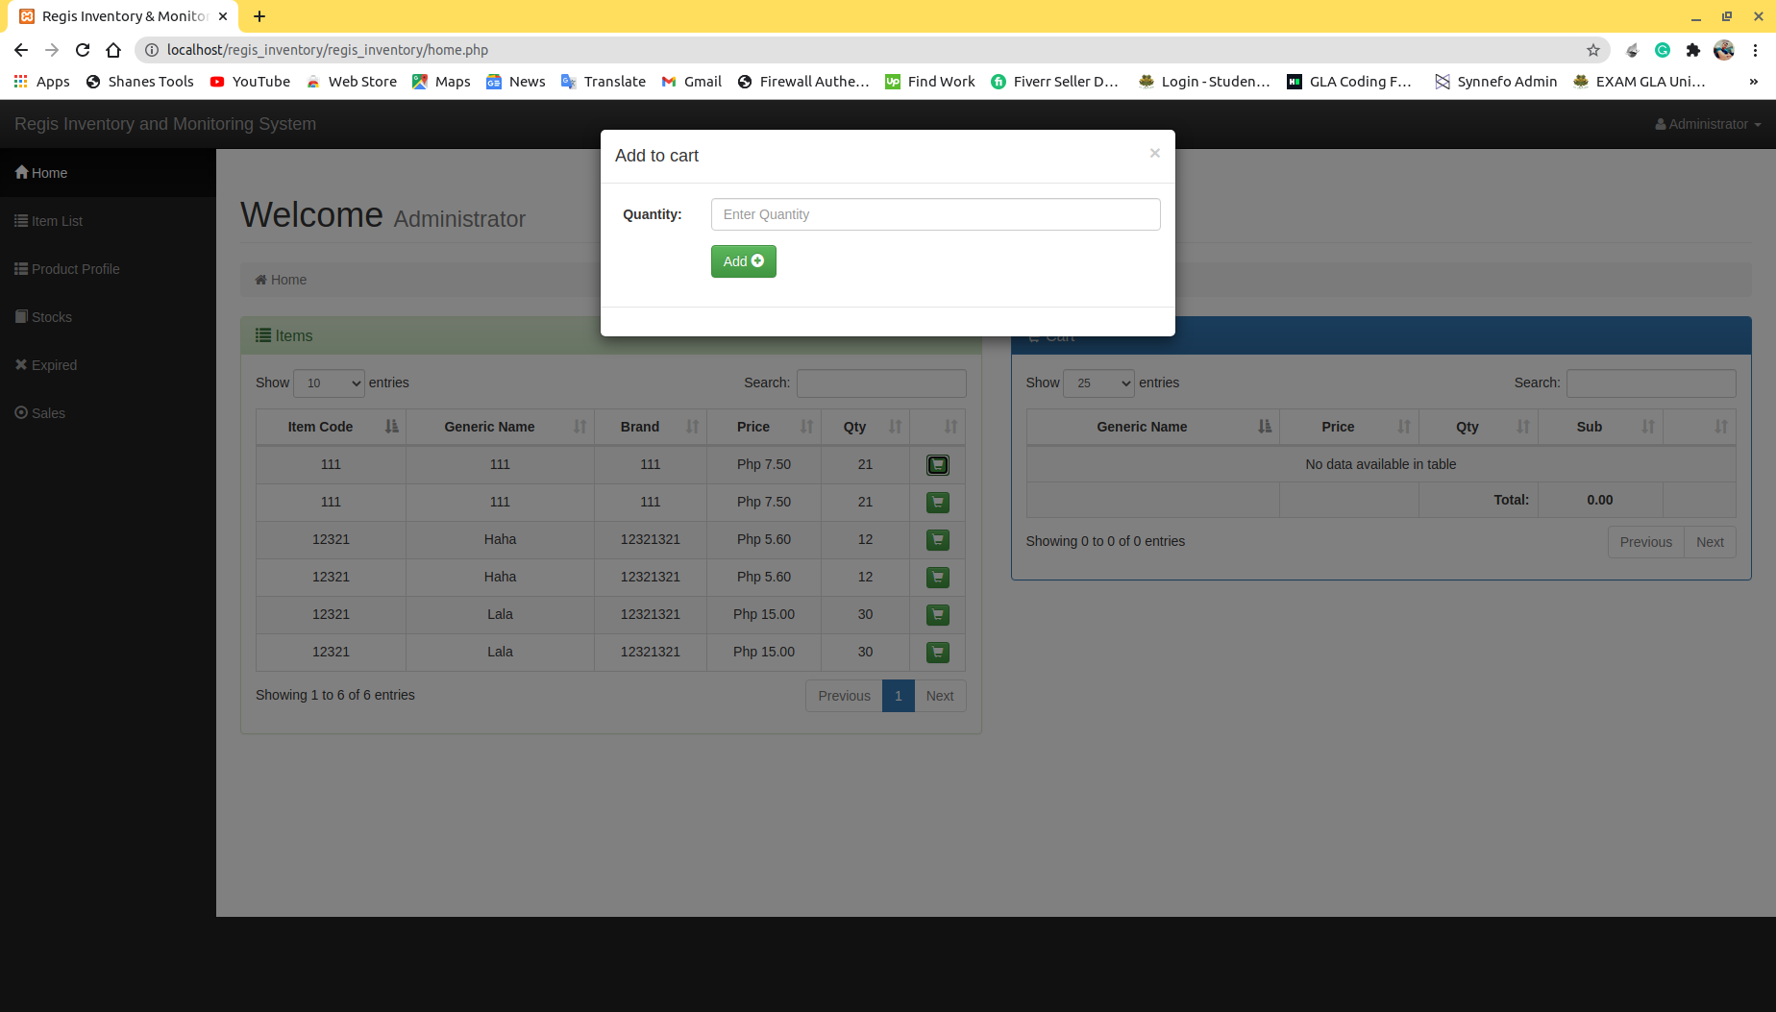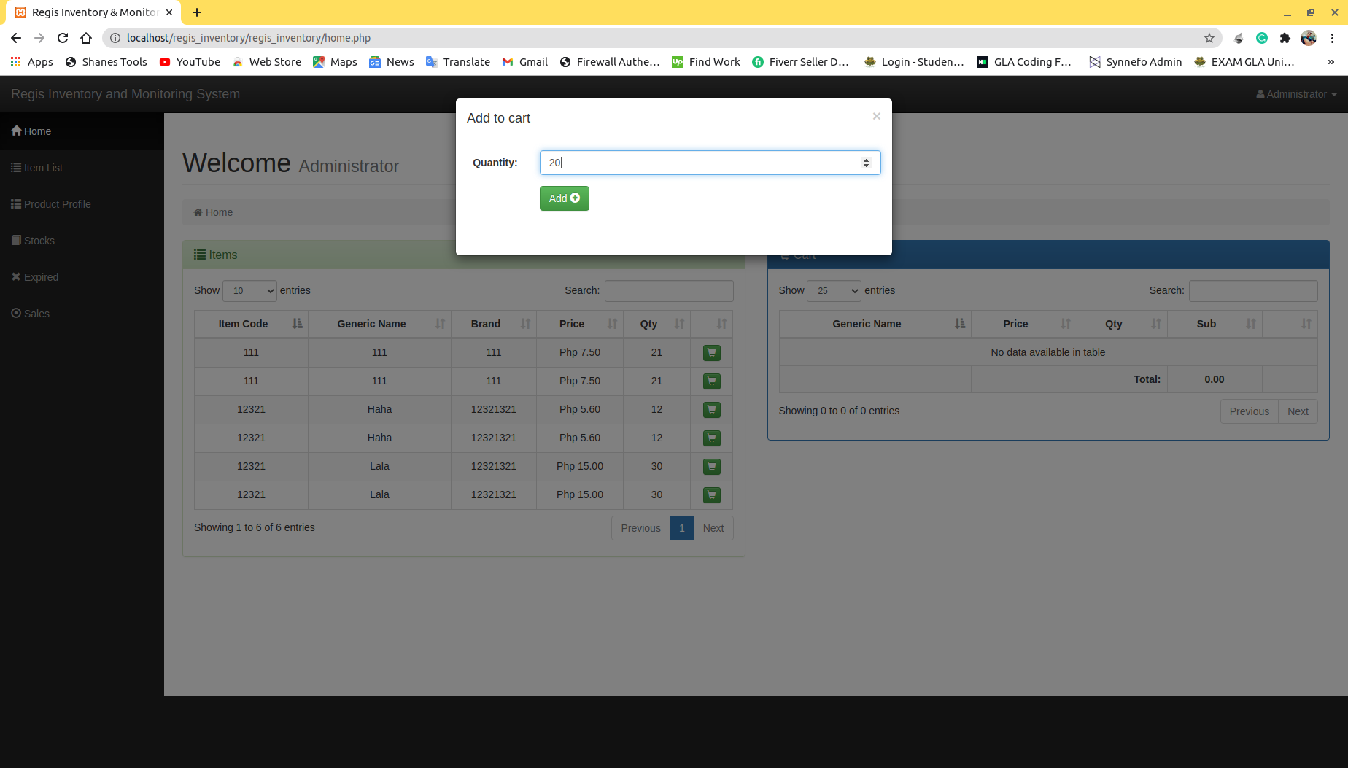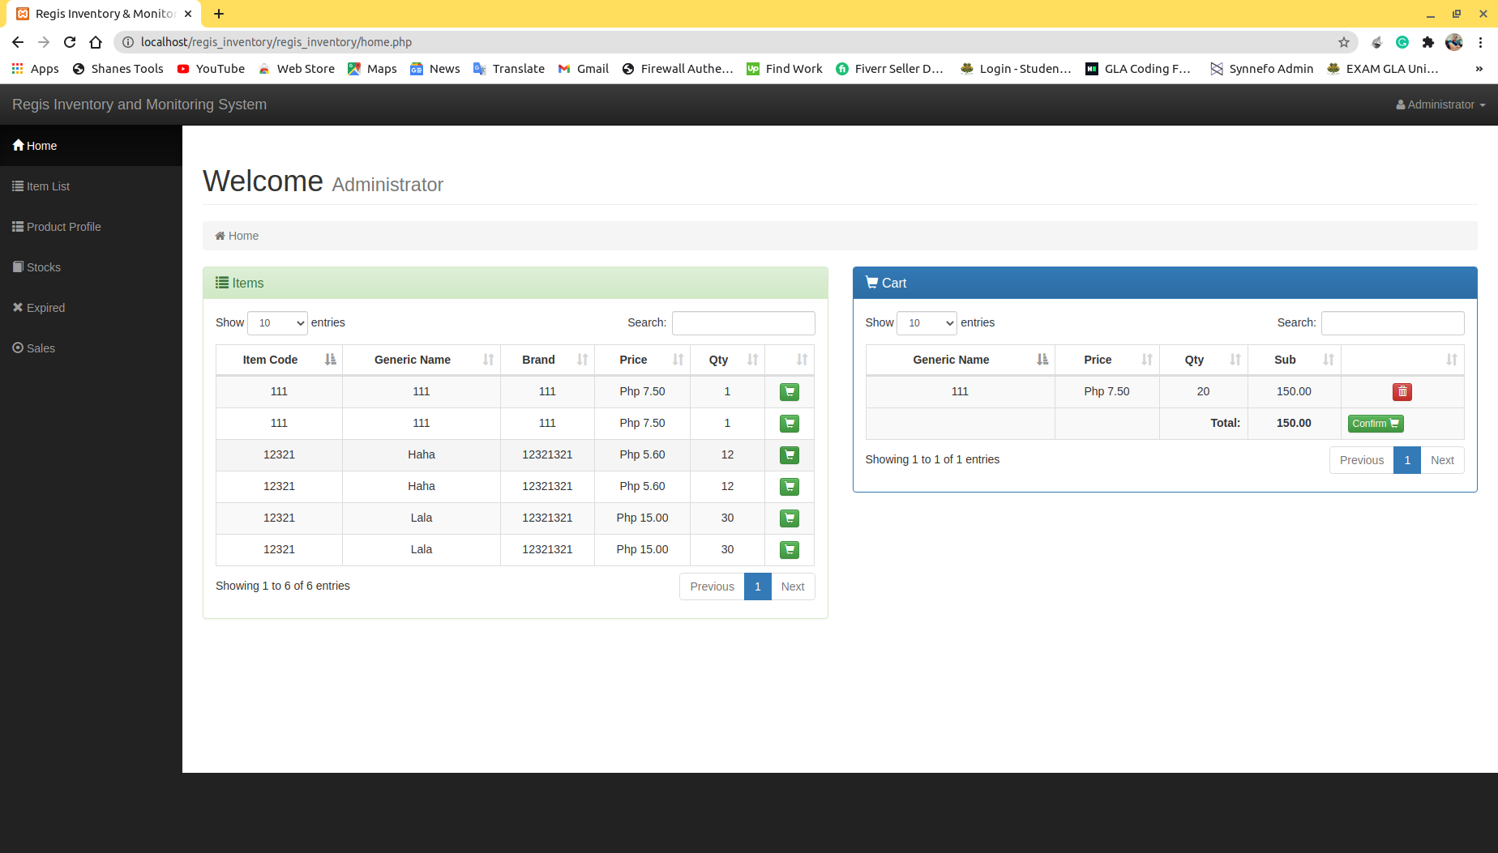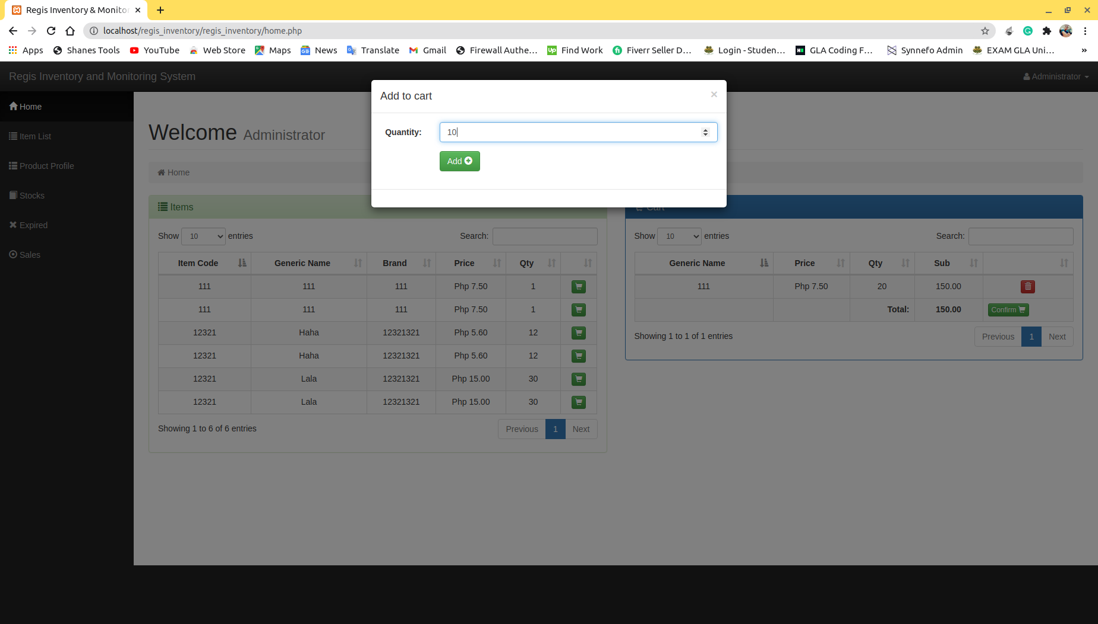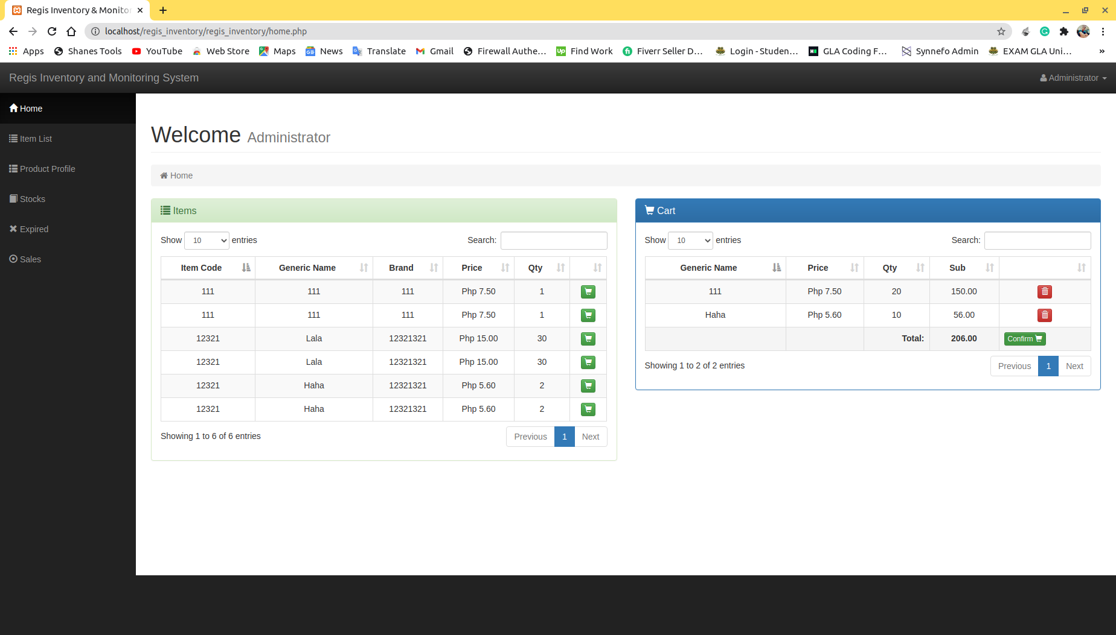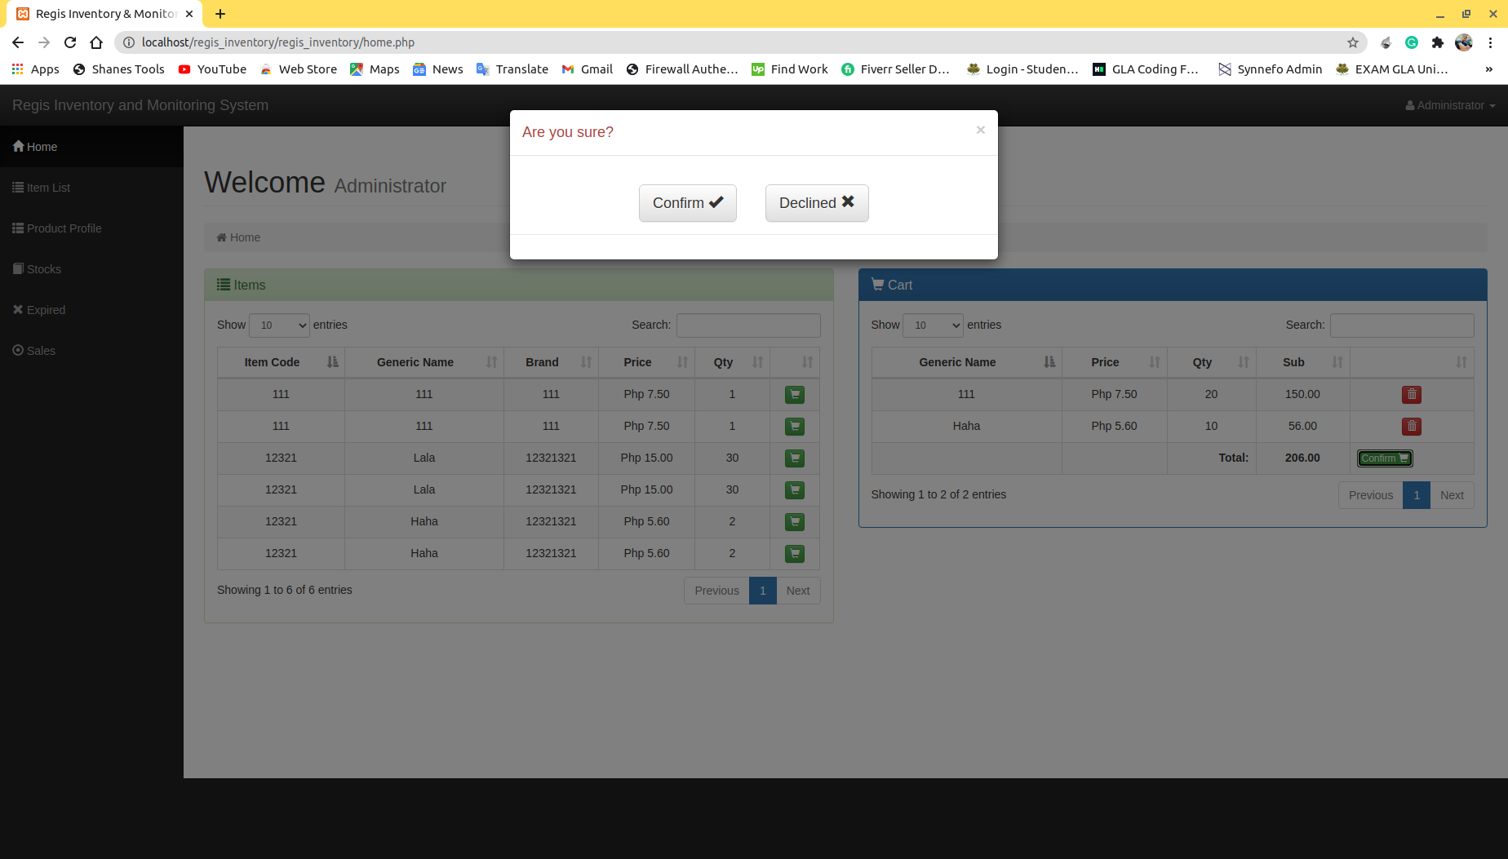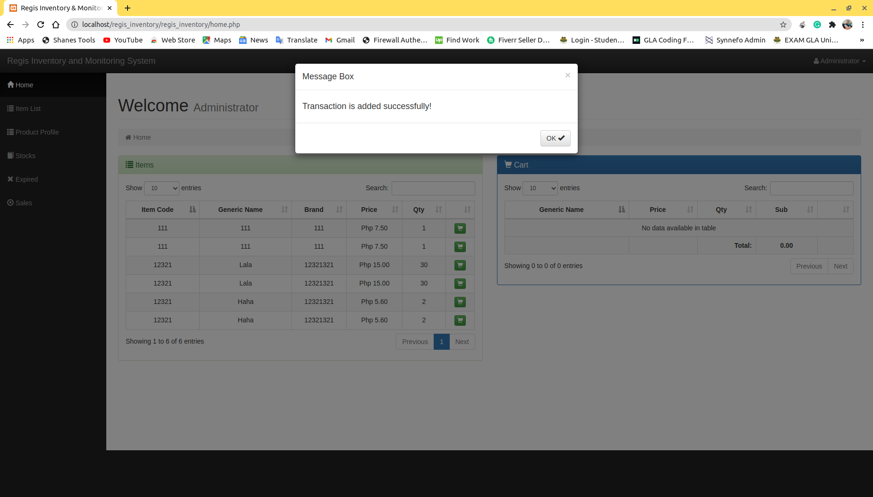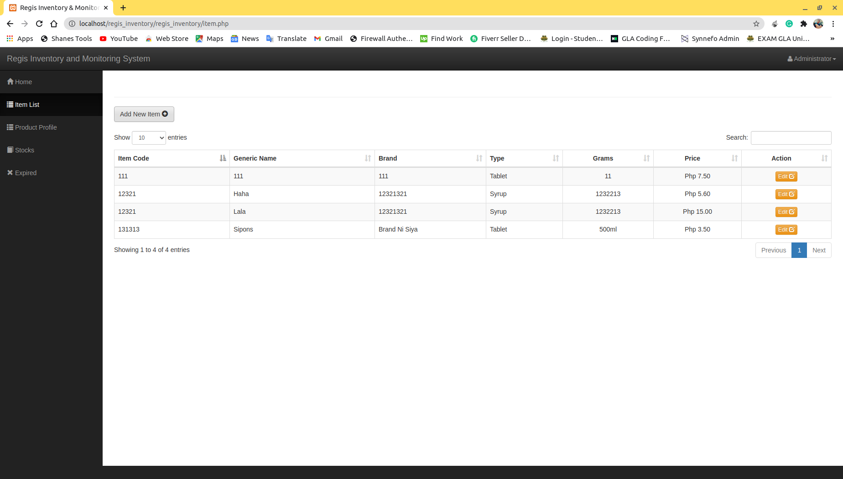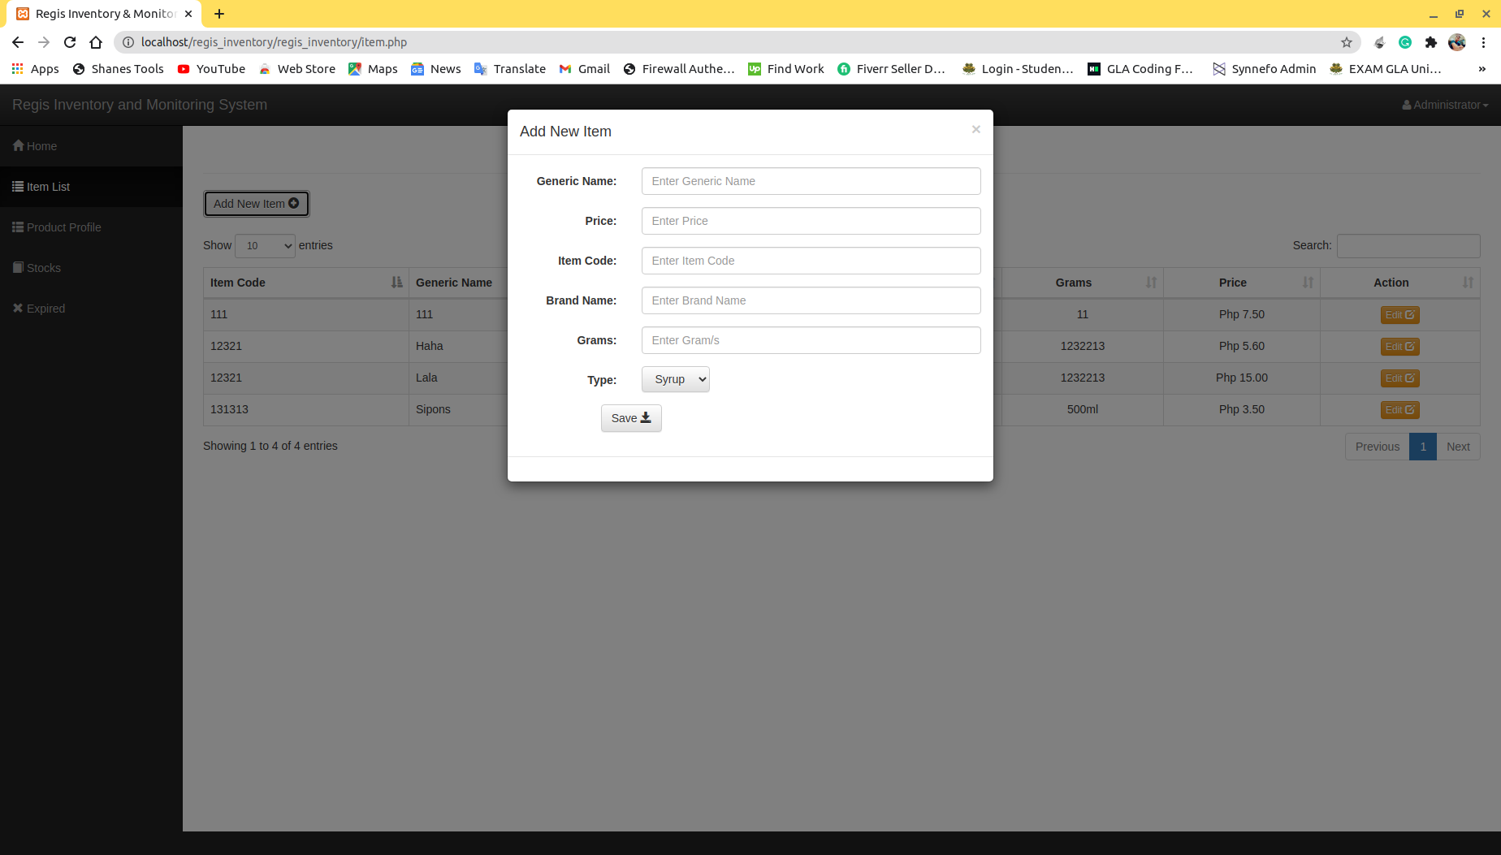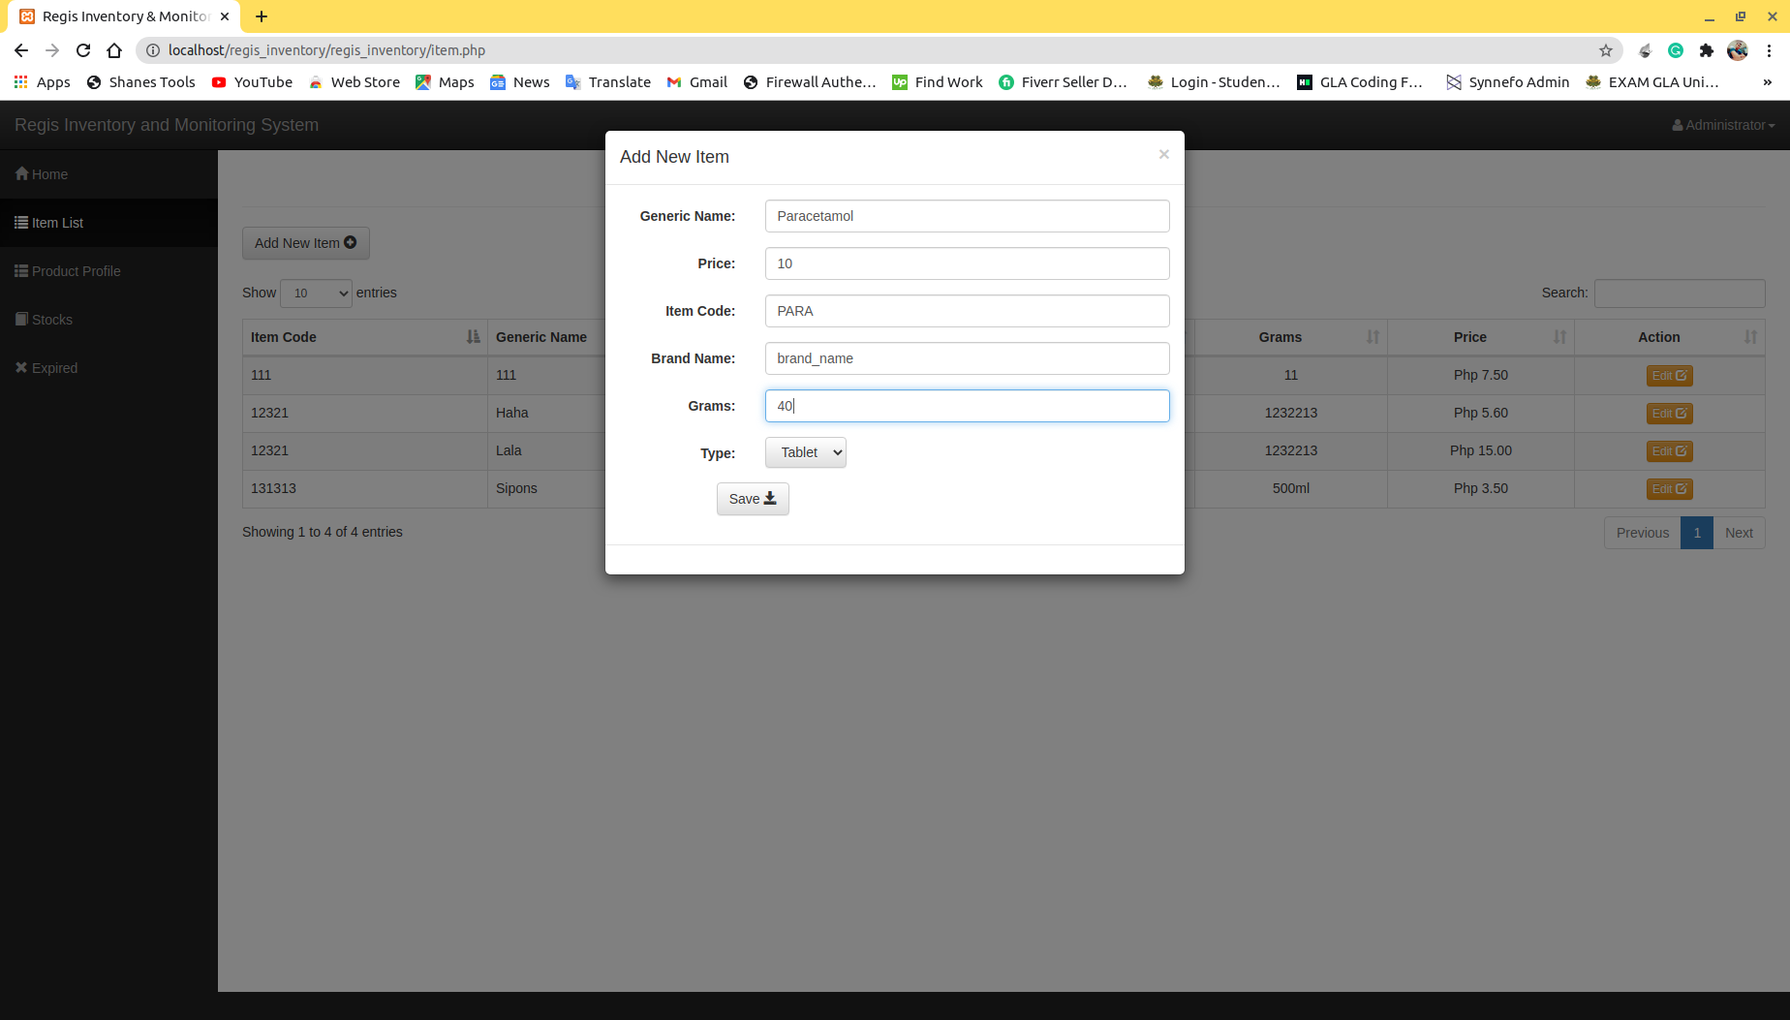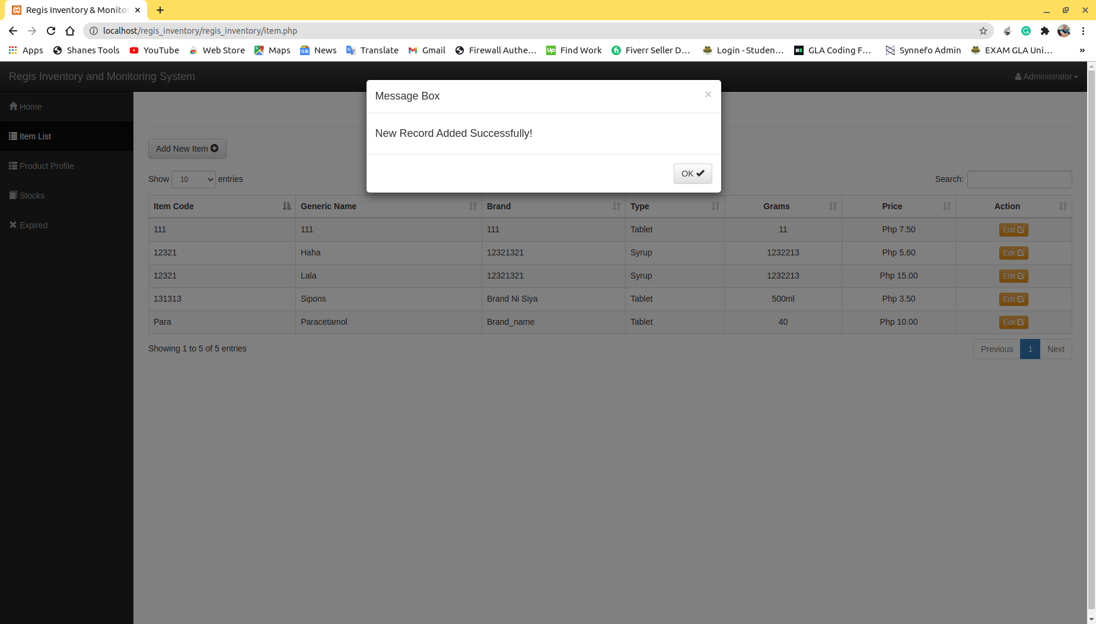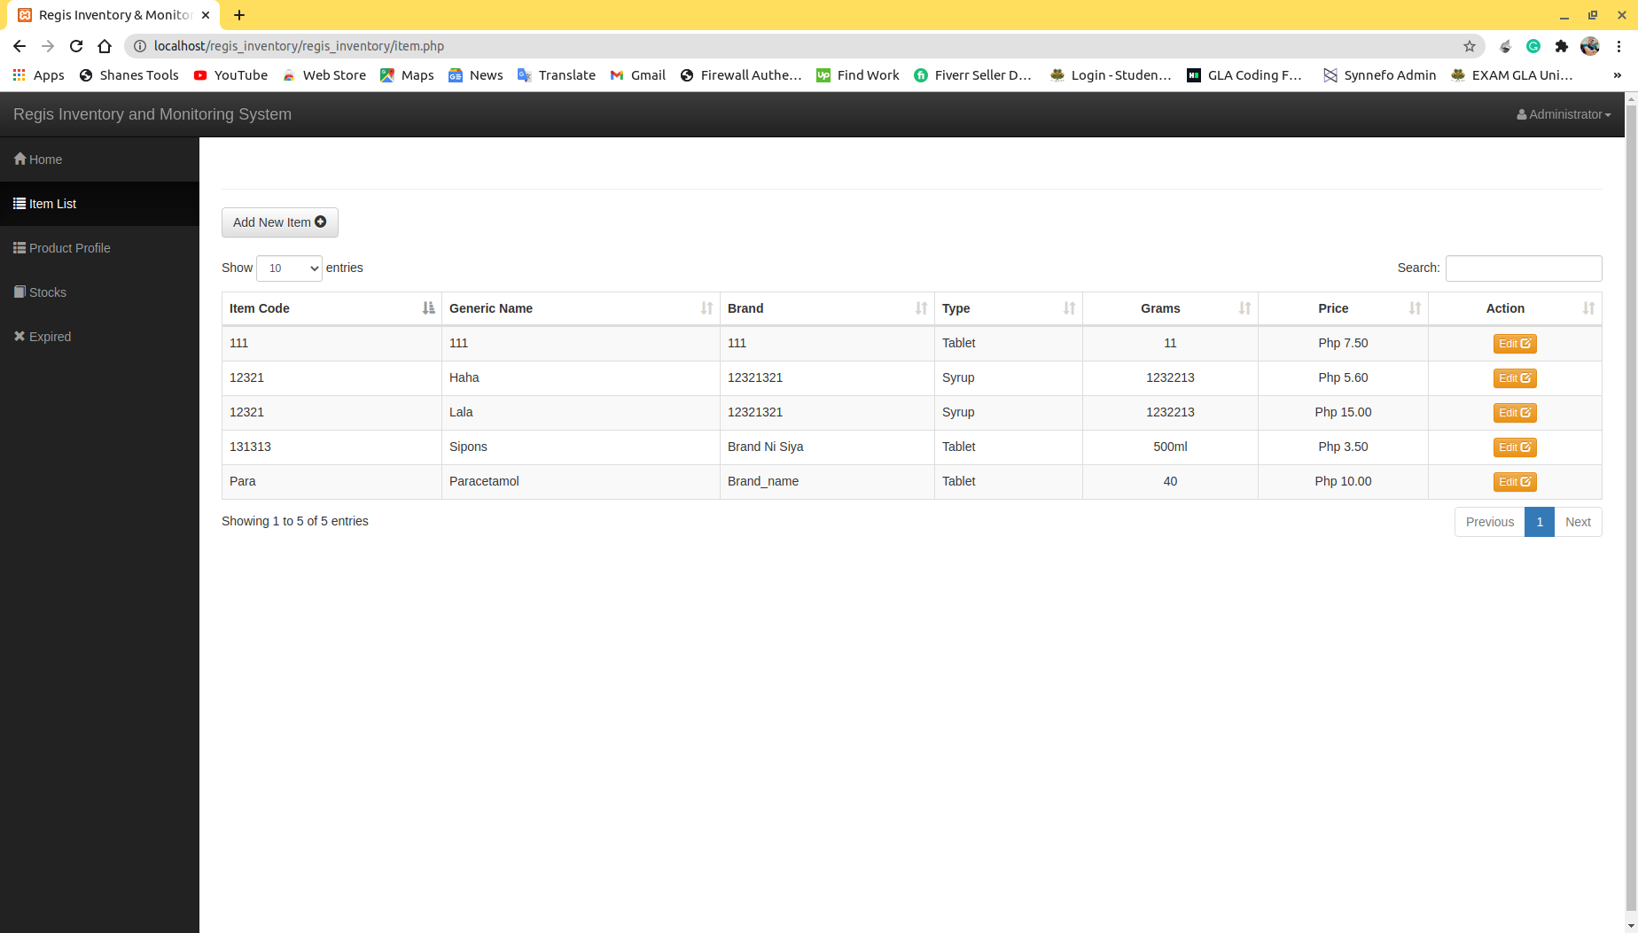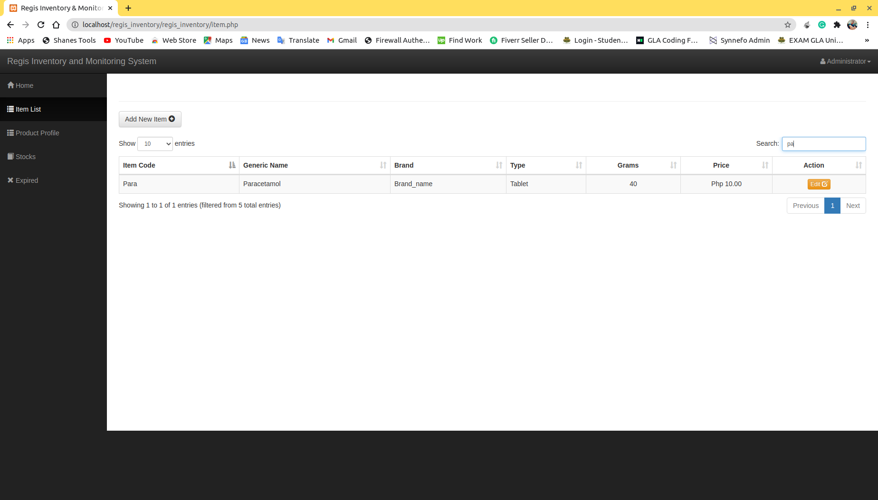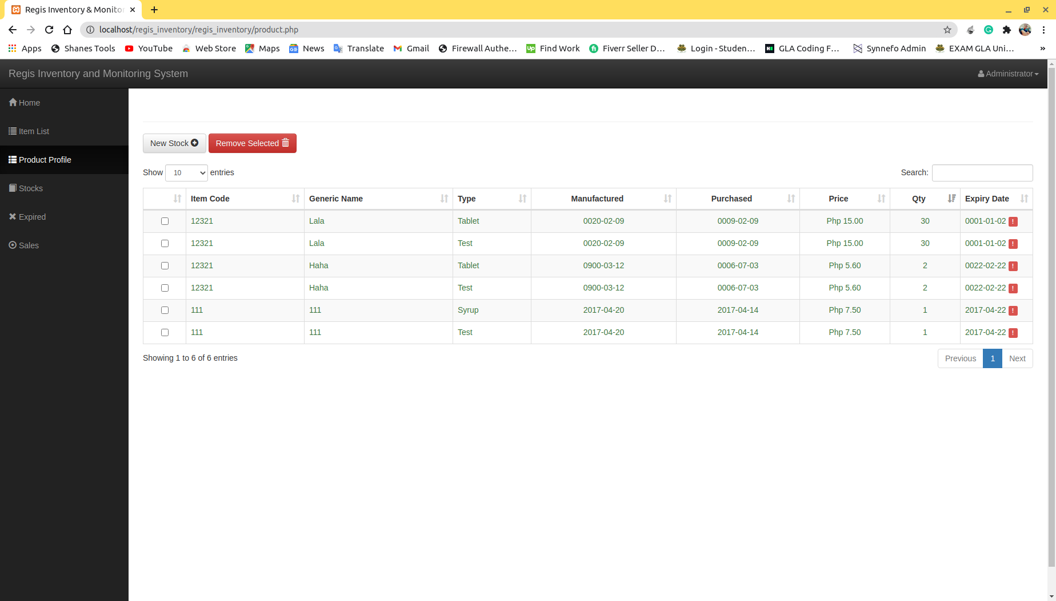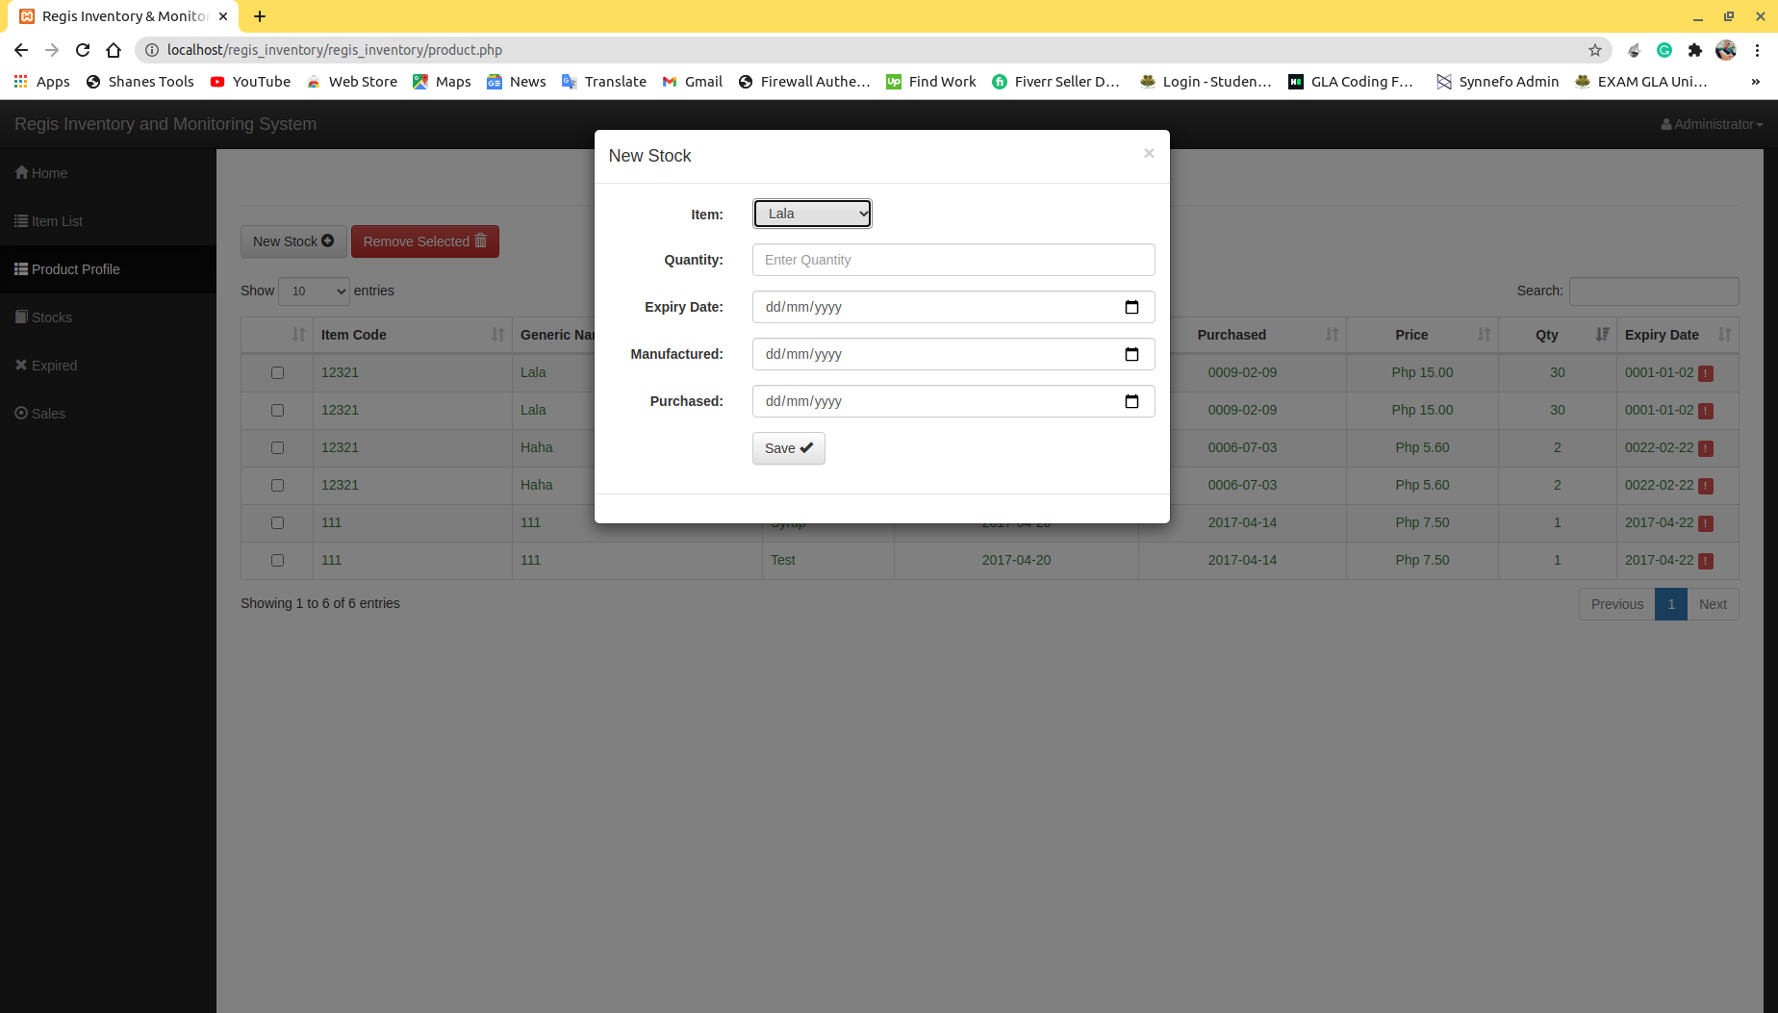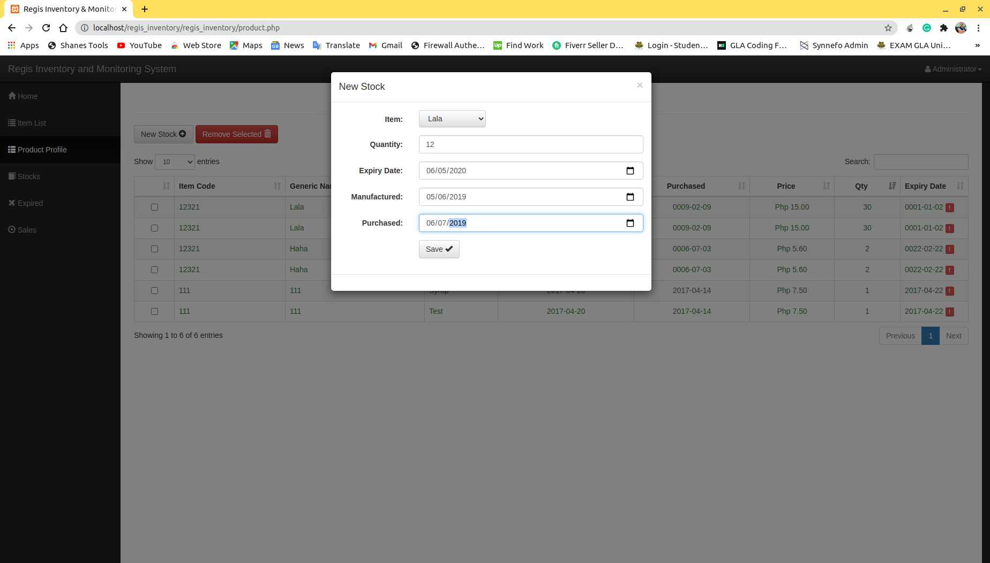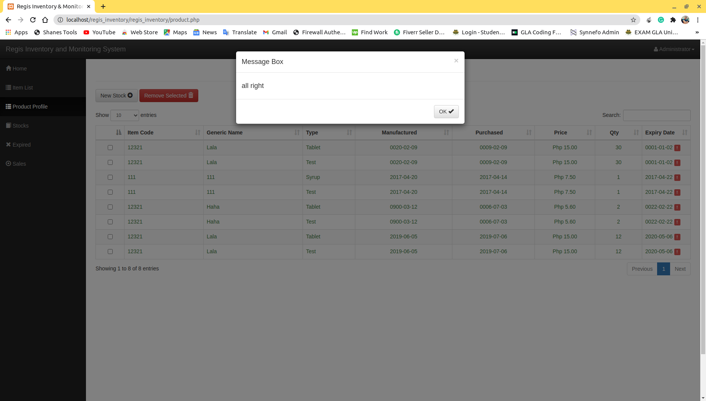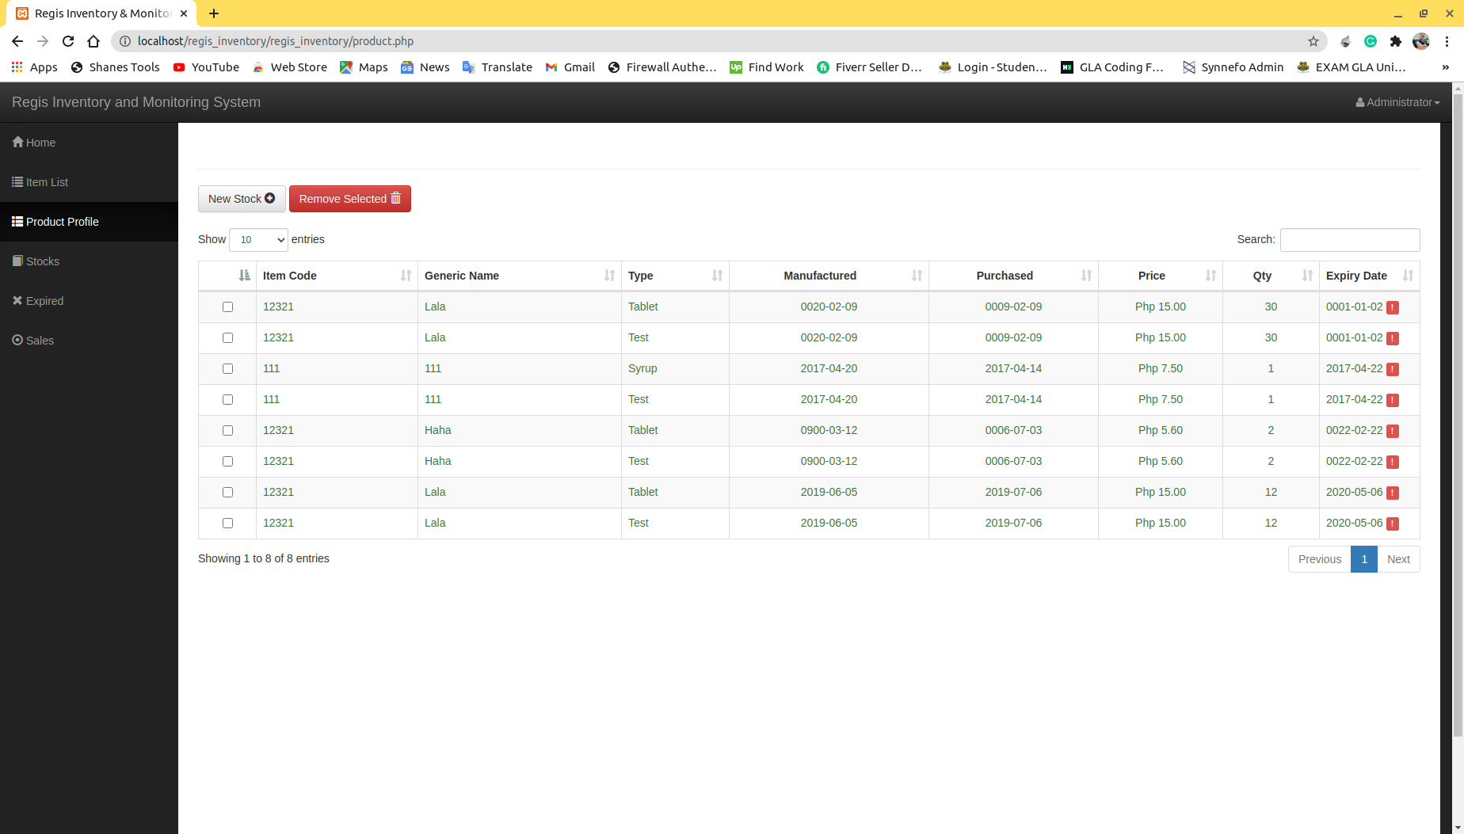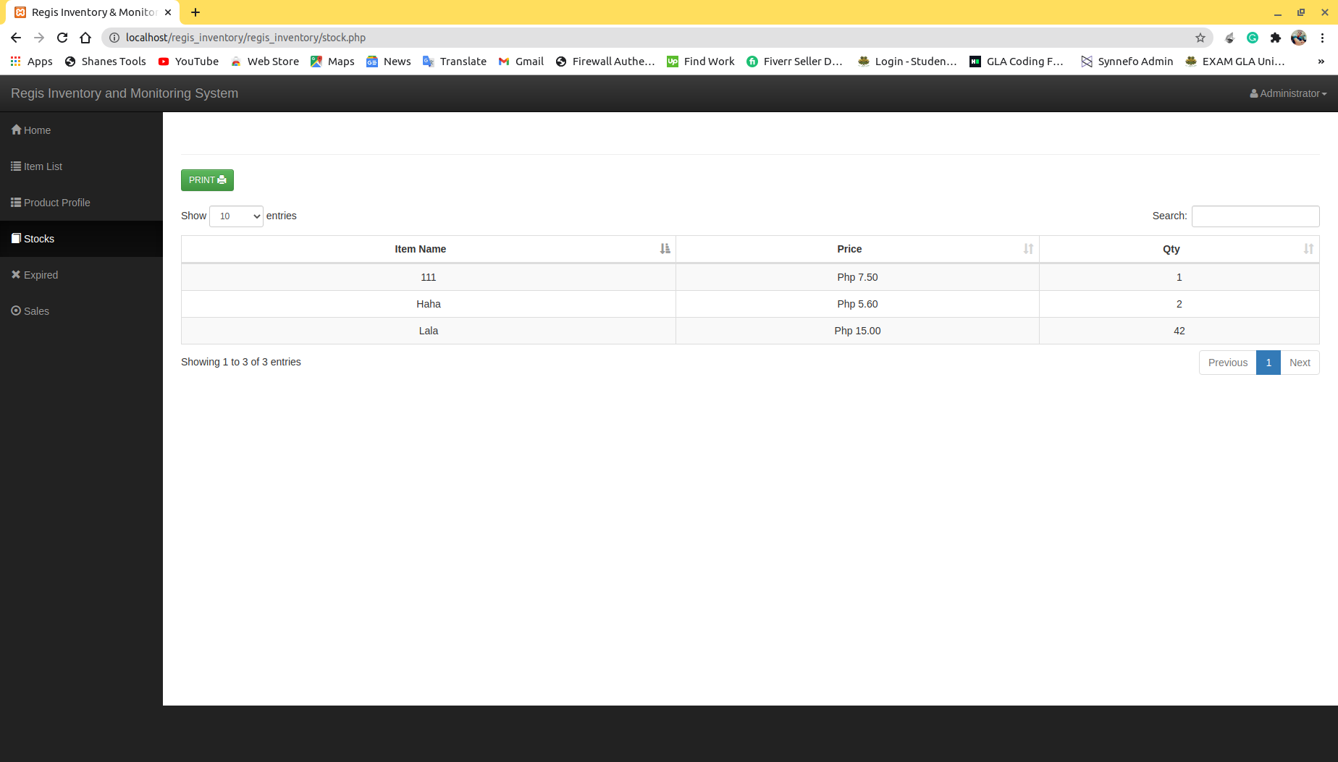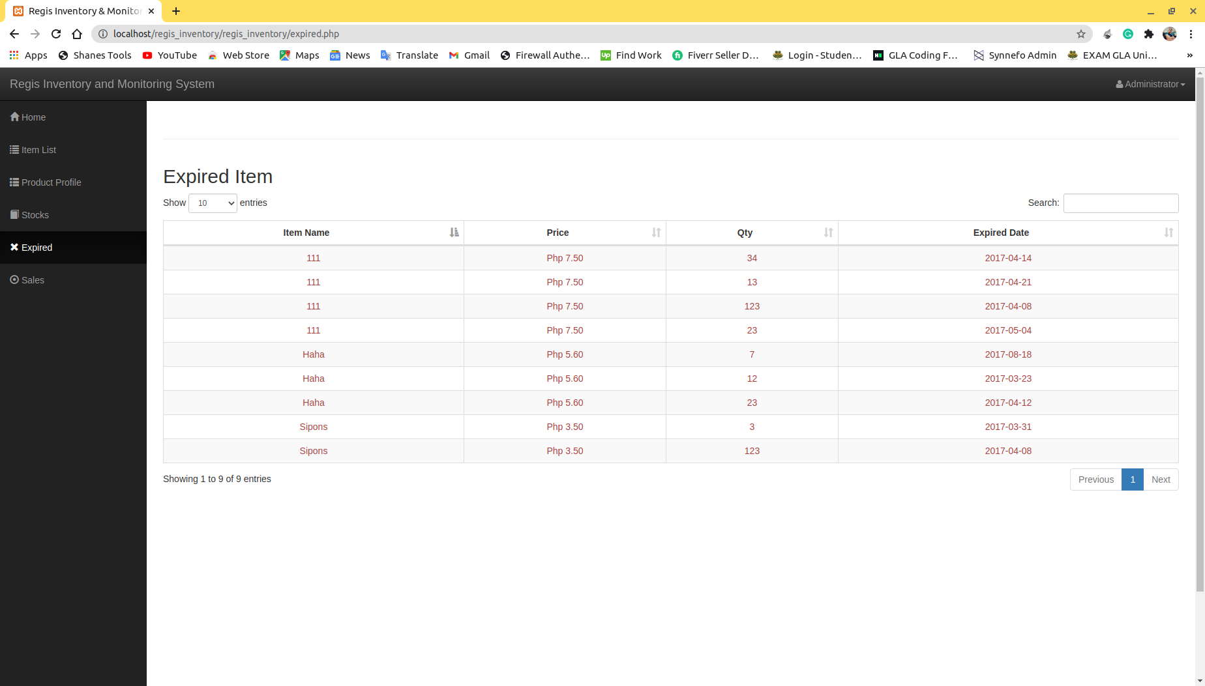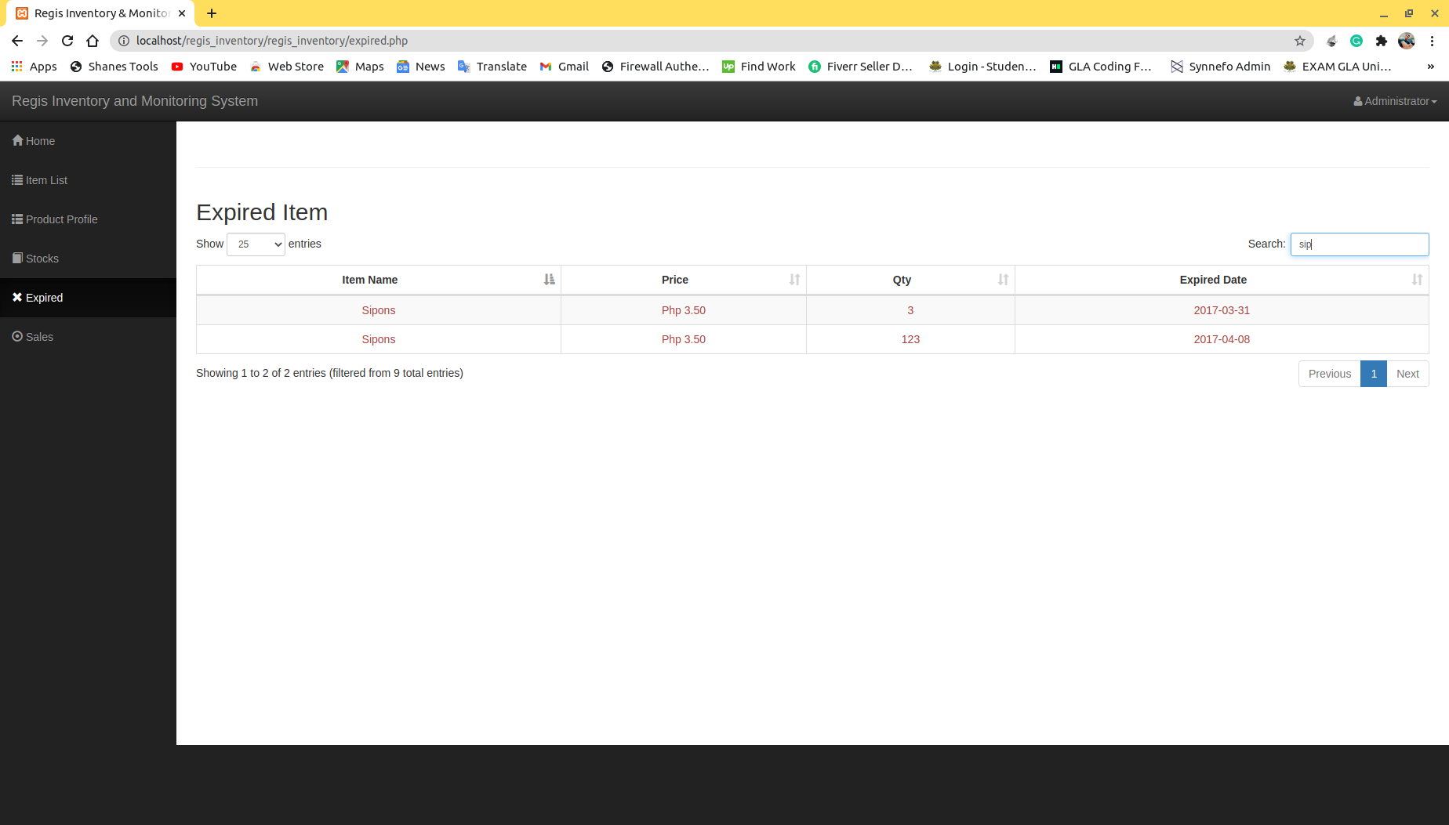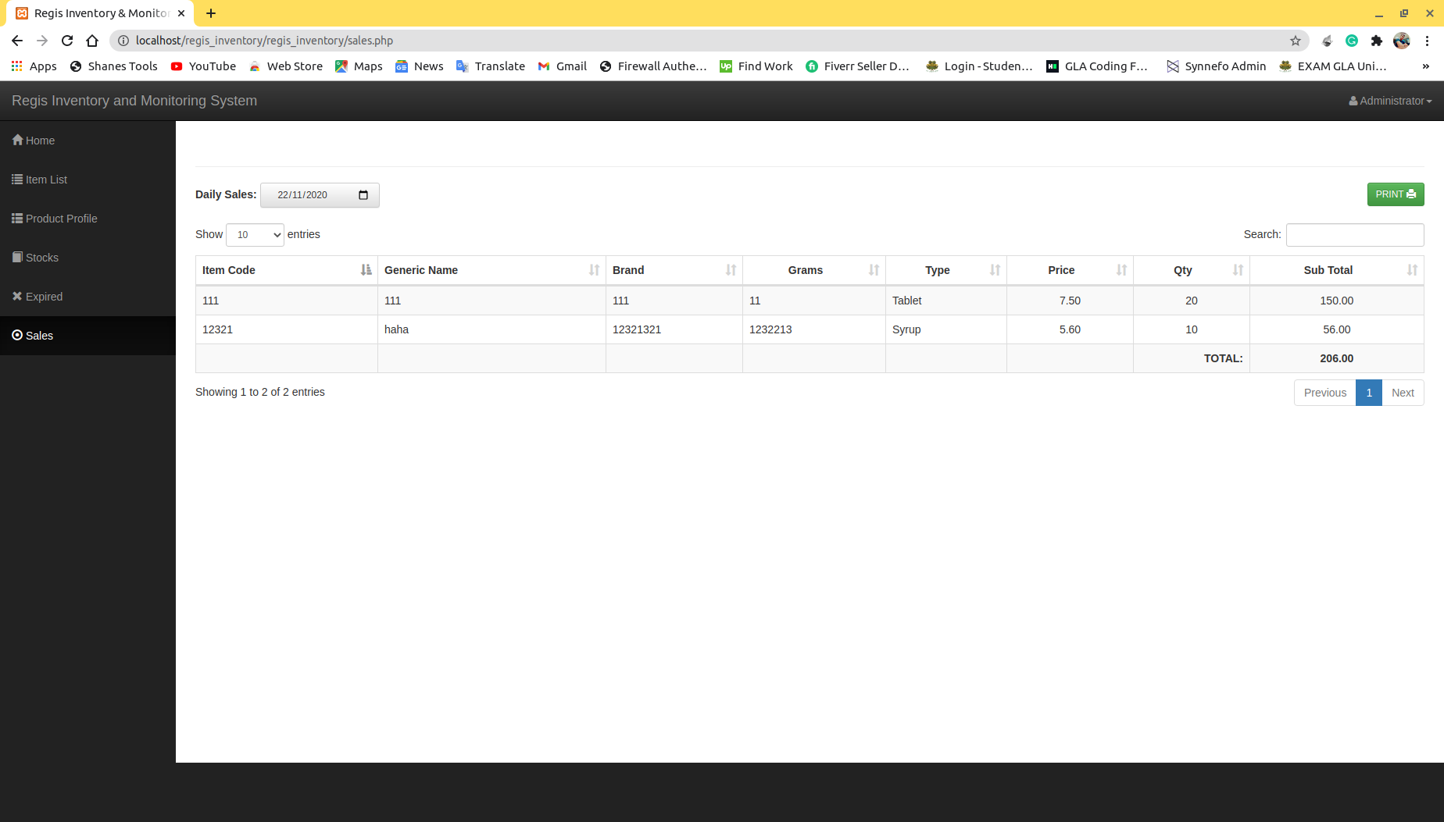

**DATA FLOW DIAGRAMS:**

* In this section of report we will see about different types of data flow diagrams related to our project:
  + 0 level DFD.
  + 1 level DFD.
  + 2 level DFD.

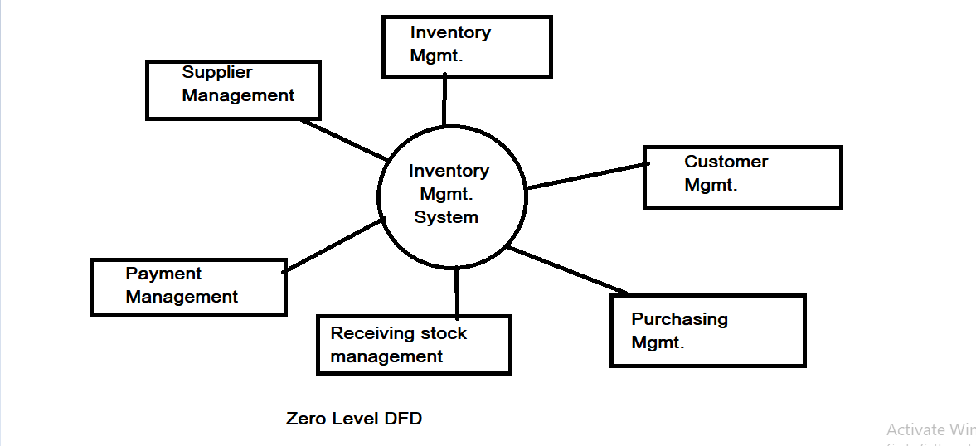

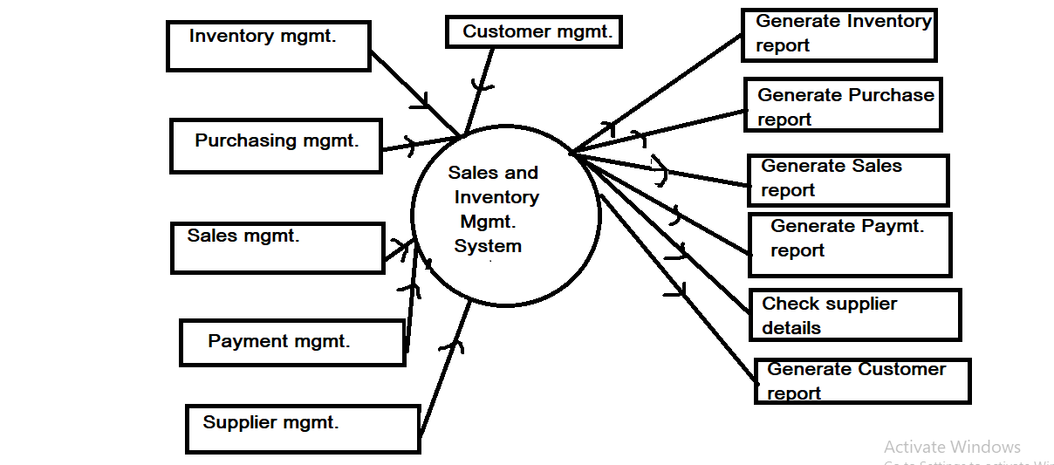

**First Level DFD**

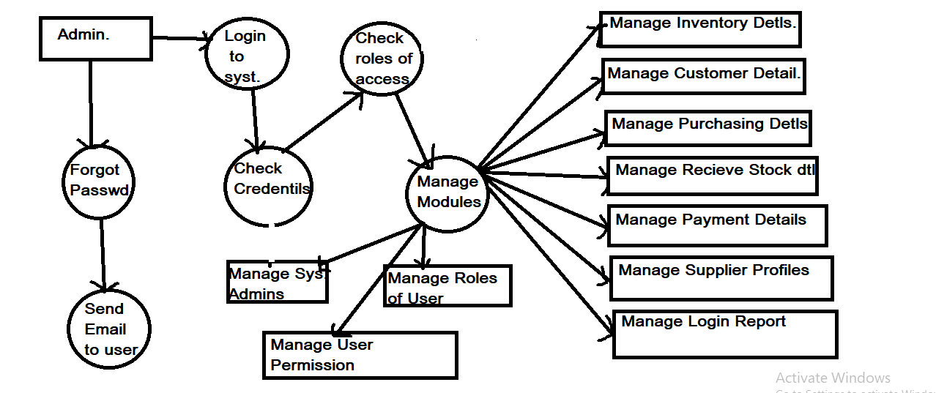

**Second Level DFD**

**SUMMARY / CONCLUSION:**

* It has user friendly interface which reduces the efforts of the user as well as for the administrator.
* It's basic aim is to provide self-health and solve the problems or issues by your own.
* It is a management system.
* It provides from consultation to purchasing medicines which reduces all efforts of the user to use different-different website or application to solve different-different problems related to health.
* It reduces the travelling and doctor's cost as well.
* Cheaper.
* Can be used Anywhere, Anytime.
* Reduces the patient tension.
* Helpful every-where and every-time

**REFERENCES:**

**https://beta-labs.in**

**https://hackr.io/tutorials/learn-bootstrap https://www.learn-html.org/**

**https://bootstrapbay.com/blog/learn-bootstrap/ https://www.w3schools.com/html**

**https://www.udemy.com/html-css-bootstrap/**